BCH 302 practical
Lab Sheet #2
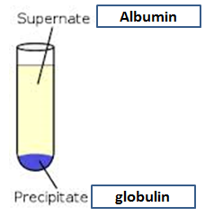
Proteins-I
1.Biuret test:
Observation | Tube
 | Add 2 ml of egg albumin+ Biuret reagent

2. Effect of salt concentration on the protein solubility:
Observation | Tube
 | globulin + NaCl
 | 3 ml of albumin solution + solid (NH4)2SO4

3. Precipitation of proteins using Acids:
Observation | Tube
3 ml of egg albumin +
Trichloroacetic acid (TCA).

 | 3 ml of conc. nitric acid + egg albumin

4.Precipitation of protein by salts of heavy metals:

Observation | Tube
1ml of egg albumin
+ 0.5ml of AgNO3

5. Protein denaturation:
Observation | Tube
 | 3 ml of egg albumin in boiling water bath for 8 min

