LAB SAFETY
What are Hazardous Chemicals?
- Hazardous chemicals are any products or materials that present any physical or health hazards when used.
- Any chemicals (including tape water) should be considered as a hazardous chemical and you must wear gloves and lab coat at all times.
Personal Safety
- Clothing
Wear:
  - Gloves
  - Long lab coat
  - Goggles/safety glasses
  - Closed-toed shoes
  - Tie back long hair
Do NOT Wear:
Sandals
Jewelry
Loose or Baggy clothing
Contact lenses
Types of Gloves
- Vinyl Gloves
Not to be used with chemicals or flame, used only to handle food and house hold.
- Latex Gloves: Used with diluted solutions of acids and bases, can be used with Acetone but not with most organic components.
- Butyl gloves
It has a very high endurance, fit to deal with oxidizing substances, resistant to leakage and water vapor
- Neoprene gloves
Best to deal with alcohol, acids and Acetonitril but not with solvents that has Chlore…
- Nitrite gloves
Used for most chemicals especially DMSO but it does not fit with aldehydes, nitro compounds, and Isocyanates.
- Silver shield gloves
The best types of gloves, suitable for the prevention of most types of chemicals and general risks
Lab Safety Equipment
- Eye Wash
- Safety Goggles
- Fire Extinguisher
- Fire Blanket
- Safety Shower: The safety shower is used primarily when large amounts of chemicals have been splashed onto the skin or clothing.
The safety shower may be used in the case of a body on fire, but a fire blanket should be used if possible.
IF the safety shower should ever be used, the person affected will need to remove all clothing including shoes and jewellery. As such, all other persons should evacuate the room to get help, and to allow for privacy.
Lab Safety Symbols:
- 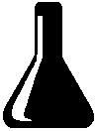 Glassware

- Heat
- Eye and Face Sharps
- Electrical Animal
- 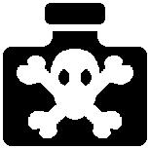 Chemical 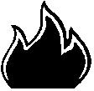 Fire

Other Chemical Hazards and Symbols:
- 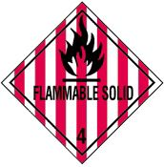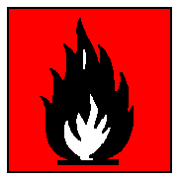 Flammable 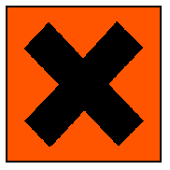 Irritant

- 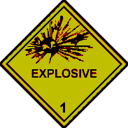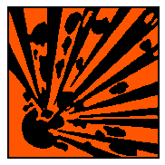 Explosive 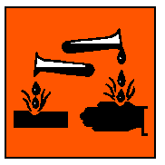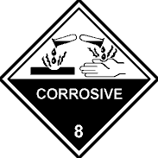Corrosive

- 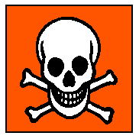 Toxic/Poison Environmental

Chemical Hazard Symbols and Definitions:
- Flammable – Any substance that will burn if exposed to an open flame.
- Explosive – A substance that may explode if exposed to heat or flame.
- Toxic/Poison – A substance that can lead to death if inhaled, ingested, or absorbed by the skin.
- Corrosive – A substance that can destroy or burn living tissue and can eat away at other materials.
- Irritant - A substance that causes inflammation upon contact with skin or mucous membranes.
- Environmental - Substances that are harmful to the environment. They must be disposed of properly, not washed down the drain.

Hazardous Materials Identification System NFPA 704 (Fire Diamond):

NFPA 704 is a standard maintained by the U.S.-based National Fire Protection Association. It defines the colloquial "fire diamond" used by emergency personnel to quickly and easily identify the risks posed by nearby hazardous materials. This is necessary to help determine what, if any, special equipment should be used, procedures followed, or precautions taken during the first moments of an emergency response.
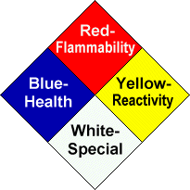

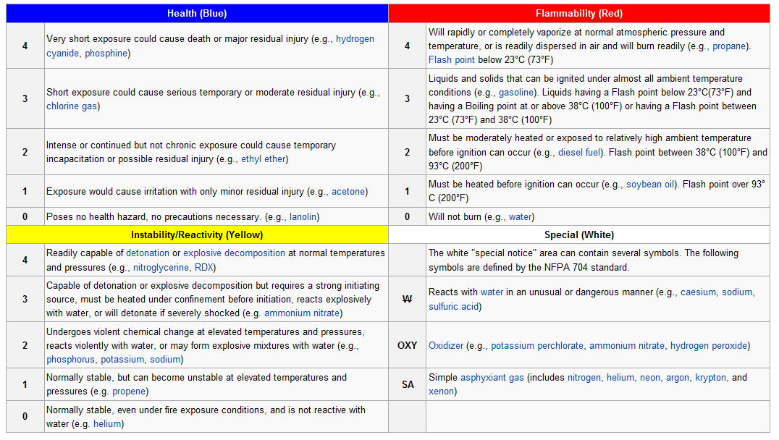

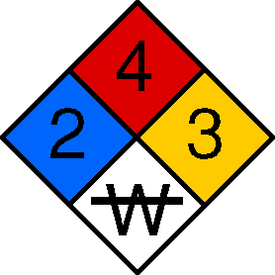

Hazardous Materials Identification System (Color Bar):

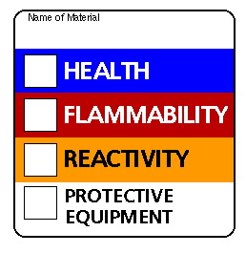

Waste Disposal
- First ask your teacher where/how to dispose of waste.
- Never pour anything down the drain unless you are told to do so.
- A waste bottle will be supplied for substance that cannot go down the drain
Reasons for proper waste disposal:
- Hazardous chemicals down the drain can lead to pollution of ground water, lakes, rivers, etc.
- Plants and animals will die if they are exposed to hazardous chemical waste.
- Serious health problems will become present in people if hazardous waste finds its way into drinking water.
Teachers & Students should protect their:

- Nose by smelling substances by wafting
- Eyes with goggles
- Hands with gloves
- Feet with closed shoes

