Lab 6 – Defeating Malware
Manual Method – without using any antivirus software
Steps | Details
1 | Start CMD
2 | Right click on ‘Command’ and ‘Run as Administrator’  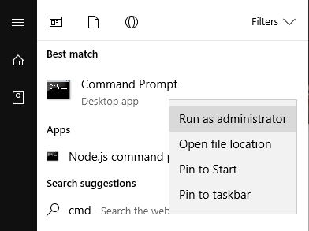
3 | Type ‘cd\’ and press ‘Enter’ Key  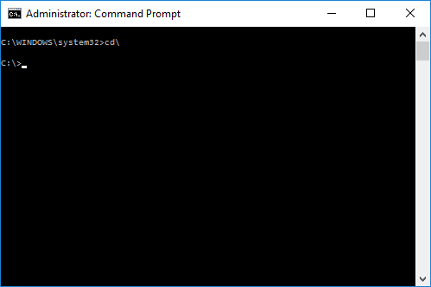
4 | Type ‘attrib’ and press ‘Enter’ key  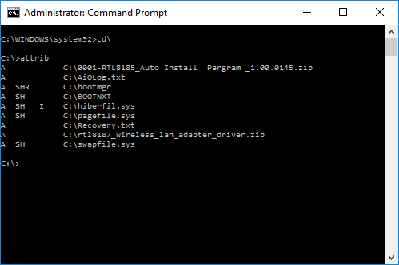
5 | If you find ‘.exe’ or ‘.inf’ file after the attrib command, do the following:  Type ‘attrib –s –h –r –a –i <<filename.extension>>  Example: attrib –s –h –r –a –i autorun.inf  del <<filename.extension>>  Similarly identify and delete anyfiles that have .exe or .inf as extension on the root drive.
6 | Now lets go to system32 folder using the command ‘cd windows\system32’.  Find if there are any files that have the attributes: system, hidden or readonly.
7 | Note down any files with .exe and/or .inf that have –S, -H or –R attributes
8 | If any such files are found use the same commands again to reset their attributes and delete them:  Type ‘attrib –s –h –r –a –i <<filename.extension>>  del <<filename.extension>>
9 | Similarly scan the appdata and temp folders to identify such files and get rid of them.

Software Method – Using MABM – Malwarebytes Anti Malware

Steps | Details
1 | Download and install MABM from https://www.malwarebytes.com  OR from my Mega Drive in Lab 6 folder https://mega.nz/#F!pm4FTLiK!H9IzRle5qtv_gwAfpw5rmQ
2 | Post installation of the MABM you can choose between custom or full scan
3 | Select custom scan on the start screen and choose only C:\ (root drive)
4 | Click on ‘Scan Now’ to begin the scan
5 | MABM will run all the files it encounters against the known and updated virus signature database and identify potential harmful files (executables, inf, sys, vol etc.,)
6 | Once the files are identified MABM will automatically quarantine them.

How to create a small malware :
- You need to stop any firewall on the VM.
- Create a text file and copy the following code:
- X5O!P%@AP[4\PZX54(P^)7CC)7}$EICAR-STANDARD-ANTIVIRUS-TEST-FILE!$H+H*
- Save the code in desktop with name eicar and extention.bin

