Ornamental fishes
Fishes that are kept in home aquariums, or for aesthetic purposes are considered ornamental fish. These fishes encompass a wide variety of species, of many shapes, sizes, and colors. Ornamental fish are usually kept in tanks or other aquarium systems.
The marine ornamental fish trade began in the 1930s in Sri Lanka, spread to Hawaii and the Philippines in the 1950s, and expanded to a multi-million dollar industry in the 1970s with fisheries established throughout the tropical Pacific, Indian and Atlantic Oceans. Currently, 45 countries supply global markets an estimated 14-30 million fish annual.
Goldfish, (Carassius auratus), ornamental aquarium and pond fish of the carp family (Cyprinidae) native to East Asia but introduced into many other areas. The goldfish resembles the carp (Cyprinus carpio) but differs from its relative in having no mouth barbels. Like all species of carp, the domestic goldfish, Carassius auratus, grows to be as large as its resources will allow (within reason, anyway). And they don't just eat fish flakes, either. ... Goldfish may also be bringing new diseases to the wild fish population
Indonesia and the Philippines supply approximately 65% of the global trade, and the United States is the largest importer, consuming from 50-60% of all marine ornamental fishes

Major importers and exporters of marine ornamental organisms. The major importers (black) are the United States, Europe and Japan. The major exporters are Indonesia and the Philippines; very large exporters include Australia, Hawaii, Florida, Fiji, Brazil, Maldives, and Sri Lanka; all other countries are small to medium exporters. This figure is modified from the Marine Aquarium Coun

Commercially important freshwater ornamental fishes
BARBS Barbs, members of the Cyprinidae family, comprise more than 400 species in their entire range, which extends from Africa, Asia and Europe to Central China, the Philippines and the East Indies. About 150 species of barbs are of ornamental value, comprising mostly of wild caught varieties. Barbus tetrazona (Tiger barb), B conchonius (Rosy barb) and Puntius titteye (cherry barb) are the most common barbs in the aquarium industry. P. denisonii, a wild caught variety of barb is mainly found in Kerala and Karnataka. 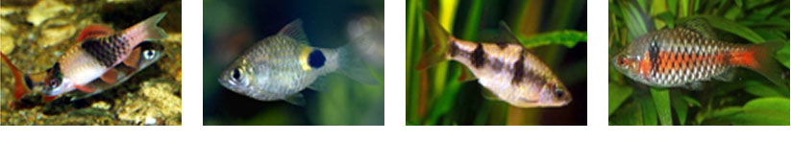 LOACHES Loaches, commonly known as Botia, are belonging to the family Cyprinidae. There are around 40 species of loaches known today, belonging to the genus Botia. They are natives of Thailand, India, Pakistan, China, Bangladesh and some Indonesian Islands. They are probably the most diverse group of fish in the hobby, both in pattern and behaviour. 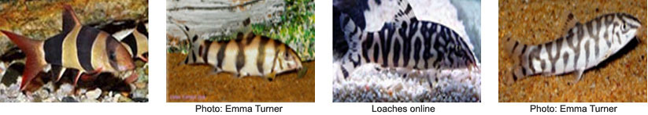 DANIO Danios, another member of the Cyprinidae family, are small and lively fish which are native to the Indian peninsula, Sri Lanka, Pakistan, Thailand, Myanmar, Malaysia and Indonesia. They are found in a variety of habitats from boulder-strewn mountain torrents to small pools in dry zone streams. There are more than 12 species reported today of which Danio malabaricus (Pearl Danio), D. albolineata and Brachydanio rerio (zebra fish) are common in the hobbyist market. Brachydanio rerio is mainly found in Kerala and Karnataka. 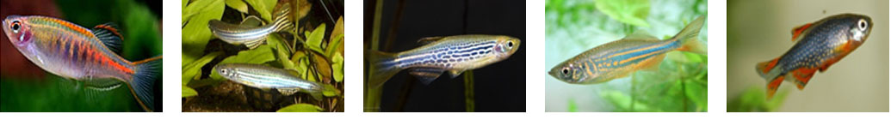 FRESHWATER SHARKS Freshwater sharks are different types of minnows, belonging to four genera, Balantiocheilos, Epalzeorhynchos, Labeo and Luciosoma, under the Cyprinidae family. They are commonly referred to as freshwater sharks in the hobby market. These minnows are widely distributed over Southeast Asia, the Malay Archipelago, Indonesia, and parts of the Middle East and Africa. Genus Epalzeorhyncho have four types of fresh water sharks, E. bicolor. 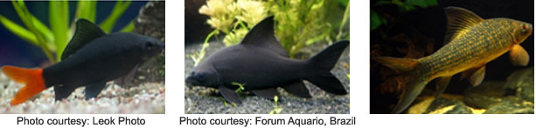 GOURAMI Gourami, the labyrinth fish, is a native of western and southern Africa, northeastern, southeastern, south and Southeast Asia. Colisa lalia, the Dwarf Gourami, occurs naturally in freshwater ponds, streams and paddy fields of northeastern India and Bangladesh, and is most popular among the Gouramis. 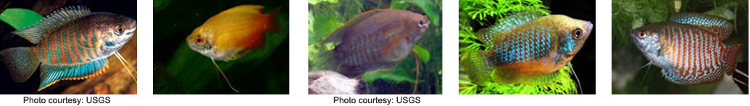 CATFISH Corydoras, commonly known as catfish, is belonging to the family Callichthydae. They are natives of South America particularly Brazil, Uruguay, northern Argentina, Venezuela, Peru and Colombia. The common species found in the hobby market are Corydoras ambiacus, C. agaassizii, C. leucomelas, C. schwa rtzi, C. punctatus, C. parallelus, C. pulcher and C. ornatus 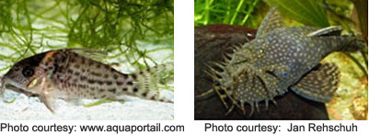
EELS Spiny eels or swamp eels are members of the family Mastacembelidae. They are distributed in India, Pakistan, Sri Lanka, Bangladesh, Nepal, Myanmar, Thailand, Malaysia, Vietnam and Indonesia. Macrognathus aculeatus (spotted spiny eel) and Mastacembalus armatus 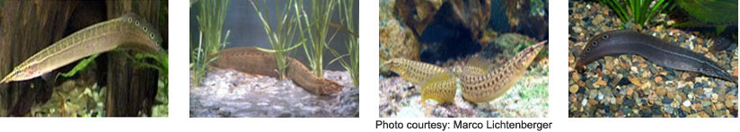 BADIS (Dwarf Chameleon) Badis badis, a native of India, Thailand and Myanmar, belongs to the Nandidae family. It is better known as the dwarf chameleon fish as it changes its colour quite often depending on mood and environment, especially during courtship and breeding. Badis has three sub species, Badis badis badis found in India 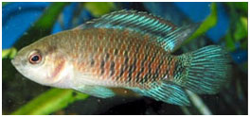 PUFFER FISH Puffer fish are members of the family, Tetraodontidae, having a worldwide distribution and found in almost every water condition. They are quite different from other ornamental fishes in appearance. The fresh water puffers include Carinotetraodon lorteti, C. salivator 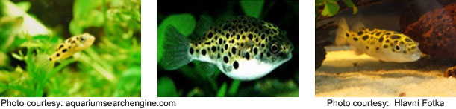 SNAK HEAD The snakeheads are characterized by their torpedo shaped body, large scale plated head and log dorsal and anal fins. 28 species of Channa are known today, C. bleheri, C. burmanica, C. gachua, 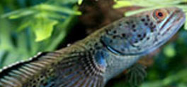
GLASS FISH Glassfish, belonging to the family Chandidae or Ambassidae, comprise mostly of fish with transparent bodies. They originate from Asia, especially Pakistan, India, Nepal, Bangladesh, Myanmar and Thailand. There are four species commonly referred to as glassfish in the trade: Chanda ranga, C. lala, C. nama and C. baculis. 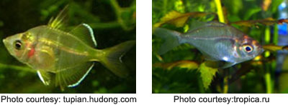
SHARK CATFISHES Pangasius is a genus of medium-large to very large shark catfishes native to freshwater in South and Southeast Asia. The term “pangasius” is sometimes used to specifically refer to the commercially important basa fish. Important species belonging to this group are Pangasius pangasius, P. nieuwenhuisii 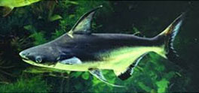
GUPPY The guppy (Poecilia reticulata), also known as ‘rainbow fish’ is one of the world’s most widely distributed tropical fish, and one of the most popular freshwater aquarium fish species. It is a member of the Poecillidae family and is live bearing. The origin is from Central America to Brazil and West Indies. 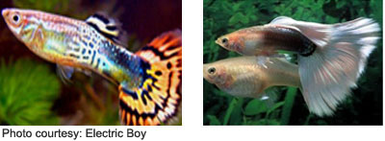
MOLLY Black molly, Poecilia sphenops, is a native of Central America, from Mexico to Columbia; sail fin molly (P. latipinna) is from Southeastern North America, from the Carolinas through the Gulf coast of Southern Mexico while Lyre tail molly (P. velifera) is found in the streams of Southern Mexico. 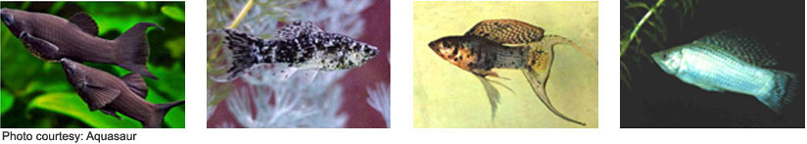
GOLD FISH The gold fish (Carassius auratus) is considered to be the most popular and attractive pet fish among all ornamental fishes, due to its many variations such as colour, fin shape, size and body structure. Though similar in appearance to carp (Cyprinus carpio), gold fish lack barbels and a dark spot at the base of each scale. The goldfish is the most common aquarium fish and one of the oldest and best-known fish in the industry 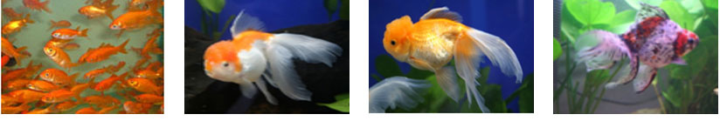 PLATY The Platy (Xiphophorus maculatus) belonging to the family Poeciliidae is native to the east coast of Central America and Southern Mexico. It is a live bearer and most popular among aquarium fishes. Several different colour variations have been developed so far such as red, yellow, orange, blue and white. Three species are commonly available; they are Southern Platy (Xiphophorus maculatus), Variatus Platy (X. variatus) and Swordtail Platy (X. xiphidium). 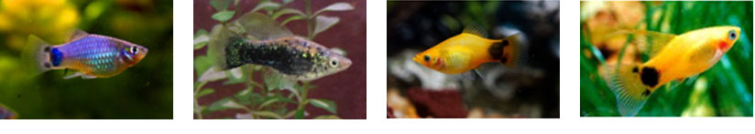 SWORD TAIL Sword tail is a native of North and Central America stretching from Veracruz, Mexico, to northwestern Honduras belonging to the family Poeciliidae. Swordtails (Xiphophorus hellerii) have been interbred to produce all kinds of interesting colors and different types of finnage. Some of the more common varieties of the Swordtail are Red, Red Wag, Red Tux, Painted, Neon Green, Marigold (and wag), Pineapple, Black, Red Twin bar, Sunset, and Gold Tuxedo.; 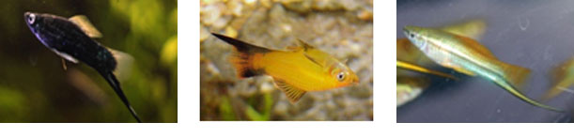 OSCAR Astronotus ocellatus is a member from the cichlid family, known under a variety of names such as Oscar, tiger Oscar or marble cichlid or the velvet cichlid. They are native of South America particularly Peru, Colombia, Brazil and French Guiana. 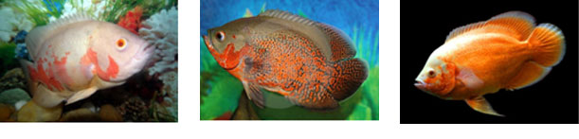 FIGHTER Siamese fighting fish (Betta splendens) is a popular aquarium fish coming under the family Osphronemidae. They are native of Mekong basin of Laos, Cambodia, Vietnam and Thailand. The colour patterns of this species ranges from vivid red, blue, bright green, purple, white, black to cream with red fins. Apart from coloration, the finnage also have varieties like veil tail, crown tail, half moon, butterfly, double tail etc. The males are very aggressive towards other males of their own kind and fight ferociously until death, hence the name of the fish. 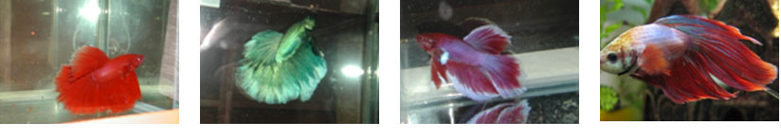SEVERUM Severums are widespread throughout the northern Amazon Basin and Guyana and are commonly referred to as ‘poor man’s discus”. There are several different color variations available, including the “Gold,” Green, Brown, and “Peruvian Green” strains. The most common species in trade include Heros severus and Heros efasciatus. 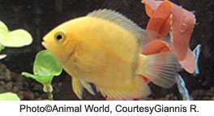
ANGEL FISH Angel fish (Pterophyllum scalare) are very popular and a favorite among hobbyist as they are beautiful and look graceful in the aquarium. In Asia, there are about 25 varieties now with unique colour patterns. They are single coloured ones like black, silver and gold and multi coloured pattern ones such as leopard, striped or zebra and lace-like, mottled or marble, half black etc. 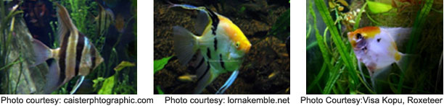DISCUS Discus (Symphysodon sp), members of cichlid group, is said to be the queen of the aquarium, native to South America, found in slow-flowing streams with alkaline water.The wild forms are blue discus (S. aequifa sciatus haraldi) the green discus (S. aequifasciata), Heckel discus (S. discus) and brown discus (S. aequifasciatus axelrodi). The wild blue discus is distributed in the rivers of Peru and Brazil while green discus is found mainly in the Peruvian Amazon. 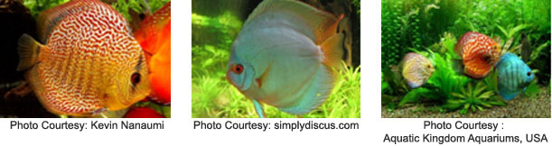 TETRA Tetra is one of the several small species of freshwater fishes from Africa, Central America and South America belonging to the biological family Characidae. There are ten varieties of tetras known, which are Neon tetras (Paracheirodon innesi), Cardinal tetra (Paracheirodon axelrodi), Black neon (Hyphessobrycon herbertaxelrodi), Black tetra (Gymnocorymbus ternetzi), Bleeding heart tetra (Hypessobrycon erythrostigma), Blood fin (Aphyocharax anisitsi), glow light tetra (Cheirodon erythrozonus), Head and tail light tetra (Hemigrammus ocellifer), Lemon tetra (Hyphessobrycon pulchripinnis), Serpae tetra (Hyphessobrycon callistus). 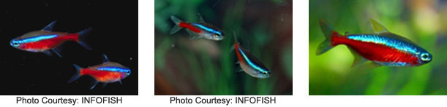

Commercially important marine ornamental fishes
GOBIES The gobies are small colourful species, usually solitary, sedentary, bottom dwelling fishes. The species include Amblyeleotris gymnocephala (masked shrimp goby), Mahidolia mystacina (Flagfin prawn goby), Paragobiodon echinocephalus,(Redhead goby), Periophthalmus argentilineatus (Barred mud skipper) 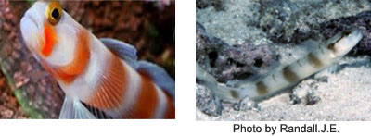
TRIGGER FISH These are often brightly colored fishes of the family Balistidae. Often marked by lines and spots, they inhabit tropical and subtropical oceans throughout the world, with the greatest species richness in the Indo-Pacific. The species recorded are Balistapus undulatus ( Orange – lined triggerfish), Balistes vetula (Queen triggerfish). 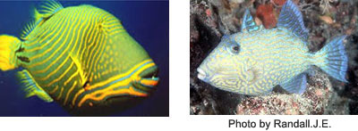
BLENNIES The blennies are small carnivorous fishes. Most species have drab colours which harmonise with their environment, but some are brilliantly coloured. The species recorded are Andamia reyi (Suckerlip blenny), Blenniellia periophthalmus (Bluedashed rock skipper) 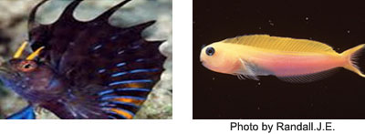
Angel fish Angelfishes are small to moderate brilliantly coloured fishes. They are subject to startling changes of colour and pattern as they grow. Favourite aquarium fishes, especially when small. The species recorded are Centropyge bicolor (Bicolor angelfish), C. eibli (Blacktain angelfish). 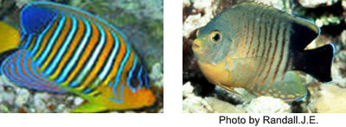
CLOWN FISHES Clown fishes are hardy, typically highly coloured and are in good demand in the marine aquarium trade. Clown fishes usually live in association with the sea anemones and also called anemone fish. Clown fishes exude a mucous substance which protects them from the stings of the anemone; when alarmed they immediately take shelter among the tentacles of the anemone, but never straying far. Major clown fish species are Amphiprion ocellaris (Clown anemone fish), A. percula (Orange clown fish), 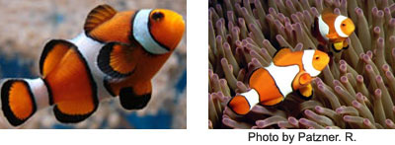
DAMSELS Damselfish, also called demoiselle, are a large group that make the family Pomacentridae together with subfamily Amphiprion (Clownfish) and subfamily Chrominae (Chromis). These are relatively small, primarily tropical marine fishes found in the Atlantic and Indo-Pacific oceans. Common damselfish available include: white tail humbug Damselfish (Dascyllus aruanus), Lemon Damsel (Pomacentrus moluccensis), 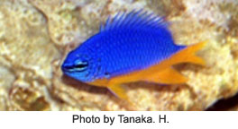
BUTTERFLY FISH These are small quick-moving marine fishes belonging to the family Chaetodontidae (order Perciformes). Butterfly fishes are found among tropical reefs around the world but are concentrated in the Indo-Pacific oceanic region. They move about with a flitting, darting motion and are very brightly coloured. The major species include four eyed butterfly fish (Chaetodon capistratus), spotfin butterfly fish(C. ocellatus), Feather-fin bull fish (Heniochus acuminatus). 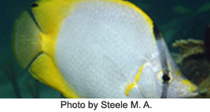
SEA STARS Starfish, commonly referred to as the sea stars are a large group of marine invertebrates called echinoderms, belonging to the class Asteroidea. Largest populations of starfish live in the Indian and Pacific oceans. 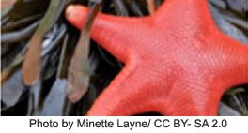
SEA ANEMONES Sea anemones, are members of the invertebrate order Actiniaria (Class Anthozoa). These are soft-bodied, primarily sedentary marine animals resembling flowers. They are largest, most numerous, and most colourful in warmer seas. Some live in brackish water. The common species include Bubble-tip anemone (Entacmaea quadricolor), Condy seaanemone (Condylactis gigantea) 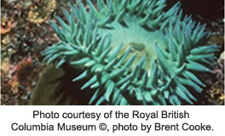
Global trade in ornamental fishes
During the last four decades, there has been considerable growth and diversification in the international trade in ornamental fishes which is valued at about US $ 5 billion. The major players in this market include USA, Europe, Japan, Australia. Singapore, ndonesia, Philippines and Sri Lanka. In recent years much interest has been shown by the home hobbyists and public aquaria to keep marine ornamentals. lnerebytheproportion of marine fish in the total global trade has jwnped from less than 15% to about 40%. The market for ornamental fishes. The market for ornamental fishes consists of 99% home-hobbyists and 1% public aquaria and research institutes. The market is mostly located in areas with high density population, ind ustrial areas and cool P. Jayasankar Scientist (Senior Scale)
eM.F.R.I., P.B. No. 1603, Tatapuram, Kochi -682014 climate (Bassleer, 1994). The industrial chain which determines the price is explained as, fishennanlbreeder -4 exporter
~ airline-4 importer/wholesale r~ retailer --> hobbyist. The importer/wholesaler plays a very important role as the link between producer and consumer. Only perfect, good and healthy fish have good market value. The extra cost of quality control in a fish house (at both export and import level) with good seawater management and trained staff thus adds to the value of the fish . Accordingto statistics, 50% of the suppliers are located in Asian
countries. Singapore. Thailand, Hong Kong, Japan and Malaysia are the major suppliers
of freshwater fish . while Indonesia, Philippines and Sri Lanka are the major suppliers of wild-caught marine fish. Philippines is knOWll for the direct export of marine exotic \'arieties. Singapore exports relatively few salt water fish. Originating from its own resources but depends mainly on re-export of Indonesia-caught fish and invertebrates, while Sri Lanka exports her OWll reef fishes and fishes coming from Maldives. Those fishes originating from the Maldives are either usually available in lesser numbers in Sri Lankan waters or are only seasonal. The largest import markets for tropical fish are USA. EEC and Japan. Approximately 14 percent of British homes and 8 percent ofuSA homes keep ornamental fish . According to Andrews (1992) 150 million ornamental fish are sold on a worldwide basis each year. CWTent opinions suggest· that about 90% of the freshwater ornamentals traded are captive-bred, while 99% of the marineomameotals exported are wild-caught.
Aquarium fish can fetch about I 00 times more price than the food fish and marine ornamentals are about ten times costlier than their freshwater counterparts (Bassleer. 1994; Gomes, 1996). Approximate export value (only indicative price) in us $ per piece: damsels: 0.50-1. 00; Wrasses: 0.85- 2.00; tangs: 3 .25-3.75; moorish idol: 3.25-3.50; powder blue surgeon: 11.00-12.50; butterfly fishes: 1.65-4.25; cardinal fishes:0.60 - 0.70.The economics and profitability of an ornamental fish exporting mit works out to be highly lucrative provided the activity is taken up on scientific hnes with appropriate marketing strategies. The activity is possible not only on large scale but also on small scale. It provides good opportunity even to small entreprenems to enter into the field. Institutional fimding for R&D activities is. however. essential. Commercial banks can formulate schemes for extending financial assistance to
prospective entrepreneurs for short-term training programmes on production of ornamental fishes. Two of the major areas which Tequire immediate attention are. la)
in-house breeding of selected species of marine ornamenta I fishes which are in great
demand to release the pressure on wildcaptme and (b) scheme of educating/training
a good number of fisherfolk in the more skilled and specialised techniques of
collecting handling. storing and transport of ornamentals which could revolutionise
the fishing industry to soInt extent. Provide enhanced cash income and thus better living
standards for those involved.

