CT 1513 - Introduction To Java
1st semester 1439-1440
Lab

- the frame contain 2 text fields and 1 button in a grid layout as shown in the following figure:

230

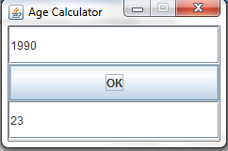
150

- The user inters its birth year and when he click the ok button his age appears

