Write a C program to do the following :
- Ask the user to enter positive numbers then print the sum of them , stop when he enter any negative number.

- (from the previous sheet )Write a program to ask the user to enter two numbers and to decide what to do with them ask him to enter 1 for adding and 2 for subtraction 3 for multiply and 4 for division(in case of division make sure the second number is not 0)
Repeat the process by asking the user if he want to do it again or to stop ,The program should be executed at least once.

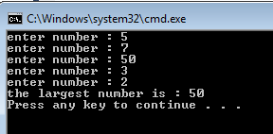
- Ask the user to enter 5 numbers then print the largest

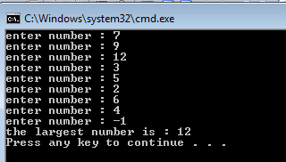
- Chang the previous program to determine the largest number for unknown set of positive numbers.

- prompts the user to enter the number of lines to draw a triangle of stars upside down
