_____

- Write a visual class named Employee to store information about user. The UML representation of the class is shown below.

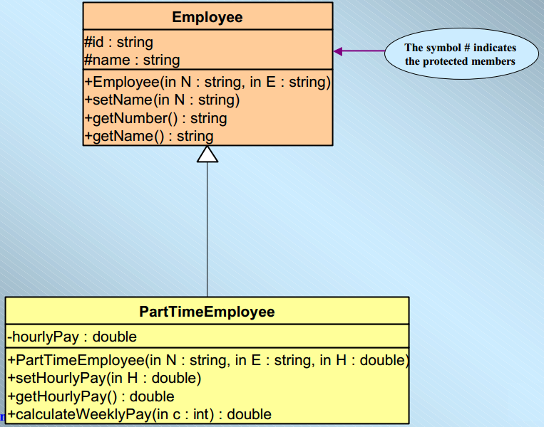

The Employee class contains:
- 2 protected attributes:
  - id (string): to store the number of the employee
  - name (string): to store the name of employee .

- A method setName( N) that initializes name to values entered by the user.
  - A method getNumber () that returns the ID of employee.
  - A method getName() that returns name of employee.

Write another visual class called PartTimeEmployee inherited from Employee class as you see in UML.

