KING SAUD UNIVERSITY
COLLEGE OF APPLIED STUDIES AND COMMUNITY SERVICE
CSC 1101 First Semester 1436-1437
Lab#4 b
________________________________________________________________________________

Q1) Draw a flow chart and write a C++ code a program that reads an employee ID that composed of three parts: the employee name, the year of the birth and the department number in the form NAME/YEAR OF BIRTH/DEPARTMENT NUMBER, then the program print the year of birth
Example
Ahmed/1410/521  1410 | Mohammed/1403/96  →1403

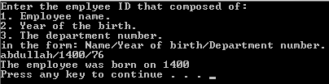
Q2) Draw a flow chart and write a C++ code for a program that reads a word then it print the word after exchanging the first and the last letters of the word
Examples
net → ten send→ dens programming → grogramminp

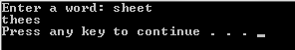

Q3) Draw a flow chart and write a C++ code a program that reads a string composed of more than 2 letters. The program then generates and prints two new strings that are the first and second parts of the original string. i.e. the string will split to 2 parts
Examples
Friend →  Fri  end | House →  Ho  use | Yes →  Y  es

