1) State the order of evaluation of the operators in the following C statement and show the value of x after the statement is performed.
- x = 5 % 5 + 5 * 5 - 5 / 5;

2) Write a C program that reads 2 numbers, person’s weight in kilograms and height in meters, then calculate the user’s BMI according to:

$$BMI= \frac{ weight in kilograms }{{height in meters}^{2}}$$
Example
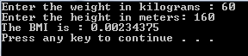

) Write a C program that calculate the Fahrenheit according to the following equation3
Fahrenheit = $\frac{9}{5}$ Celsius + 32
Example:

