GC311 – Database Concepts
Lab #2

Q1: The many-to-many relationship between books and authors can be modeled with 3 tables, as shown below. A books table contains data about books (such as title and price); an authors table contains data about the authors (such as name and email). A table called books_authors joins the books and authors tables and captures the many-to-many relationship between books and authors.
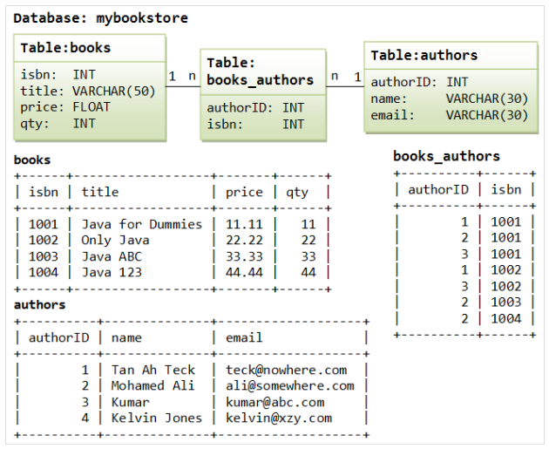

- Using Data Manipulation language (DML), write SQL query using oracle.
  - List full details of all authors arranged in descending order of name.
  - List all books with a price between 30 and 50.
  - List all java programming language books.
  - How many books that cost more than 20?
  - How many java programming language books.
  - Find sum of quantities of all books.
  - Find minimum, maximum, and average book price.

