KING SAUD UNIVERSITY
COLLEGE OF APPLIED STUDIES AND COMMUNITY SERVICE
CSC 1101 First Semester 1436-1437
Lab#2

1) Write a C++ code for a program that reads two floating point numbers and then the program the sum, difference, product and division of the two numbers.
Apply the following format:
- Set the width for printing to 6 and use # as a fill character.
- The number of significant digits that be printed is 2.
Example
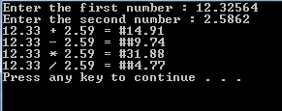

2) Write a complete program that calculate the BMI using the following equation:

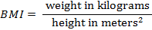
Example
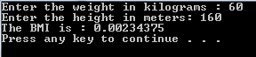
3) Write a complete program that calculate the Fahrenheit using the following equation:
Fahrenheit = Celsius + 32
Example:
