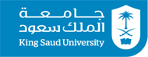
King Saud University
College of Nursing
^{1st} Semester SY 1439 – 1440
2018

WEEK | TIME-IN | SIGNATURE | TIME-OUT | SIGNATURE
Student Name:
Student ID:

