**Interference of Light Exercises**

**(Lecture 8)**

1. **A laser beam (λ = 632.8 nm) is incident on two slits 0.200 mm apart. How far apart are the bright interference fringes on a screen 5.00 m away from the double slits?**

Solution:

You are asked about bright fringes, so we need constructive interference, so the path lengths taken by the light going the two slits has to differ by an integer number of wavelengths. So considering two adjacent fringes, namely the “mth-order” and the next one (m+1), we get

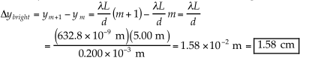

1. **Light of wavelength 460 nm falls on two slits spaced 0.300 mm apart. What is the required distance from the slit to a screen if the spacing between the first and second dark fringes is to be 4.00 mm?**

Solution:

So this time you are dealing with dark fringes (destructive interference; odd 1/2 wavelength difference in path length), and we are given the separation between the fringes, and asked to calculate the distance to the screen.

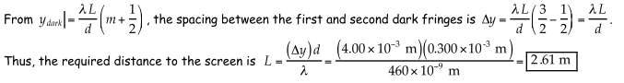

1. **Viewing screen is separated from a double-slit source by 1.2 m. The distance between the two slits is 0.030 mm. the second-order bright fringe (m=2) is 4.5 cm from the center line.**

**Determine the wavelength of the light?**

Solution:

m=2

$y_{bright}=4.5×{10}^{-2}m$

$L=1.2 m$

$d=0.030×{10}^{-3}m$

$λ=\frac{y_{bright} ×d}{m L}$

$λ= \frac{(4.5×{10}^{-2}m)×(0.030×{10}^{-3}m)}{(2×1.2 m)}$

$λ=5.6×{10}^{-7}m=560 nm$

1. **Calculate the minimum thickness of a soap-bubble film (n= 1.33) that results in constructive interference in the reflected light if the film is illuminated with light whose wavelength in free space is λ= 600 nm.**

Solution:

The minimum film thickness for constructive interference in the reflected light corresponds to m=0 in the equation 2nt=(m+1/2)λ where (m=0, 1,2…..)

This gives $2nt= \frac{λ}{2}$

$n=\frac{λ}{4t}$

$n= \frac{600 nm}{4×1.33}=113 nm$