Nursing college
Maternity & Child Health Nursing Department
NUR 327

Infant/Children Assessment sheet
Medical- Surgical unit/ ICU
Date: / /
Date Received: / /
( ) On Time (0.5) ( ) Late

Student name:
ID #:
Department: Score:
Instructors' name:
/60
/10
Signature:

Socio-demographic data |  | /3
Patient name : |  | 0.25
Age : |  | 0.25
Sex: ( ) Male ( ) Female |  | 0.25
Date of birth : |  | 0.25
Date of Admission: |  | 0.25
Accompanied to hospital by: |  | 0.25
Diagnosis: ------------------------------------------------------------------------------ |  | 1
Data source: ( ) Care giver ( ) Patient ( )File |  | 0.25
Allergy: ( )Yes ( ) No If yes specify : |  | 0.25
History  / 4.5 | Chief complaints:  1
Present History:
1
 | Past History:  Previous hospitalization: ( ) Yes ( ) No If yes  When: Why? | 1.5
 | Family history: | 1
Vital Signs  / 1.25 | Temperature:  Pulse:  Respiratory rate:  BP:  SPO2:

Integumentary System  / 3 | Skin Color: ( )Normal ( )Pale ( )Cyanotic ( )Jaundice ( )Flushed 0.5
 | Temperature : ( ) Warm ( ) Cool 0.5
 | Texture: ( ) Intact ( )Smooth ( ) Dry ( )Oily 0.5
 | Lesion: ( ) None ( )Bruises ( )Scar ( )Rash 0.5
Surgical incision: ( ) None ( ) Dressing 0.5
location:__________ ( ) clear ( ) Dry ( ) intact 0.5
Drainage: ( ) Yes ( ) No
 | Others:
Head & Face  / 4.5 | Hair: ( ) Normal ( ) Loss of hair ( ) excessive body hair ( ) itchy scalp 0.5
Fontanels: ( ) Open ( ) Close 0.25
( ) Normal Flat ( ) Sunken ( ) bulged 0.25
 | Eyes: ( ) Clear ( ) Discharge ( )Puffy ( )Redness 0.5
 | Ears: ( ) Normal placement ( )Use a hearing aid ( ) Discharge 0.5
Mouth: ( ) Normal ( ) Sores ( ) Coating ( ) Bleeding gums ( ) Loss of teeth ( ) Delay eruption of Teeth ( ) Toothache ( ) Dental caries
0.5
 | Tong: ( ) Pink ( ) Moist ( ) Freely movable ( ) Tide ( ) Coating 0.5
 | The roof of the mouth: ( ) Normal ( ) Cleft palate 0.5
 | Lips: ( ) Normal ( ) Cleft lips 0.5
Neck: ( ) Normal ( )Swelling ( ) Stiffness ( )Distended neck vein 0.5
( )Enlarged lymph nod
 | Others:
Respiratory system  / 3.5 | Breathing:( ) Normal ( ) Hypoventilation ( ) Hyperventilation 0.5
 | Cough: ( ) None ( ) Productive ( ) Nonproductive 0.5
Lung Sound: ( )Normal ( )wheeze ( )Rhonchi ( )crackles ( ) Stridor 0.5
0.5
Chest Movement: 0.5
( ) Symmetrical ( ) Asymmetrical ( ) Using of accessory muscles ( ) Nasal flaring
( ) Substernal intercostal notch ( ) Sub clavicular retraction
 | Chest Shape: ( ) Normal ( ) Pigeon chest ( ) Funnel chest ( ) Other 0.5
Oxygen Therapy : 0.5
( ) Room Air ( ) O2@ _____L/min FiO2____ % per _______
( ) Other:
 | Others:

Cardiovascular System  / 3 | Heart sound: ( ) Normal ( ) Abnormal 0.5
 | Pulse : ( ) Regular ( ) Irregular 0.5
 | Strength : ( ) Normal ( )Weak ( )Bounding 0.5
 | Peripheral circulation:( ) Extremity cold ( ) Clammy ( ) Edema ( ) Cyanosis 0.5
 | Cap refill less than 2 sec: ( ) yes ( ) No 0.5
 | Pitting edema: ( ) yes ( ) No 0.5
 | Others:
Gastrointestinal System  / 4.5 | Diet: | NPO( ) Reg. ( ) Clear liquid ( ) Other ( ) _______ 0.5
 | Appetite: | ( )Good ( )Poor ( ) Refused ( ) Nausea ( )Emesis  ( ) Vomiting ( )Other ---------- 0.5
 | Feeding Tube: | ( ) N.A ( ) NG ( ) GT ( ) Other:……. 0.5
 | Abdomen: | ( ) Soft ( ) Firm ( ) Hard ( ) Distended 0.5  Girth: ___ cm 0.5
 | Bowel sound: | ( ) Normal ( ) Hyperactive ( ) Hypoactive ( ) Absent 0.5
 | Elimination: | ( ) Normal ( ) Diarrhea ( ) Constipation 0.5
 | Consistency: | ( ) Soft ( ) Watery ( ) Solid 0.5
 | Color of stool: | Color: ( ) Normal ( ) Abnormal 0.25
 | Umbilicus: | ( )Herniation ( ) Fistula ( ) Cleanliness ( ) Discharge 0.25
 | Others:
Genitourinary System  / 1. 5 | Male  Urethral meatus: ( ) Normal ( ) Abnormal 0.25  Scrotum: ( ) Normal ( ) Abnormal 0.25  Testes: ( ) Normal ( ) Abnormal 0.25
Female
Labia: ( ) Normal ( ) Abnormal
Urethral meatus: ( ) Normal ( ) Abnormal
Urine: ( ) Continent ( ) Incontinent ( ) Foley ( ) Diaper 0.25
Color: Character: 0.5
 | Anus: ( ) Open ( ) Closed ( ) Redness ( ) Inflammation
 | Others:
Musculoskeletal System  /1.25 | ( ) Muscle weakness ( ) Hypotonic ( ) Atrophy ( ) Hypertrophy  ( ) Dystrophy ( ) Joint swelling ( ) Joint stiffness 0.25
Extremities: ( )Symmetry of length ( ) Symmetry of size ( )Full range of motion ( ) Tenderness
( ) Normal no. of finger ( ) Normal no. of toes
( ) Clubbing finger ( ) Bowleg ( ) Knock-knee 1

Neurological System  / 1.5 | LOC: ( ) Alert ( ) lethargic ( ) Oriented ( ) Confusing ( ) Cooperative ( ) Hyperactive ( )Hypoactive ( ) Sedated 0. 25
 | Pupils size : ( ) Equal ( ) Not equal 0.25
 | Reactivity : ( ) Reactive ( ) Not reactive 0.25
 | Speech: ( ) Normal ( ) Slurred ( ) Incoherent 0.25
 | Balance: ( )Normal ( ) Paralysis ( ) Weakness 0.25
Reflex: ( )Rooting ( ) Gaging ( )Sucking ( ) Moro ( ) Sitting ( ) Grasping ( ) Walking ( ) planter ( ) Swallowing ( ) Bladder control ( ) Bowel control
0.25
 | Others:
Coma assessment (Glasgow coma scale) 1
Coma scale total

Pain Assessment Tools 1.5
A. Behavioral Pain Scale: ( For neonatal & infant ) A score greater than 3 indicates pain.

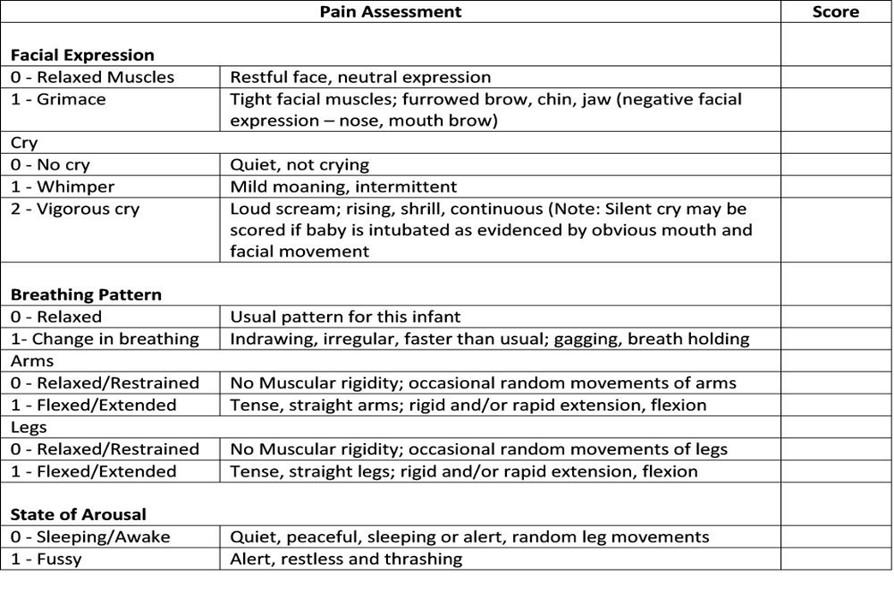
Total patient's pain score:
Scoring: 0-3 no pain 4-6 mild pain 7-9 moderate pain 10-12 severe pain
b. " WONG BAKER" pain scale: (ages 7 years and above)
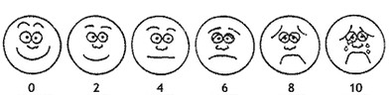

Pain: ( ) Gradual ( ) Sudden  Severity: ( 10 scale)  What makes it better : ( )Movement ( ) Rest ( ) Food/drink ( ) Position  What makes it worse: ( )Movement ( ) Rest ( ) Food/drink ( ) Position | Quality of pain: ( )Constant ( )Intermittent ( )Dull  ( )Tearing ( )Cramping ( )Burning  Location:  Duration : hours / Days

Laboratory Investigation

/ 4
Diagnostic Test

/ 2
Fluid & nutritional intake  /3.5 | Name  /0.5 | Type  /0.5 | Amount  /0.5 | Nursing role  /2
1.
2.
3.
4.
1.
2.
3.
4.

Medications /7.5

Name and class  /2.25 |  | Dose and rout  / 1.5 |  | Action of Medication  / 1.5 |  | Nursing consideration  / 2.25
Brand name:  Generic name:  Classification: | 0.25  0.25  0.25 | Dose:  Rout: | 0.25  0.25 |  | 0.5 | 1.  2.  3. | 0.25  0.25  0.25

Nursing care plan / 10

Nursing diagnosis  /3 | Goals  / 1.5 | Nursing interventions  / 3 | Evaluation  /2.5
1- |  | 1-  2-  3-  4-
2- |  | 1-  2-  3-  4-
3- |  | 1-  2-  3-  4-

