Immunization in infancy and childhood

Objective:
At the end of this procedure the student nurse will be able to:

- Define immunization.
- Identify different types of immunization.
- Describe routine vaccination schedule recommended in KSA.
- Prepare the equipment needed for the procedure .
- Illustrate adverse reaction and contraindication of different vaccines.
- Demonstrating the steps of immunization procedure.

Definition of vaccination:
It is an effort to prevent or modify natural infection by administration of antigen or an antibody. Its aim is to build up resistance in the child against certain infectious diseases.
Types of immunization:
- Passive immunization:

Its classified into;

Natural Passive Immunization: It includes passage of maternal antibodies to the fetus through the placenta especially in the third trimester. Also through breast milk, a substance called colostrum.

Artificial passive immunization: It is an administration of immunoglobulin which contains antibodies in such preparations may be antiviral, antibacterial, or antitoxins either alone or combined.
- Active immunization

It is an entrance of antigens, which stimulates formation of antibodies by the immune system. It is classified into:

Natural Active immunization:
By acquiring the infection either sub clinically or clinically. It is life long in measles, German measles, chicken pox and mumps.

  - Acquired Active immunization:
By vaccines.

Types of Vaccines & Toxoids:
    - Live attenuated Viruses: e.g. measles, mumps, oral poliomyelitis (sabin)(oral drops ), rubella vaccine.
    - Inactivated (killed) virus: e.g. Hepatitis A,B, poliomyelitis (Salk) (injection ) vaccines.
    - Live attenuated strains of bacteria, e.g. BCG (bacilli calmette- Guerin).
    - Inactivated (killed) bacteria: pertussis, cholera vaccine.
- Toxoide: detoxified bacterial toxins still retaining their capacity to stimulate the formation of antibodies (antitoxins):
  - tetanus and diphtheria toxoids.

Recommended Routine Vaccination Schedule in KSA :

Visits | Vaccine
At birth | - BCG (Bacillus Calmette–Guérin).  - HepB (Hepatitis B).
At 2 month | - IPV(Inactivated polio vaccine)  - DTaP (Diphtheria, Tetanus, and Pertussis)  - HepB  - Hib (Haemophilus influenzae type B).  - PCV (Pneumococcal conjugate).  - Rota (Rotavirus).
At 4 month | - IPV  - DTaP  - HepB  - Hib  - PCV  - Rota
At 6 month | - OPV (Oral polio vaccine).  - IPV  - DTaP  - HepB  - Hib  - PCV

At 9 month | - Measles  - MCV4 ( Meningococcal conjugate quadrivalent).
At 12 month | - OPV  - MMR (Measles, Mumps, and Rubella).  - PCV  - MCV4
At 18 month | - OPV  - DTaP  - Hib  - MMR  - Varicella  - Hepatitis A
At 24 month | - Hepatitis A
At 4 to 6 years First class primary school age | - OPV  - DTaP  - MMR  - Varicella.

Some vaccine adverse reaction and the contraindications :

Vaccine | Site of injection | Adverse reaction | Contraindication
BCG | ID | ♥ Persistent ulcer at site of vaccine.  ♥ Cold abscess.  ♥ Osteomyelitis ( inflammation of bone or bone marrow).  ♥ Disseminated BCG infection ( if immune deficient) | ✵ Premature babies   Infection skin diseases..   Malnutrition.
DTaP | IM |  Local tenderness.   Erythema.   Swelling at the site of injection.   Low grade fever.   Behavioral changes (drowsiness, eating less, prolonged or unusual cry). | ✵ Encephalopathy within 7 days of previous DPT vaccination.   Convulsions within 48 hours-72 hours of previous DPT vaccination.   Personal history of seizures that began recently or are poorly controlled.   Persistent unusual high-pitched cry (for>3 hours) within 48 hours of DPT vaccination.   Fever > 40.5C unexplained by other cause within 48 hours of DPT vaccination.

✵ Shock – like state within 48 hours of DPT vaccination.
✵ Allergic (anaphylactic) reaction to the vaccine.
Measles | SQ |  Soreness at the injection site   Malaise, fever,   Rash 5 to 12 day later.   Idiopathic thrombocytopenia purpura ,encephalitis and anaphylaxis are a severe reaction but it is rare | ✵ Sever reaction to the previous dose.   Pregnant women .   Congenital or acquired immune disorder (not HIV infection).

Guidelines for storing vaccines in a refrigerator:
- Do not keep opening and closing the refrigerator door, since this raises the temperature inside the refrigerator.
- Do not put vaccines on the door shelves. The temperature in this part of the refrigerator is too warm to store vaccines, and when the door is opened the door shelves are instantly exposed to room temperature.
- Discard all expired or vaccines that have been reconstituted for more than six hours.
- The refrigerator should not be packed too full. Approximately half of the total space inside should be left empty to allow air to circulate around the vaccines and diluents and keep them cool.
- There is a two compartments in the refrigerator should be used as follows:
- The main compartment (the refrigerator), in which the temperature should be kept between +2ºC and +8ºC, is used for storing vaccines and diluents.
- The top compartment (the freezer) is used for freezing ice-packs. If the refrigerator is working properly, this compartment will be between –15ºC and –20ºC.
- If using a front-loading refrigerator with the freezing compartment on the top ,vaccines should be stored as follows:
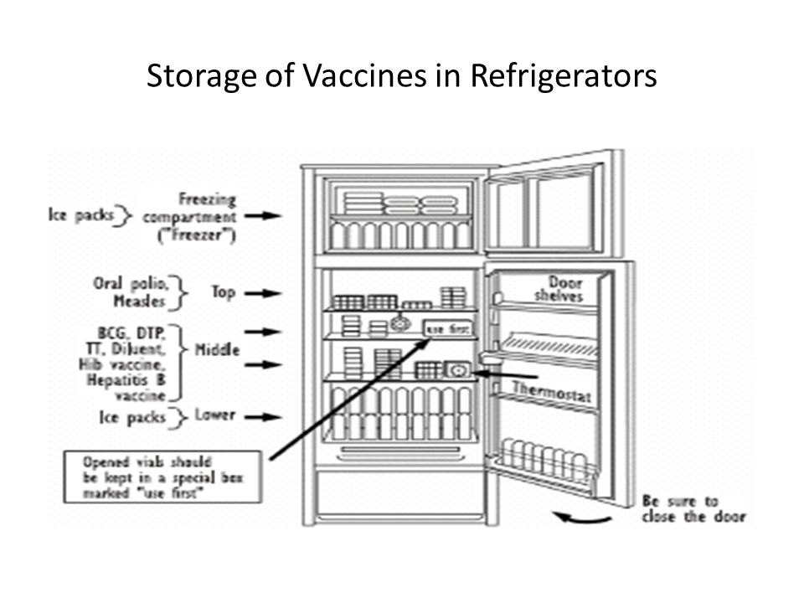
- OPV and freeze-dried vaccines (BCG and measles) on the top shelf
- all other vaccines on the middle shelves
- diluents on the bottom.

Nursing responsibility before immunization :
    - Assess parent's readiness to learn and barriers that would affect teaching, including communication barriers and cultural beliefs and practices.
    - Obtain child's immunization record from parent. If child does not already have an immunization record provide one to the family.
    - Provide the parent with verbal and written information about the vaccines to be administered.
    - Teach the parent about the recommended immunization schedule necessary for children and the rationale for administration, route of administration, immunizations required for school entry, possible adverse reactions.
    - Assess the child's previous vaccine history.
    - Assess the child's allergy history including latex allergy.
    - Assess the child for presence of fever and illness symptoms, and pregnancy in post-pubertal females; assess the immunocompromised status of child and family.
    - Obtain informed consent from the parent or legal guardian to administer the immunization.
Reminder:

- High body temperature and severe illness are reasons to delay immunization until the child has recovered from the acute stage of illness.
- Monitor illnesses, such as a cold, otitis media, and mild diarrhea without fever, are not contraindications to immunization.

Procedure for administering vaccines:

Equipment's:

- Health department or institution specific documentation records
- Child's immunization record
- Equipment needed to administer vaccine.( clean gloves, needle & syringe, alcohol swap, adhesive bandage).

Procedure:

Steps | Rationale
- If needed, review vaccine information with the parent and answer questions regarding the immunizations to be given. | ✵ Assist parent in understanding the benefits and possible side effects of vaccines.
- Encourage the parent to comfort child during and after immunization administration.
- Perform hand hygiene. | ✵ Reduces transmission of microorganisms
- Gather and prepare all needed supplies before entering the child's room. | ✵ Save time.
- Don gloves and administer vaccines via route indicated on immunization schedule; follow procedures. | ✵ Standard precaution to reduce transmission of microorganisms.   Vaccine must be administered via indicated route to elicit immune response.
- A -If the child requires multiple injections, administer the injections in different extremities.  B- If multiple injections must be given in the same extremity, leave at least 1 inch between the injection sites.  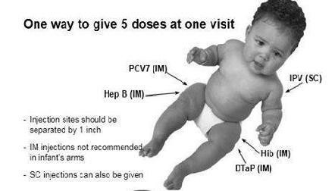 | ✵ Allow for optimal absorption of vaccine and decreases irritation at sites of injection and overlapping local reactions.
- Apply adhesive bandages to immunization sites as needed. Evaluate necessity of adhesive bandage use in young children as it may present a chocking hazard. | ✵ Aids in stopping bleeding and provides comfort measure for child.
- Dispose of equipment and waste in appropriate receptacles. | - Standard precautions.
- Provide parent with information about time frame for child's next scheduled immunizations. | ✵ Reinforces immunization schedule to improve compliance.

Nursing responsibility after immunization:
- Evaluate child for immediate response to vaccine administration, noting immediate reaction, presence of local irritation at injection sites, and presence of any symptoms indicating anaphylactic reaction (e.g., respiratory distress or decreased respiratory effort, change in responsiveness ).
- Document vaccine administration in child's medical record. Documentation should include:
  - Name and title of provider administering vaccine.
  - Type of vaccine.
  - Route of vaccine administration.
  - Sites of injection.
  - Adverse reactions

- Document the vaccine administration in the child's home immunization record. Documentation should include:
- Name of immunization.
- Initials of provider who administered vaccine.
- Date of administration.
- The provider's name and address.

- Instruct parent about care of the child after immunizations:
- For discomfort, apply a cool, clean washcloth to injection sites for 24 hours, followed by warm compresses.
- Acetaminophen may be administered as needed.

- Instruct family to contact the healthcare provider or seek immediate medical care if the child experiences:
1. Body temperature higher than 40 C.
2. Seizure.
3. Persistent or inconsolable crying lasting more than 3 hours.
4. Change in level of consciousness.
5. Collapse or shock like state.

ALERT:

- Children should not be given aspirin. Aspirin administration in children has been associated with Reye Syndrome.

