HW # 2

CH # 5

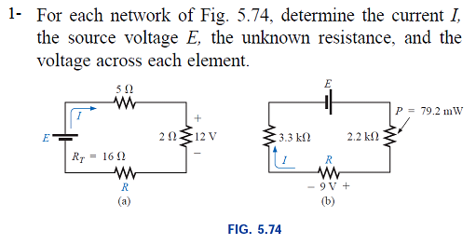

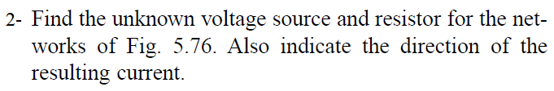

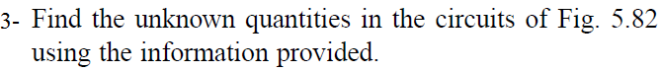

|  |  |
| --- | --- |
|  |  |

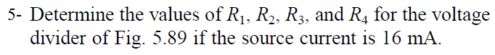

CH # 6



    
    
    

