How to access and login to My Statistics Lab
1-Go to https://lms.ksu.edu.sa/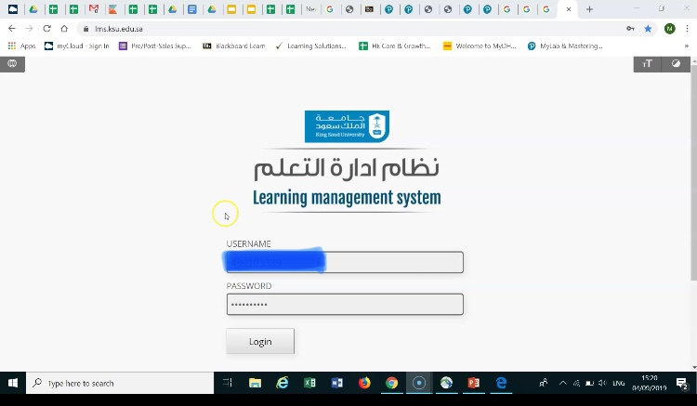

2-Select the course Introduction to Statistics in Business
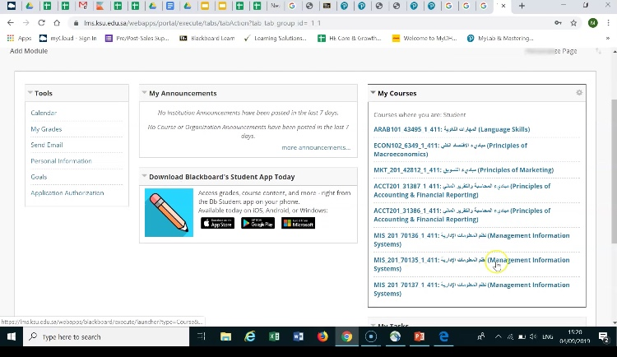

3-Click on Homework الواجبات
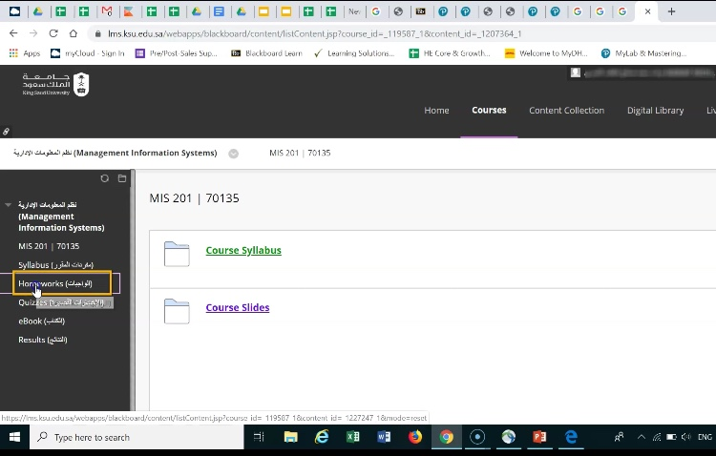
4-Click on Homework1
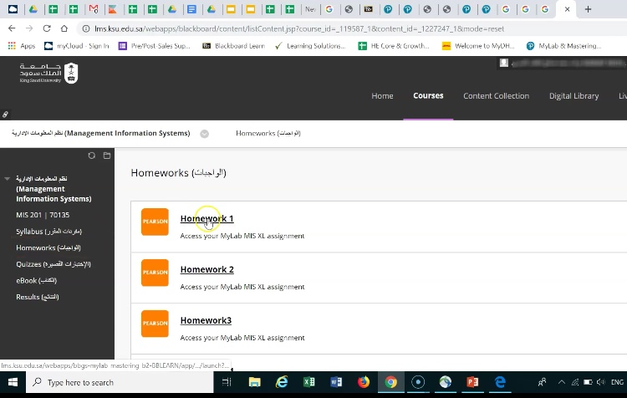

5-Click on I Accept
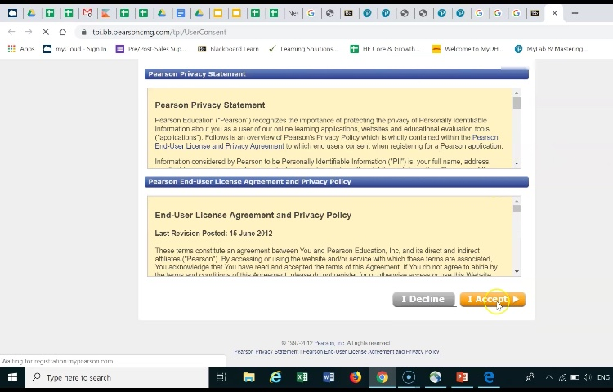
6-Choose Great a Pearson Account
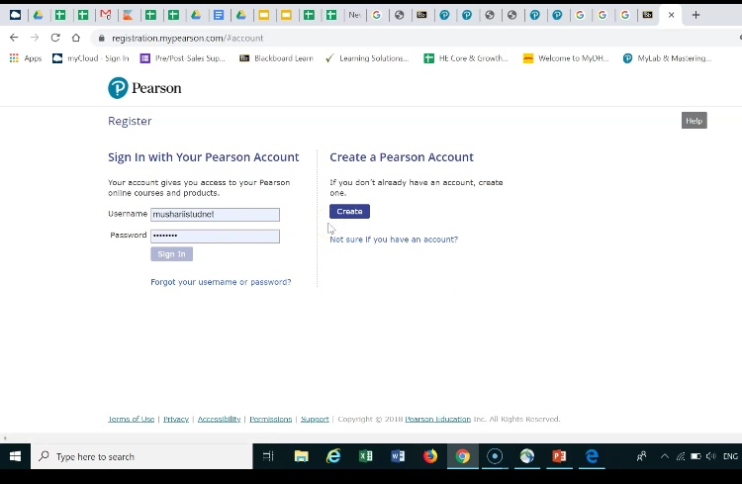
7-Use your KSU email and fill the information
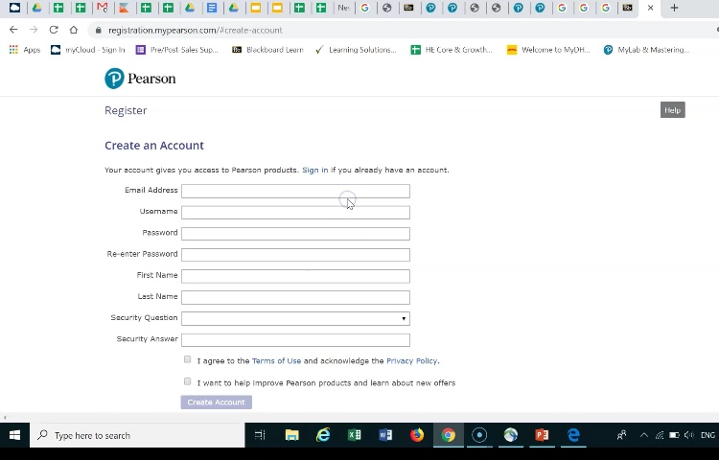

8-Select Access Code
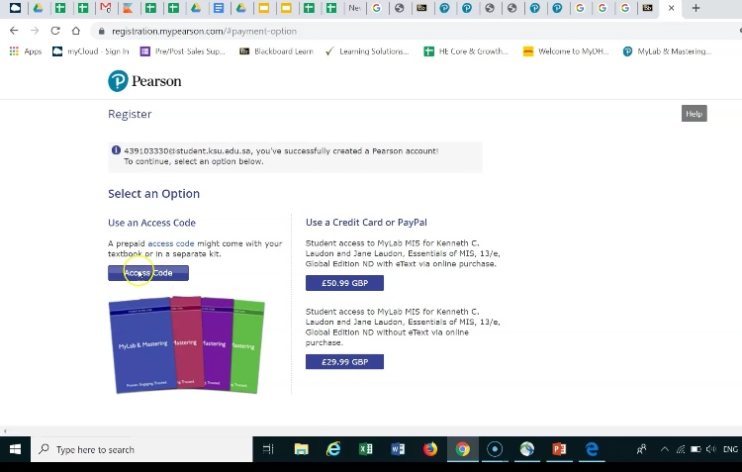
9-Enter Access Code ,Then Click Finish
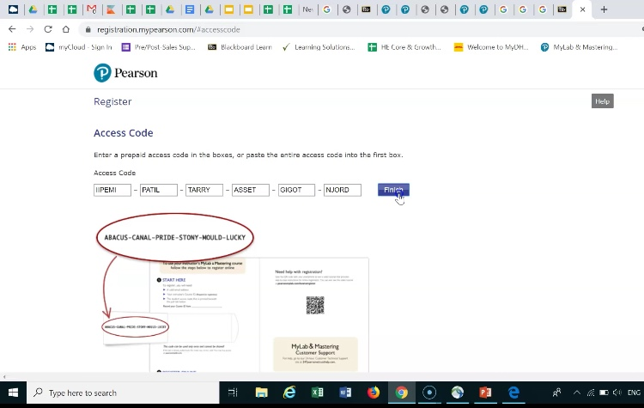

10-You will get “You’re done!” Print this page
