In this sheet you are asking to do the following:
- Create a visual basic application that reads and display data from a text file (Containing your Name and your ID number) as this example:

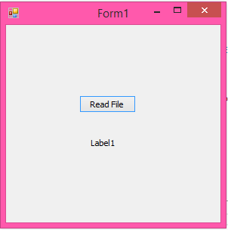

When we click Read File, file imformation (contiaing your name and id) shall be shown, ex:

