Experiment (1): Hemolysing Agents

Method:

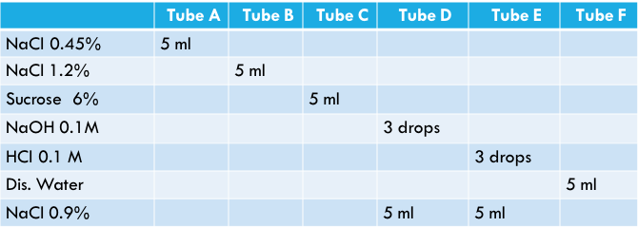
Label 6 tubes (A F). Then, add 1ml of RBCs suspended in saline into each tube

Wait maximum for 30 min and observe wither hemolysis has taken place

Results:

Experiment (2): Detection of Blood by Benzidine

Method
- Place 3ml of sample in a boiling water bath for 3 minutes.
- Cool it under tap water.
-Add 2 ml Benzidine+ 1 mlH₂O₂

Result
Tube | A | B | C | D | E | F
Result
(Yes or No)

Does the sample contain blood or not?

