Nursing college
Gavage feeding

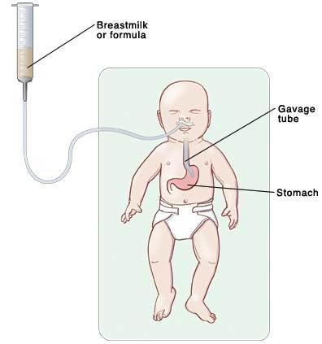
NGT Insertion & Gavage Feeding

Objective :
At the end of this procedure the student nurse will be able to:

- Define gavage feeding.
- Understanding the purpose of nasogastric tube insertion.
- Prepare the equipment needed for the procedure.
- Illustrate the indications and contraindication of NGT insertion.
- Demonstrate steps of nasogastric tube insertion.
- Demonstrate steps of gavage feeding procedure.
- Understanding the nursing responsibilities of gavage feeding.

Definition of gavage feeding:
Gavage feeding is a way to provide formula or breast milk or medications through a tub passed from nose to the stomach, called nasogastric tube or( NGT) .
Purpose of nasogastric tube insertion:
- To provide a method of feeding or administering medication that requires minimal patient‘s effort, when the infant is unable to suck or swallow.
- To provide a route that allows adequate calories or fluid intake.
- To prevent fatigue or cyanosis could occur from bottle-feeding.
- To provide a safe method of feeding in sick infant.

Indications | Contraindications
1. Poor sucking reflex ,premature baby. | 1. Absent bowel sound.
2. Post operatively. | 2. True paralytic ileus.
3. Respiratory distress. | 3. Severe facial fractures especially to the nose.
4. Loss of consciousness. | 4. Skull ,Neck or maxillary fractures.
5. Cyanosis after feeding by bottle or medicine dropper. | 5. Obstructed esophagus, esophageal varices.
6. Congenital abnormalities ,as cleft lip, cleft palate. | 6. Obstructed airway as well as clotting disorders.
7. Swallowing disorders. | 7. After cleft palate repair.
8. Neurologic impairment e.g.: cerebral palsy, epilepsy, brain injury, multiple sclerosis.

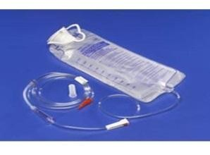
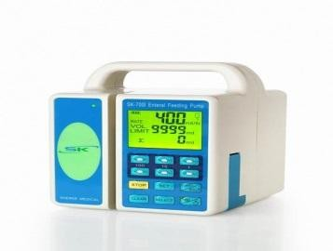
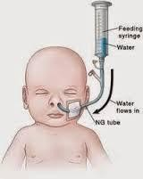
Size of nasogastric tube :

Tube size | Weight of child
5 French | 2 Kg
8 French | 3–9 Kg
10 French | 10–20 Kg
12 French | 20–30 Kg
14 French | 30–50 Kg
16 French | > 50 Kg

NGT insertion procedure:

A. Assessment
- Assess patency of nares
- Assess client‘s medical history: nosebleeds, nasal surgery, deviated septum
- Assess client‘s mental status.
- Assess bowel sounds
- Assess client‘s gag reflex.
B. Planning (Gather equipment's)
- Appropriate NGT size.
- PH test strips.
- Tongue blade.
- Flashlight.
- Emesis basin.
- Syringe size of 3ml , 5ml, 50ml . Tubing for feeding pump
- 1 inch wide tape or commercial fixation device.
- Suctioning available and ready.
- Stethoscope.
- Gloves.
- Pacifier if necessary.
- Towel
- Clamp.
- Lubricant.
15. Formula feeding. Enteral feeding pump
16. pump and setup.
C. Implementation:
Steps | Rational
1. Explain procedure to child or parents. | ✵ To facilitate cooperation and decrease fear.
2. Position the child in high fowlers position. | ✵ To prevent aspiration.
3. Wash hands and wear clean gloves. | Reduces transmission of microorganisms.
4. Measure length of tube to be inserted and

mark tube with a piece of tape:  - a-Measure from the tip of the nose to the earlobe and from the earlobe to the lower end of the xyphoid process. This is a commonly used method.  - b-Measure from the nose to the earlobe and from the earlobe to a point halfway between the xyphoid and the umbilicus. | 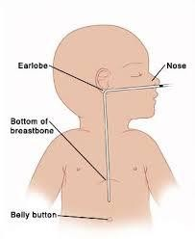
5. Examine feeding tube ( NGT) for flaws.
6. Lubricate the tube with saline . | ✵ To facilitate passage through nasopharynx and prevent mucus membrane damage.
7. Gently insert tube through nostril to back of throat (posterior nasopharynx). Aim back and down toward the ear.
8. Have child flex head toward chest after tube has passed through nasopharynx
9. Emphasize the need to mouth breathe and swallow during the procedure. | ✵ Swallowing facilitates the passage of the tube through the oropharynx.
10. Advance tube each time child swallows until desired length has been reached.
11. Do not force tube. If resistance is met or child starts to cough, choke or become cyanotic stop advancing the tube and pull back.

N.B. Persistent gagging – prolonged intubation and stimulation of the gag reflex can result in vomiting and aspiration
-Coughing may indicate presence of tube in the airway.
12. Temporarily secure the tube with tape to stabilize it while checking the tube position.
- Check tube position through :
  - Insufflation of air while listening for the sound of the air.
  - Withdrawal of gastric/intestinal contents, checking contents withdrawn for pH and other characteristics
  - Inserting end of tube in the water and watching for bubbles.
  - The most reliable method for confirming placement is X ray.
14. Once the tube placement is confirmed tape the tube securely in place and label the tube with

date and time of insertion.
15. Dispose equipment , gloves properly and washing hands. | Reduces transmission of microorganisms.
16. Documentation:
Size of the tube, length of tube from the nostril to end of tube and child response, aspirate pH and characteristics.

Gavage feeding procedure :

Steps | Rational
1. Check feeding order e.g.
(Gavage 30ml Pediasure+ 10 ml flushing q6h).
2. Prepare formula and check temperature, it should be in room temperature. | Cold formula can cause gastric cramping.
3. Explain the procedure to child or family. | ✵ To facilitate cooperation and decrease fear.
4. Provide privacy.
5. Perform hand washing and wearing clean gloves. | Reduces transmission of microorganisms.
6. Position the child in high Fowler's position. If an the infant a mummy restraint may be necessary.
7. Assess child respiratory status and color.
8. Check placement of tube before each feeding using one of these method:
- Inject 3-5 ml air into the catheter and the stomach. At the same time listen to the typical growing stomach sound with a stethoscope placed over the epigastric region.
- Chest X-ray to confirm the correct placement read by physician .
- Put the end of the catheter in cup filled with water , if you see bubbles the tube is in the lung .
- Aspirate small amount of stomach content and test acidity by pH tape.
- Observe and gently palpate abdomen for the tip of the catheter.
9. Connect the syringe to the NGT and aspirate before feeding begins:  - If over ½ the previous feeding is obtained, return the aspirate , withhold the feeding.  - If small residual of formula is obtained return the aspirate and continue the feeding. | Prevention of overfeeding and early signs of feeding intolerance.

10. Pour the feeding formula .Be careful no air should go in the catheter.
11.The flow of feeding should be slow and do not apply pressure. | ✵ Food taken too rapidly will interfere with peristalsis, causing abdominal distention and regurgitation
12. Elevate syringe 15-20cm, above the child head.
13. When the feeding is completed, flush the with clear water. | To prevent the tube clogging and provide the child with additional free water.
14.Before the fluid reaches the end of the catheter clamp it off. | ✵ To prevent air enters the stomach and causes abdominal distention.
15. Hold, cuddle and burp the child | ✵ To provide a adequate expulsion air swallowed or ingested during feeding which lead to decrease abdominal distention and allow for better tolerance of feeding.
16. Place the child on right side for at least 30 minutes. | ✵ To facilitate gastric emptying and minimize regurgitation and aspiration.
17. Observe the child condition, activity and tolerance after feeding(note any vomiting or abdominal distention).
18. Dispose equipment , gloves properly and washing hands. | Reduces transmission of microorganisms.
19. Documentation: Time and amount of feeding, amount retained or vomited ,and activity before, during and following feeding.

Nursing responsibilities:
 Following verification by x-ray of tube placement. The nurse is responsible for ensuring that the tube has remained in the intended position before administering formula or medication through the tube.
 Verification of placement is performed before each intermittent feeding and at least once every 12 hour shift for continuous feedings and prior to medication administration
 Identify signs and symptoms of inadvertent respiratory migration coughing, choking, Decreased pulse oximetry.
 Identify conditions that increase the risk for spontaneous tube dislocation from the intended position (retching, vomiting, nasotracheal suctioning, severe coughing)

 Residual volume – aspirate with syringe minimum every shift (usually q4h).
If residual volume is greater than 100cc notify physician.
 Right product, right time, right client, right rate…..check and chart.
 Monitor intake and output
 Flush tube with a minimum of 30-50cc water prior to initiating feed, when feed is finished, before and after the administration of medications and q4-6h around the clock.
 Change feed bag and tubing q24h, need to label and chart
 Elevate the head of the bed to 30 degrees to prevent aspiration.
 Note blood values – BUN, creatinine, glucose.
 Monitor blood glucose q6h until maximum infusion rate has been increased and maintained for 24h.
 Keep tube feeding formulas at room temperature.
 A Registered Dietician determines the caloric requirements for each client and orders the formula to be use, the rate and the appropriate amount of water to be used to flush the tube.

