Final Exam
RAD464
Student Name:……………………………………………………………………. ID Number: …………………………

Write the correct answer:
IMAGE 1 (1 mark)
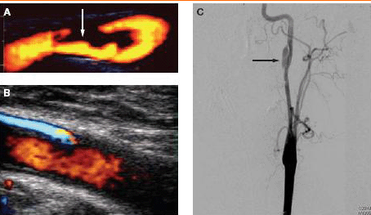
A-…………………………………………………
B-………………………………………………….
C-………………………………………………….

IMAGE 2 (1mark)
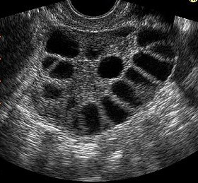
………………………………………………………………………

IMAGE 3 (1mark)

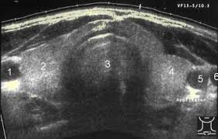
1-…………………………… 2-…………………………
3-………………………….. 4-………………………….
5-…………………………. 6-……………………………

IMAGE 4 (1 mark)

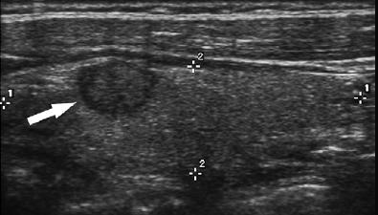
…………………………………………………………

IMAGE 5 (1 mark)





