FINAL EXAM

Student Name:

ID:

**Computer Engineering Department**

**College of Computer and Information Sciences**

**Instructor: Dr. Kashif Akhtar Saleem**

**Course Code: CEN 445 Duration: 3 hour**

**Course Name: NETWORK PROTOCOLS AND ALGORITHMS Date: July 20, 2013**

**Semester: Summer Semester 33/34**

**Section 1**

1. Layer 3 in the OSI reference model

A Application

B Network

C Transport

1. Routing Algorithms is _____

A move frames from one end of a wire to the other

B how to get packets from source to destination

C to send command or work to operating system

D part of data link layer

1. Hop is ________

A device

B link

C router

1. Data is divided into small parts and called as

A dots

B capsules

C packets

D signals

1. Network layer designers have freedom in writing specs of services to _______________ layer

A transport

B application

C data link

D physical

1. Internet community is __________________ and Telephone companies based on ____________________

A Internet and telephone

B connection‐oriented and connectionless

C connectionless and connection‐oriented

1. Forwarding

A put the packet in the appropriate output line and look up the routing tables

B look up the routing tables and put the packet in the appropriate output line

C look up the routing tables

D None of Above

1. Shortest Path Routing

A Build a graph of network & Each node represent a router

B Each arc represent a link

C Find shortest path between the two nodes

D or All Above

1. ARPANET

A Advanced Research Projects Agency Network

B Advanced Routing Projects Agency Network

C Advanced Research Potential Agency Network

1. DVR is ______________________________

A Digital vector routing

B Distance vehicular routing

C Distance vector routing

D or All Above.

1. Multicast Routing is to

A send packets to multiple nodes

B sending message to a group of nodes

C sending message to a group of routers

D or All Above

1. What is Jitter?

A. delay curves

B. variation in delay

C. Huge data distortion

**Section 2**

1. Solve via Dijkstra’s Algorithm the following and write route cost in boxes:

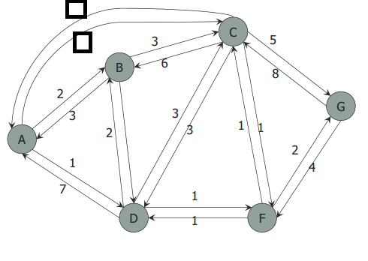

2. Fill the table on next page according to Bellman‐Ford Algorithm and mark routes on following

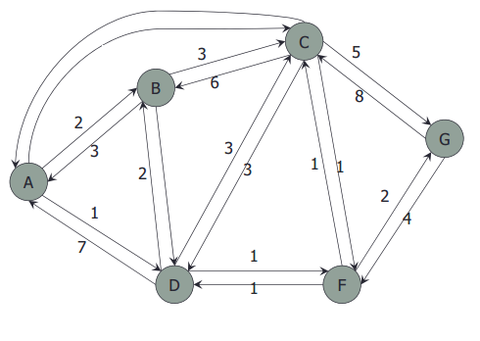

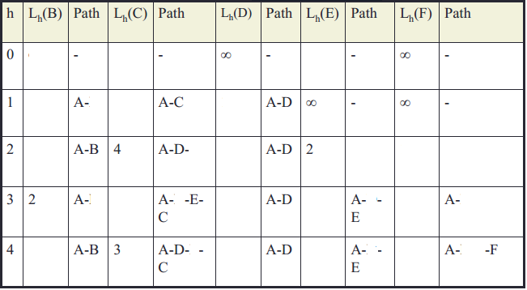

**Section 3 (Provide answer / Solve any 18 of the following 25 Questions)**

1. a) What is connection-oriented service and connectionless service. Provide two example of each.

1. b) Are there any circumstances when connection-oriented service will (or at least should) deliver packets out of order? Explain.

2. Give three examples of protocol parameters that might be negotiated when a connection is set up

3. Give a simple heuristic for finding two paths through a network from a given source to a given destination that can survive the loss of any communication line (assuming two such paths exist). The routers are considered reliable enough, so it is not necessary to worry about the possibility of router crashes.

4. Implementation of Connectionless Service Requires

5. Implementation of Connection‐Oriented Service

6. Comparison of Virtual Circuit and Datagram. Fill the following

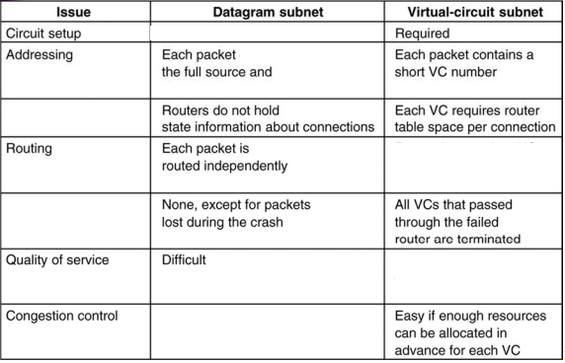

7. What are the two major classes of routing?

8. If delays are recorded as 8-bit numbers in a 50-router network, and delay vectors are exchanged twice a second, how much bandwidth per (full-duplex) line is chewed up by the distributed routing algorithm? Assume that each router has three lines to other routers.

9. In the text it was stated that when a mobile host is not at home, packets sent to its home LAN are intercepted by its home agent on that LAN. For an IP network on an 802.3 LAN, how does the home agent accomplish this interception?

10. Compute a multicast spanning tree for router *C* in the following subnet for a group with members at routers *A*, *B*, *C*, *D*, *E*, *F*, *I*, and *K*.



11. In the simplest version of the Chord algorithm for peer-to-peer lookup, searches do not use the finger table. Instead, they are linear around the circle, in either direction. Can a node accurately predict which direction it should search? Discuss your answer.

12. A datagram subnet allows routers to drop packets whenever they need to. The probability of a router discarding a packet is α. Consider the case of a source host connected to the source router, which is connected to the destination router, and then to the destination host. If either of the routers discards a packet, the source host eventually times out and tries again. If both host-router and router-router lines are counted as hops, what is the mean number of

(a) hops a packet makes per transmission?

(b) transmissions a packet makes?

(c) hops required per received packet?

15. A network on the Internet has a subnet mask of 255.255.240.0. What is the maximum number of hosts it can handle?

16. The CPU in a router can process 2 million packets/sec. The load offered to it is 2 million packets/sec. If a route from source to destination contains 17 routers, how much time is spent being queued and serviced by the CPUs?

17. Suppose that host A is connected to a router R 1, R 1 is connected to another router, R 2, and R 2 is connected to host B.

Suppose that a TCP message that contains 900 bytes of data and 20 bytes of TCP header is passed to the IP code at host A for delivery to B.

Show the Total length, Identification, DF, MF, and Fragment offset fields of the IP header in each packet transmitted over the three links.

Assume that link A-R1 can support a maximum frame size of 1024 bytes including a 14-byte frame header, link R1-R2 can support a maximum frame size of 512 bytes, including an 8-byte frame header, and link R2-B can support a maximum frame size of 512 bytes including a 12-byte frame header.

18. What is ARP protocol?

19. ARP and RARP both map addresses from one space to another. In this respect, they are similar. However, their implementations are fundamentally different. In what major way do they differ?

20. Describe a way to reassemble IP fragments at the destination.

21. IPv6 uses 16-byte addresses. If a block of 1 million addresses is allocated every picosecond, how long will the addresses last?

22. In our example transport primitives of Figure below, LISTEN is a blocking call. Is this strictly necessary? If not, explain how a nonblocking primitive could be used. What advantage would this have over the scheme described in the text?



23. Why does the maximum packet lifetime, T, have to be large enough to ensure that not only the packet but also its acknowledgements have vanished?

24. Which one is sink tree and explain why and give additional name of it.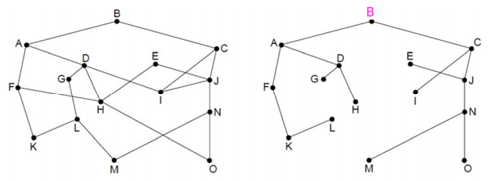

25. TBA, LBA, RSVP is abbreviations of which algorithms to maintain quality?

15

Last Page