Suhail Alhejji
geo 512, fall 2017 Term paper
The Similarities and Differences in the Petrogenesis of the Two Volcanic Fields, Potrillo, New Mexico, USA, and Harrat Kishb, western Saudi Arabia

1-Introduction:
The basaltic volcanism that is associated with continental rifts has taken place in many different locations on our planet. The most two popular examples of this type of volcanism found in East Africa rift and Rio Grande rift (RGR). Usually, this volcanism produces relatively higher alkali magmas. What happens there is that we see a continental extension and thinning in the lithosphere, which caused an asthenospheric upwelling and sometimes may have associated with mantle plumes. I have chosen two volcanic lava fields in two different continental locations to understand this type of volcanism, its products and evolutions. The two locations are Potrillo volcanic field in the southern part of the Rio Grande rift, USA, and the volcanic lava field of Harrat Kishb in western Saudi Arabia. The younger phase of volcanism in western Arabia has been thought that has been related to the Afar mantle plume in East Africa rift the form of mantle flows moving north to the western part of the Arabian Peninsula (Chang and Van der Lee, 2011). The motivation of this work came from the special and similar characteristics that both the volcanic fields have. For example, the two volcanic fields consist of alkali basalts associated with high abundances of upper mantle to lower crustal xenoliths, rift-related, and they have some interesting well-known explosive crater like Kilbourne Hole, and Al Whabah Hole maar. The goal of this paper is to determine the petrogenesis for the basaltic rocks in Harrat Kishb, western Saudi Arabia, and the volcanic field of Potrillo, New Mexico, USA. This paper investigates the source and compositions of these xenoliths, the role of crustal contaminations in the petrogenesis of that continental volcanism, and major/trace element variations and correlations for the two volcanic basaltic fields which reflect their genesis. There are some limitations could prevent me achieving the aim of this study. One of these limitations is that this is only a ten pages paper, I cannot describe in depth the petrogensis of these rocks in two different locations. I am doing is a summary of the most published paper that investigate the theory behind the origin of these rocks.
2- Geologic Setting:
A-Rio Grande rift:
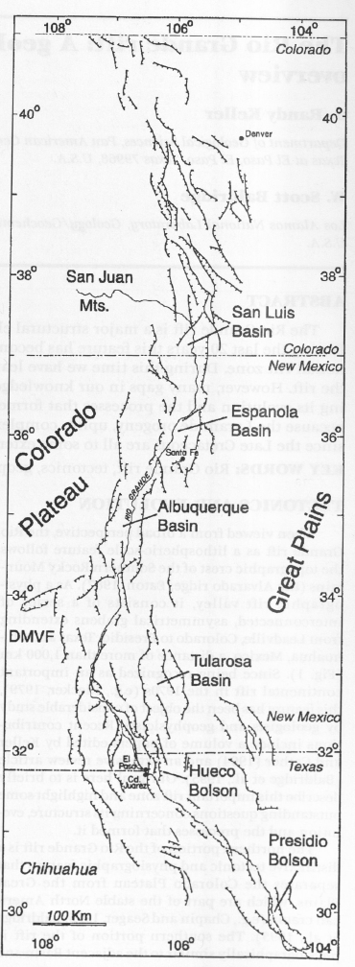
Rio Grande rift is a north-trending continental rift that has an average width of 50 km. It extends more than 1000 km from southern part of Colorado in the north to Chihuahua city, Mexico in the south (Keller, 1999). The extension of the earth’s lithosphere in that area began to spread apart about 35 million years ago, and it has not stopped it since that time. This continental rift zone consists of four main basins (San Luis, Espanola, Albuquerque, and Tularosa basins) and much smaller basins in the south toward Mexico (Fig. 1). Geologically, the Rio Grande rift (RGR) is divided into two portions, regarding their tectonism, the northern and southern portions. The northern part of RGR shows a separation between the two ancient Precambrian provinces of the Colorado Plateau and the Great plain of the North American carton (Keller, 1999). However, the southern part of RGR has similar characteristics to the adjacent Basin and Range province, but it has some distinctive features like evidence of crustal thinning and Quaternary tectonism (Keller et al., 1990). Therefore, it has been studied that the southern portion of the RGR, compositionally, has no pattern of rock composition distributions, where we can see sub-alkaline magmatism occurs in the axis of the rift and alkaline off the axis, like what has been found in the northern portion (Anthony et al., 1992). The volcanism of RGR is considered as a minor when it is compared with other continental-rifts volcanism such as East Africa continental rift zone (Olsen et al., 1987). Also, most of the volcanism in RGR is younger than 5 Ma and dominated by alkaline basaltic composition (Olsen et al., 1987).
(Figure 1) this map shows all rift zones in Rio Grande rift with the names of the basins’ (modified after: Keller, 1999)

B-The formation of the Arabian Harrats:
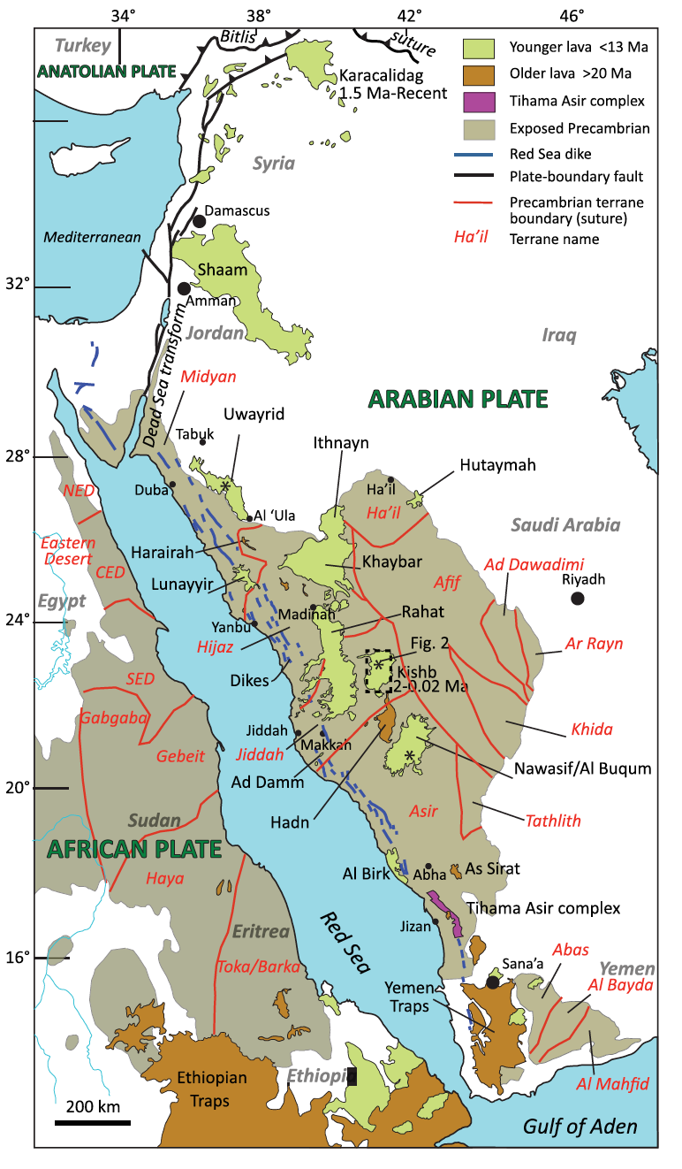
The Arabian Harrats are these Cenozoic to recent intra-continental basaltic provinces that set on the stable Precambrian Arabian Shield, which is the only type of volcanism within the Arabian plate that remains partially active. Camp and Roobol (1992) attributed the volcanism in western Arabia into two different distinct phases; the first phase (from 32 – 20 Ma) was associated with the opening of the Red Sea and a passive mantle upwelling, produced basaltic lava fields of tholeiitic to transitional composition, while the second phase (from ~12 Ma – recent) has been associated with an active mantle upwelling, producing transitional to alkalic lava compositions. Each of these two phases has a specific direction; the older volcanic activity has the same trend of the Red Sea NW-SE direction, whereas the younger period shows the N-S trend and forms the volcanic axis of the Makkah-Madinah-Nafud (MMN) line. Harrat Kishb is off the volcanic axis, but it has the same trend of the younger phase of volcanism, north-south. These processes have been accompanied with plate extensions and thinning of the lithosphere beneath the Arabian harrats (Duncan and Al-Alamri, 2013). However, the current main source for all of these processes that controlled the volcanism in western Arabia is the horizontal northward mantle flow that is coming from the Afar triple junction in east Africa as channels through the Gulf of Aden and Red Sea (Fig.2) (Chang and Van der Lee, 2011).
3- Geology and Geochronology of Potrillo and Kishb:
The two volcanic lava fields are considered as late Cenozoic basaltic volcanism, Harrat Kishb has started its volcanism in the late Pliocene epoch, whereas the volcanism has taken a place in the early Pleistocene epoch. The K-Ar age determination in the two volcanic lava fields resulted that the volcanic lava field of Harrat Kishb has slightly older rocks than the Potrillo volcanic field. Harrat Kishb has rock ages range from 2Ma to prehistoric ~4.5 ka (Camp et al., 1992), while Potrillo’s rocks range from 900 ka to 15.9 ka (Anthony et al., 1991); however, the rocks that represent the volcanism in Potrillo volcanic field are much younger in age <80 Ka (Anthony and Poths, 1992). That means that the volcanism in Harrat Kishb is older and last for a longer time than the volcanism in Potrillo volcanic field. However, I think we need a new age determination for these lavas by using the new technique of ⁴⁰Ar/³⁹Ar incremental heating methods to have a more accurate result. This is because that these lavas contain a high abundance of mantle xenoliths and altered olivine phenocrysts which can make an error in the result by producing usually an older age measurement. We saw this happen in many places, especially in the Arabian Harrats, where the new age technique of ⁴⁰Ar/³⁹Ar produced much younger age measurement, sometimes by two to three million years (Duncan and Al-amri, 2013; Duncan et al., 2016).
(Figure 2) this map illustrates the western volcanism in western Arabia, the dark brown color indicates the older volcanism while the light the green shows the younger volcanism. (modified after Ahmed et al, 2016)
The volcanic lava field of Harrat Kishb is one of the few Harrats that represents the younger volcanism in western Arabia and located off the north-trending Makkah-Madinah-Nafud (MMN) line, about 75 km east of this 600-km-long rift line (Fig.2) (Camp and Robool, 1991). Harrat Kishb is divided into 3 main stratigraphic volcanic units which are Diakah, Nafrat and Hil basalts, where the older unit is the most extended and voluminous volcanic unit (Fig.3-c) (Camp and Robool, 1991; camp et al., 1992). This volcanic field is relatively a small basaltic field, where its lavas only cover an area of about 5,890 km² but we can find a > 10,000 km² in western Arabia especially on axial of MMN line (camp et al. 1992). Harrat Kishb is famous by its bimodal lavas, where we can see the alkali olivine basaltic lavas and phonolite lavas emplaced next to each other (Fig.3-b) (Camp and Robool, 1991). This bimodal lava composition has been attributed to a magma mixing process happened at a shallow depth (Camp et al., 1992). This issue has been discussed more in depth in the petrogenesis section. Another thing that Harrat Kishb is famous of is the high abundance of mantle xenoliths, which has been attributed to a fast magma rising from deep mantle with no stopping in the lower or the deep crust for a long time (Camp and Robool, 1991). This is also discussed in the next sections in depth.
On the other hand, Potrillo volcanic lava field is much smaller than Harrat Kishb, where its lavas only cover an area of about 805 km² (Hoffer, 1976). Even though it is a considerably small volcanic field, it has many volcanic features that maybe a larger volcanic field do not have, such as the five maar craters, the number of cinder cones, and the extended lava flows. Potrillo volcanic field is not well stratigraphically defined, but it is divided based on locations and ages into three units: The West Potrillo Mountains, the Aden and Afton volcanic centers, and the north-ternding small flows and cinder cones in the east close to the Rio Grande rift (Hoffer, 1976; Anthony and Poths, 1992). Potrillo volcanic lava field represents that southern portion volcanism of the Rio Grande rifts, where we can see the evidence of the lithospheric thinning associated with Quaternary tectonism (Keller, 1999). Unlikely what we see in volcanic field of Harrat Kishb, the volcanic lava field of Potrillo is exclusively consisted of alkali basaltic lavas (Fig.3-a) (nepheline-normative) (Anthony et al., 1992). The high abundance of crustal and mantle xenoliths in Portrillo field is believed to have erupted rapidly to the surface, in some locations less than 3 days of ascending (Hamblock et al., 2007; Reid et al., 1989). These xenoliths give a better understanding to the lithospheric mantle and the source of these magma at depth, which it is discussed in the following section.
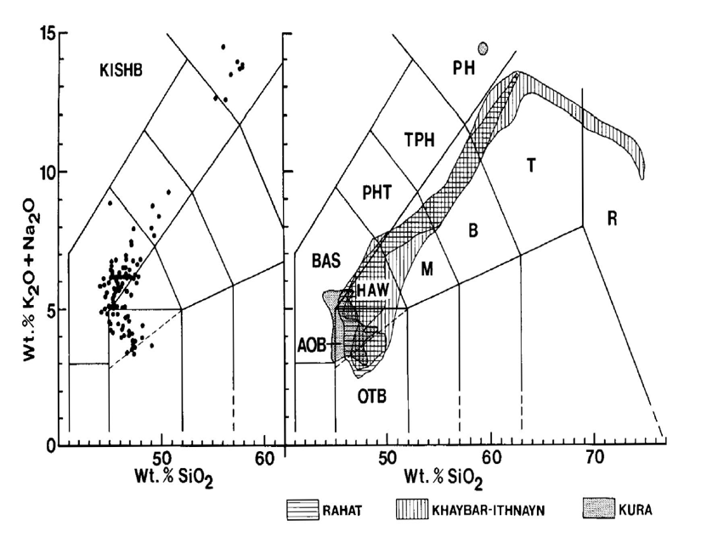
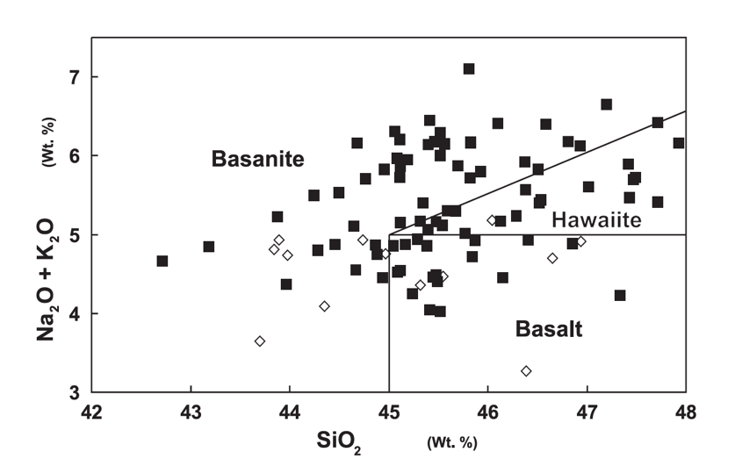
(C)
(A)
(B)
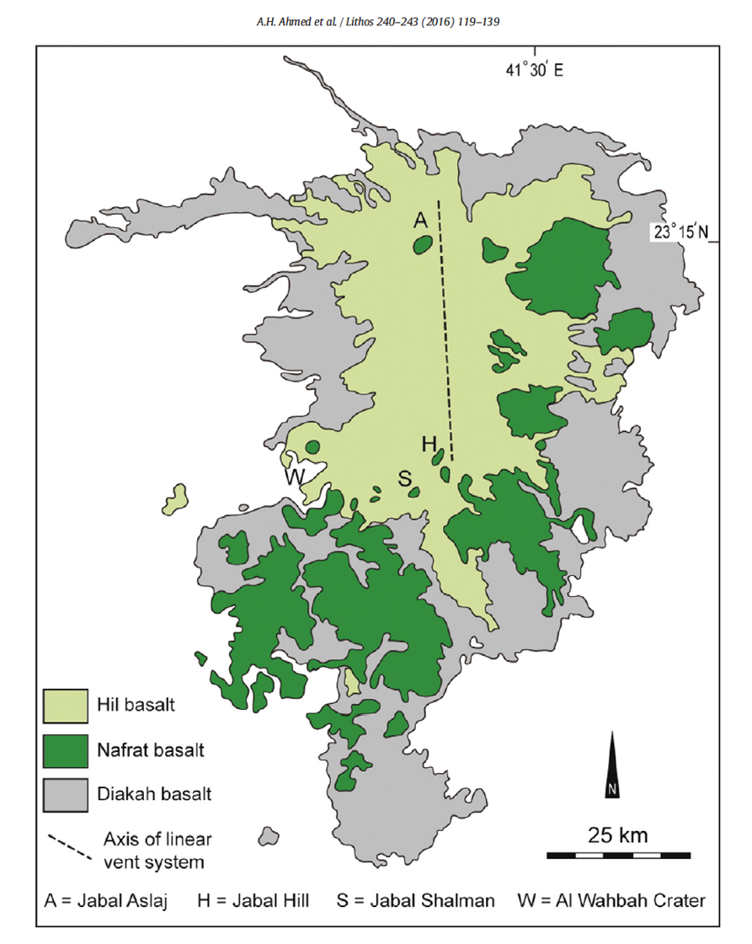
(Figure 3 a,b,c) (A) a TAS diagram shows the narrow range of alkaline basalts in Potrillo volcanic field from Basalt to Hawaiite to Basanite (Thompson et al., 2005). (B) a TAS diagram illustrates the two different compositions of alkaline rocks (Basanite and Phonolite) and comparing that with other volcanic fields in western Arabia (after: Camp et al., 1992). (C) a simplified map for Harrat Kishb shows how the most voluminous volcanic unit is the oldest unit and the north-trending of younger volcanism here. (after: Ahmed et al., 2016).

4-The source of the xenolith:
The two volcanic lava fields of Potrillo and Harrat Kishb are well-known of their high abundances and wide varieties of xenoliths that are found in their lavas and they are coming from different locations in deep earth. Studying these xenolith assemblages could give us an idea about the compositions and temperatures of the lithospheric mantle beneath these two volcanic fields. Xenolith assemblages in Harrat Kishb indicate upper mantle compositions, where 92% are peridotites (Iherzolites and pyroxene-bearing harzburgites) and the rest are spinel-rich wehrlites (Camp et al., 1992; Ahmed et al., 2016). Based on the mineralogy and texture, the conditions of these mantle xenoliths have been estimated to be ranging from 9 to 16 kbar for the pressure and temperatures that range from 877° C to 1227° C (Ahmed et al., 2016). That could indicate the origin depth range from 30 to 60 km deep, near the crust-mantle boundary (Fig.5). Most of Harrat Kishb xenoliths have undergone some deformation and recrystallization processes (McGuire, 1987). That has been shown by the mineral exsolution and zoning textures which may suggest a re-equilibrium process has happen in response to dropping of the temperature and pressure conditions (McGuire, 1987). The xenoliths in Harrat Kishb show a wide range of depletion range nature from very fertile mantle (spinel-rich wehrlite xenoliths) under high pressure to medium depleted upper mantle represented by (harzburgites and Ihezolite) (Ahmed et al., 2016).
Potrillo volcanic field exhibit a wider range of xenolith compositions that are from upper crust, but with low abundance, to upper mantle xenolith (Hamblock et al., 2007). Middle and lower xenoliths compositions are also found in Potrillo volcanic lava field. The upper crust xenoliths are the oldest, found in the old Cambrian to Precambrian rocks, and have a variety of xenolith compositions, Quartzite xenolith is the most dominate (Hamblock et al., 2007). The middle-crust xenoliths have an Oligocene age (~27Ma), and it has been thought that they symbolize a hidden plutonic complex. Their compositions are Monzonite to quartz diorite, and the depth of the plutonic complex is 11-18 km which has been suggested by the Al element in the hornblende, indicating that its pressure to be about 6-9 kbar (Hamblock et al., 2007). However, the lower crustal xenoliths consist of metasedimentary to metaigneous lithologies, from garnet granulite to anorthosite. Based on their compositions (especially, garnet), it has been assumed that they were coming from greater than 20 km depth and a temperature between 750° C to 1000° C (Hamblock et al., 2007). On the other hand, the mantle xenoliths mainly made up of peridotites (spinel Ihezolite, hazugite, and dunite) with some clinopyoxenite (Thompson et al., 2005; Hamblock et al., 2007; Satsukawa et al., 2011). Generally, most of the xenoliths in Potrillo volcanic field are existed at maar explosive craters, such as Potrillo maar and Kilbourne Hole. However, the crustal xenoliths are more abundant at Potrillo maar than at Kilbourne maar Hole, except the upper crustal xenoliths which are exclusively located at Kilbourne Hole (Hamblock et al., 2007). Figure 4 is a cross-section for Potrillo volcanic field that is constructed by (Hamblock et al., 2007) which shows what it beneath the volcanic field by using the geophysical data (seismic velocities) and the geochemical data that are extracted from the crustal and mantle xenoliths.
The most famous xenoliths that are found in Potrillo volcanic field is the mantle xenoliths that are located in Kilbourne Hole. Since its maar eruption was so young in the geologic scale which about ~10,000 year, it could indicate the current lithospheric mantle conditions beneath the great continental rift of Rio Grande (Anthony and Poths, 1992; Satsukawa et al., 2011). The xenoliths in Kilbourne Hole are peridotites that are consist of spinel Iherozlite, hazburgites, and dunite. These peridotite compositions are divided into two groups: Group 1 which is coarse-grained peridotite xenoliths that are accompanied with Cr diopside and thin bands of pyroxenites; and Group 2 which consists of peridotites that are veined by pyroxenite and wehrlite (Thompson et al., 2005). Hydrous minerals like mica and amphibole are rarely found in this xenolith suite (Irving, 1980; Thompson et al., 2005). Depending on their compositions and textures, these xenoliths show a continuous order of xenoliths at depth, from 850° C at ~ 35 km depth (Group 2) to 1050° C at ~70 km depth (Group 1). These ranges of low potential temperature values do not indicate a convecting mantle, rather they could represent a stable lithospheric mantle that goes down about 70 km below the volcanic field of Potrillo (Bussod & Williams, 1991; Thompson et al., 2005).

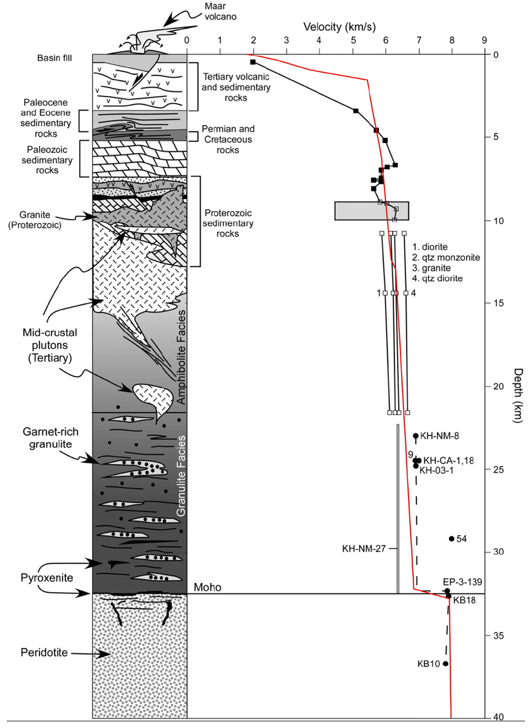

(Figure 4) a cross-section for Potrillo volcanic field that is constructed by (Hamblock et al., 2007) which shows what it beneath the volcanic field by using the geophysical data (seismic velocities) and the geochemical data that are extracted from the crustal and mantle xenoliths.

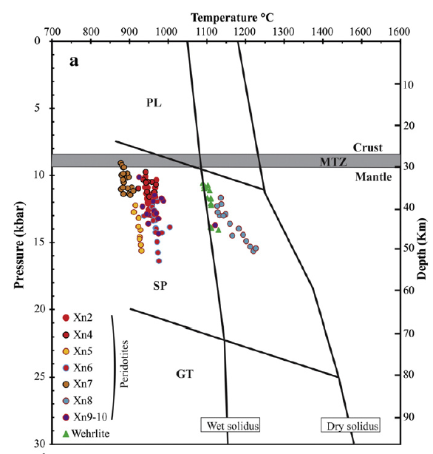

(Figure 5); the source of xenolith at Harrat Kishb range from 35 to 60 km depth and located near the crust-mantle boundary. (Ahmed et al., 2016)

5-Petrogenesis:
Comparing and describing the origin of the rocks in the two volcanic lava fields is not an easy task. Each of these lavas has its own characteristic and feature. In order to understand the petrogenesis of the volcanism at Harrat Kishb, we should talk about the genesis of basanites and phonolites together. Camp et al. (1992) assumed that the source of these the alkali basalt rocks in Kishb came from multiple magmatic reservoirs that are located near the crustal-mantle boundary where the melts composed of olivine, pyroxene, and spinel, which fractioned and resulted magmas that are dominated by basanite and alkali olivine basalts (AOB). The oldest volcanic stratigraphic unit in Harrat Kishb, which is the Diakhah basalt (fig.3), is the most voluminous unit that were derived by largest degree of melting and less differentiated, whereas the youngest unit, Hil basalt, were produced by the lowest degree of partial melting and the evidence of differentiation is seen more in that unit (Camp et al., 1992). Thus, the degree of partial melting has decreased with time while the differentiation and fractional crystallization have increased with time. The result of this differentiation has been the phonolite lavas and the MgO variations has shown that clearly (Fig.8-a). The magmas have started to crystalize the most the most primitive basalts and end up with crystalizing the least primitive which is in that case is the phonolite (Camp et al., 1992). Even that most primitive rocks have undergone of same degree of fractional crystallization because of the relatively low Mg# values, where the average is less than 60, and low values of compatible elements, such as Ni by less than 300 ppm. The phonolite lavas were resulted of “flow crystallization” of basanitic magmas in the crust (Camp et al., 1992). the fractionation of Clinopyroxene, feldspar, and apatite has resulted a residual liquid that a phonolite composition (Camp et al., 1992). The evidence of the basanite-to-phonolite differentiation is shown by modeling the crystallizing behavior of Clinopyroxene, feldspar, and apatite and using Zr as an index. Camp et al. (1992) plotted Zr with Sc, Sr, and P₂O₅ to show the early and late-stage of fractional crystallization (Fig. 6). Even though we have seen some evidence of rapid ascending rate of magma, like seen mantle xenoliths in some of the lavas, not all basanitic magmas have experienced the same rate of fast up movement. Fractionating basanite to phonolite requires a slow rate of ascending or stopping in some place within the crust and that slow movement can be caused by the changing in the volatile contents.
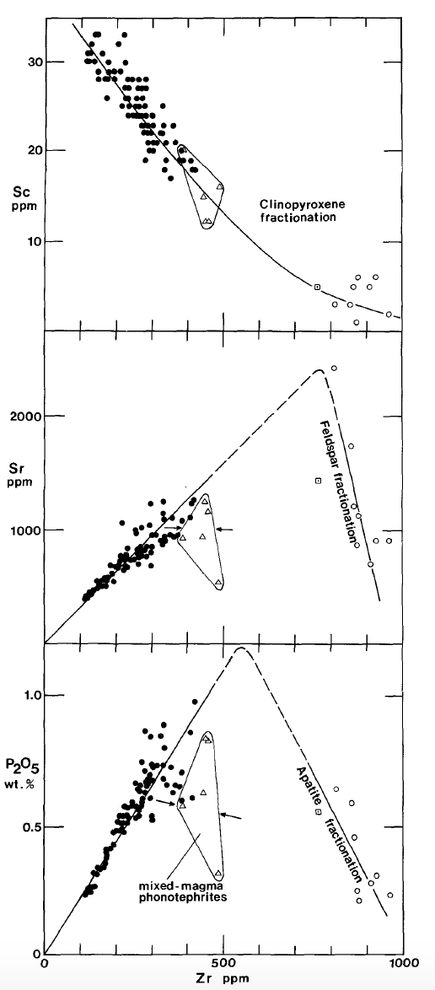
Although there is some evidence of magmatic differentiation within the rocks of Potrillo vlacanic field, it has not resulted any different composition like what it is in Harrat Kishb with Phonolite. The stratigraphic change in composition, where the incompatible element concentrations increase and Mg # decreases up-section, indicating that the magmas have undergone differentiation (Fig.7-b). Also, the concentration of compatible elements like Ni and Cr are ranging, respectively, from 332 to 47 ppm, and Cr from 409 to 55 ppm (Thompson et al., 2005). That could indicate also a fractional crystallization process that caused the variation of Mg-rich lavas and Mg-Ni-Cr lavas. On the other hand, the high abundance of Olivine and Plagioclase phenocrysts, which they are in the liquidus phase at low pressure, suggesting a shallow level of crystallization. About 30 to 40 km depth, which is consistent with the depth of Moho in this region (Anthony et al., 1992).
(Figure 6): modeling of the fractional crystallization using Zr-variations with Sc, Sr, and P₂O₅. It is clear that phonolite, shown in open circles, is the final product of fractionation the Clinopyroxene, feldspar, and apatite. (Camp et al., 1992)

Regarding the crustal contamination, the magmatic sources in two volcanic lava fields have not been undergone a significant crustal influence or involvement. Various methods of investigating this issue have been used in Harrat Kishb and Potrillo. It has been thought that megacrysts of plagioclase and altered xenolith that were found in lavas of Harrat Kishb is an evidence of crystal contamination. Therefore, Camp et al. (1992) use the plot of Nb/Y versus Rb/Y to determine if the rocks are contaminated by any crustal involvement (Fig.7-b). The crustal rocks usually have very low values of Nb/Y and high values of Rb/Y. Rocks in Harrat Kishb did not show any similarities to these values, but on the contrary, they showed high values of Nb/Y and relatively low values of Rb/Y indicating that there is not such a crustal involvement in the petrogenesis of Harrat Kishb’s lavas (Fig.10. On the other hand, Thompson et al. (2005) investigated the crustal contamination in the petrogenesis of the rocks of Potrillo volcanic field by using the ⁸⁷Sr/⁸⁶Sr and ¹⁴³Nd/¹⁴⁴Nd ratios (Fig. 7-a). The crustal rocks usually have higher values of ⁸⁷Sr/⁸⁶Sr up to 0.79 and lower values of ¹⁴³Nd/¹⁴⁴Nd which reach sometimes 0.5119. What has been found is the values of the xenoliths and lavas in Potrillo volcanic field fit the values of Oceanic island basalt (OIB) with evidence of crustal contamination. The values range from 0.5131 to 0.5129 for ¹⁴³Nd/¹⁴⁴Nd, and from 0.7025 to 0.7040 for ⁸⁷Sr/⁸⁶Sr telling that there is no such an influence of crustal contamination (Fig. 7-a) (Thompson et al., 2005).
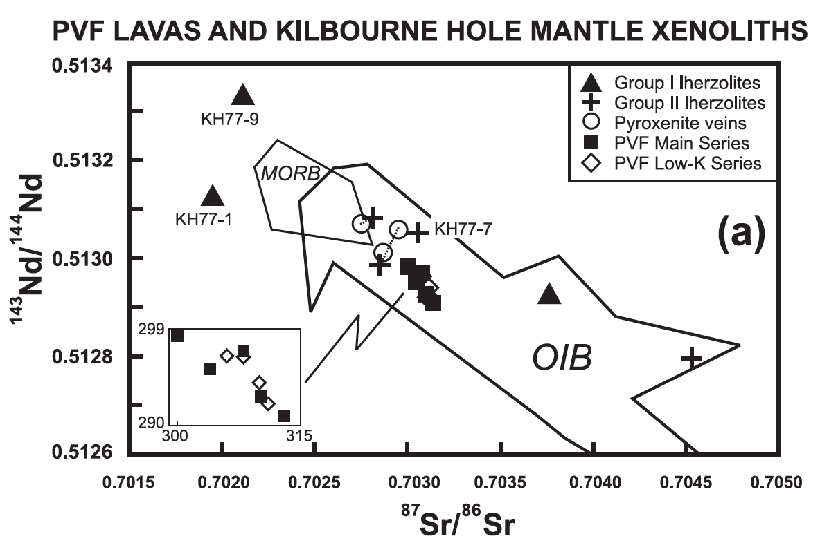
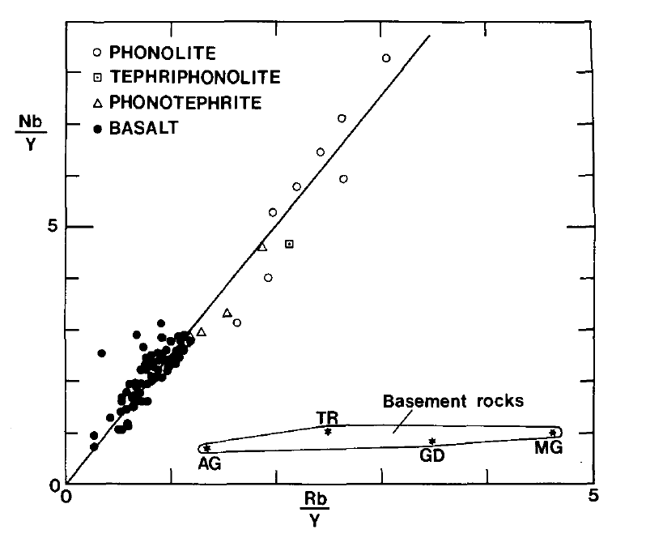
(Figure 7 a&b) trace elements variations show that in both volcanic field we do not see any role for crustal contamination involving in the petrogenesis of these rocks (a): Potrillo volcanic field (Thompson et al., 2005). (b): Harrat Kishb (Camp et al.,1992).
(b)

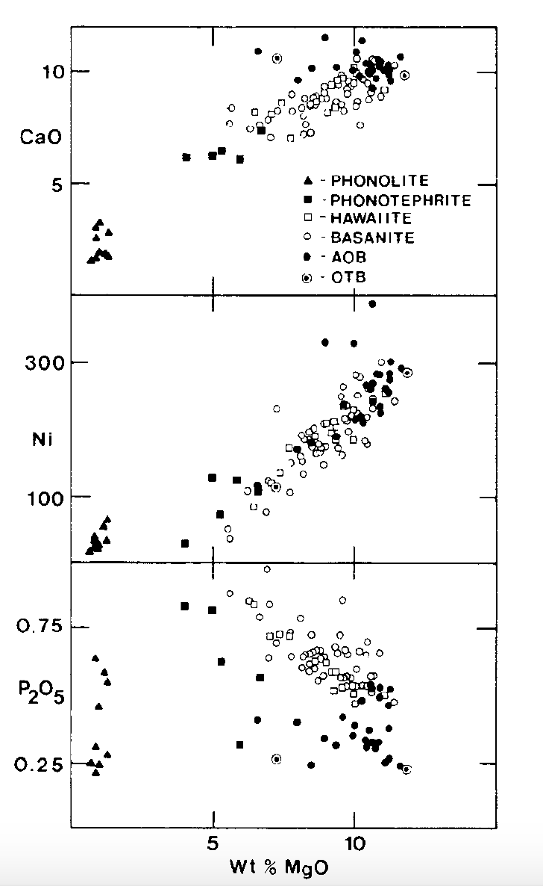
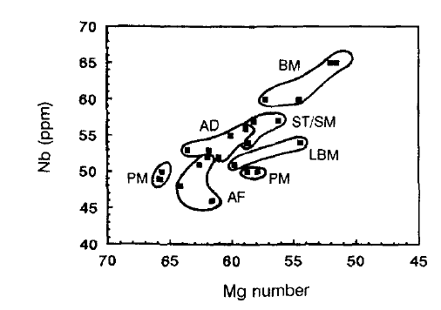
Oldest
Youngest
Stratigraphic section
(a)

(Figure 8 a&b): the two volcanic fields show evidences of magmatic differentiation. (a): incompatible elements and Mg# variations illustrate some degree of differentiation when we go up-section, Potrillo volcanic field (Anthony et al., 1992). (b): compatible elements with MgO% show that lavas have undergone high degree of magmatic differentiation, which produced the phonolite (Camp et al., 1992)

6-Conclusion:
After studying the both volcanic lava fields, I come with three main points regarding the differences and similarities of the petrogenesis of these rocks:
1- crustal contamination does not play any significant role in the petrogenesis of rocks in the both volcanic fields. Even though have a thick lithosphere in both locations, and that could indicate that the magmas did not stay long time in the crust.
2- The result of fractional crystallization is seen clearer in Harrat Kishb than what it is in Potrillo volcanic field. Fractional crystallization resulted a different rock composition “phonolite” in Harrat Kishb, whereas in Potrillo volcanic field shows only some major and trace variations between the older units and the younger volcanic units.
3- According to the composition of the phenocrysts and mantle xenoliths in both locations, we have almost the same range of lithospheric mantle, that is ranging from about 40 to 60 km deep. However, we see a shallower depth of crystallization in Potrillo volcanic field because of the abundance of plagioclases megacrysts that are seen in its rocks.

References:

Ahmed, Moghazi, Moufti, Dawood, & Ali. (2016). Nature of the lithospheric mantle beneath the Arabian Shield and genesis of Al-spinel micropods: Evidence from the mantle xenoliths of Harrat Kishb, Western Saudi Arabia. LITHOS, 240-243, 119-139.

Anthony, E. Y., & Poths, J. (1992). 3 He surface exposure dating and its implications for magma evolution in the Potrillo volcanic field, Rio Grande Rift, New Mexico, USA. Geochimica et Cosmochimica Acta, 56(11), 4105-4108.

Anthony, E. Y., Hoffer, J. M., Waggoner, W. K., & Chen, W. (1992). Compositional diversity in late Cenozoic mafic lavas in the Rio Grande rift and Basin and Range province, southern New Mexico. Geological Society of America Bulletin, 104(8), 973-979.

Baldridge, W. S., Perry, F. V., Vaniman, D. T., Nealey, L. D., Leavy, B. D., Laughlin, A. W., ... & Gladney, E. S. (1991). Middle to late Cenozoic magmatism of the southeastern Colorado Plateau and central Rio Grande rift (New Mexico and Arizona, USA): A model for continental rifting. Tectonophysics, 197(2-4), 327-354.

Camp, V., Roobol, M. John, & Saudi Arabia. Mudīrīyah al-ʻĀmmah lil-Tharwah al-Maʻdinīyah. (1991). Geologic map of the Cenozoic lava field of Harrat Kishb, Kingdom of Saudi Arabia (Geoscience map (Jiddah, Saudi Arabia); GM-132). Jiddah, Saudi Arabia]: Ministry of Petroleum and Mineral Resources, Directorate General of Mineral Resources.

Camp, V. E., Roobol, M. J., & Hooper, P. R. (1992). The Arabian continental alkali basalt province: Part III. Evolution of Harrat Kishb, Kingdom of Saudi Arabia. Geological Society of America Bulletin, 104(4), 379-396.

Camp, V. E., & Roobol, M. J. (1992). Upwelling asthenosphere beneath western Arabia and its regional implications. Journal of Geophysical Research: Solid Earth, 97(B11), 15255-15271.

Hamblock, J. M., Andronicos, C. L., Miller, K. C., Barnes, C. G., Ren, M. H., Averill, M. G., & Anthony, E. Y. (2007). A composite geologic and seismic profile beneath the southern Rio Grande rift, New Mexico, based on xenolith mineralogy, temperature, and pressure. Tectonophysics, 442(1), 14-48.

Hoffer, J. M. (1976). The Potrillo basalt field, south-central New Mexico. Cenozoic Volcanism in Southwestern New Mexico, 5, 89-92.

Keller, G. R., & Baldridge, W. S. (1999). The Rio Grande rift. Rocky Mountain Geology, 34(1), 121-130.

Kil, Y., & Wendlandt, R. F. (2004). Pressure and temperature evolution of upper mantle under the Rio Grande Rift. Contributions to Mineralogy and Petrology, 148(3), 265-280.

Olsen, K., Scott Baldridge, W., & Callender, J. (1987). Rio Grande rift: An overview. Tectonophysics., 143(1), 119-139.

Roobol, M. J., & Camp, V. E. (1991). Geologic map of the Cenozoic lava field of Harrat Kishb. Kingdom of Saudi Arabia: Saudi Arabian Directorate General of Mineral Resources Geoscience Map GM-132, with explanatory text, 34.

McGUIRE, A. V. (1988). Petrology of mantle xenoliths from Harrat al Kishb: the mantle beneath western Saudi Arabia. Journal of petrology, 29(1), 73-92.

McMillan, N. J., Dickin, A. P., & Haag, D. (2000). Evolution of magma source regions in the Rio Grande rift, southern New Mexico. Geological Society of America Bulletin, 112(10), 1582-1593.

Moufti, M., Németh, K., El-Masry, N., & Qaddah, A. (2013). Geoheritage values of one of the largest maar craters in the Arabian Peninsula: the Al Wahbah Crater and other volcanoes (Harrat Kishb, Saudi Arabia). Open Geosciences, 5(2), 254-271.

Satsukawa, T., Michibayashi, K., Anthony, E. Y., Stern, R. J., Gao, S. S., & Liu, K. H. (2011). Seismic anisotropy of the uppermost mantle beneath the Rio Grande rift: Evidence from Kilbourne Hole peridotite xenoliths, New Mexico. Earth and Planetary Science Letters, 311(1), 172-181.

Wahab, Antar Abdel, Mostafa A. Abul Maaty, Finlay M. Stuart, Hesham Awad, and Aziz Kafafy. "The geology and geochronology of Al Wahbah maar crater, Harrat Kishb, Saudi Arabia." Quaternary Geochronology 21 (2014): 70-76.

