Features of Jawless Fish
Jawless fish are missing the following parts:
- Jaws.
- Paired fins.
- A stomach.
Characteristics they do have include:
- A notochord, both in larvae and adults. Recall a notochord is a support rod that runs along the back of the fish.
- Seven or more paired gill pouches. These organs take dissolved oxygen from water.
- The branchial arches, a series of arches that support the gills of aquatic amphibians and fishes. They lie close to the body's surface.
- A light sensitive pineal eye, an eye-like structure that can detect light.
- A cartilaginous skeleton, a skeleton made of a flexible rubber-like supportive material called cartilage. This is similar to the skeleton of cartilaginous fish, which includes sharks and rays.
- A heart with two chambers.
- Reproduction using external fertilization.
- They are ectothermic. This means that their internal temperature depends on the temperature of their environment.

Classification of Jawless Fish
Most scientists agree that the jawless fish are part of the the superclass Agnatha. They belong to the phylum Chordata, subphylum Vertebrata. There are two living groups of jawless fish, with about 100 species in total: lampreys and hagfish (Figure below). Although hagfish belong to the subphylum Vertebrata, they do not technically have vertebrae (though they do have a skull), whereas lampreys do have vertebrae. For this reason, scientists still disagree on the classification of jawless fish. The hagfish is almost completely blind. The hagfish eats marine worms and other invertebrates. It is found on muddy sea floors and may live in very large groups of up to 15,000 individuals. There are about 60 species of hagfish.
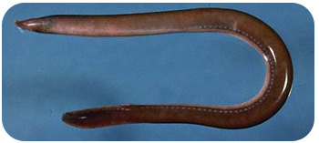
Lamprey: The lampreylooks like an eel, but it has a jawless sucking mouth that it attaches to a fish. It is a parasite and sucks tissue and fluids out of the fish it is attached to. The lamprey's mouth has a ring of cartilage that supports it and rows of horny teeth that it uses to latch on to a fish.
Lampreys are found in temperate rivers and coastal seas and can range in size from 5 to 40 inches. Lampreys begin their lives as freshwater larvae. In the larval stage, lamprey usually are found on muddy river and lake bottoms where they filter feed on microorganisms.

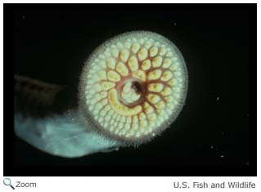

Chondrichthyes
Chondrichthyes is a class that contains the cartilaginous fishes: they are jawed vertebrates with paired fins, paired nares, scales, a heart with its chambers in series, and skeletons made of cartilage rather than bone. The class is divided into two subclasses: Elasmobranchii (sharks, rays, skates, and sawfish) and Holocephali (chimaeras, sometimes called ghost sharks, which are sometimes separated into their own class).
Within the infraphylum Gnathostomata, cartilaginous fishes are distinct from all other jawed vertebrates.
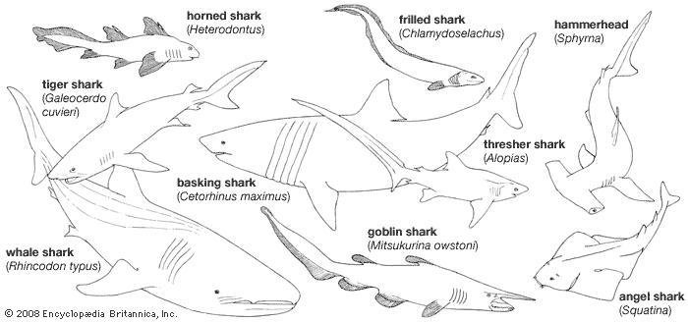
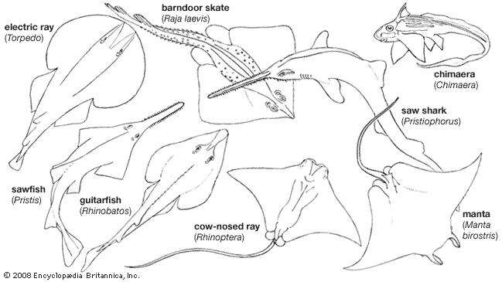
Different types of Chondrichthyes
Chondrichthyans have toothlike scales called dermal denticles or placoid scales. Denticles usually provide two functions: always protection, and in most cases, streamlining. Mucous glands exist in some species, as well.
All chondrichthyans breathe through five to seven pairs of gills, depending on the species. In general, pelagic species must keep swimming to keep oxygenated water moving through their gills, whilst demersal species can actively pump water in through their spiracles and out through their gills. However, this is only a general rule and many species differ.
A spiracle is a small hole found behind each eye. These can be tiny and circular, such as found on the nurse shark (Ginglymostoma cirratum), to extended and slit-like, such as found on the wobbegongs (Orectolobidae). Many larger, pelagic species, such as the mackerel sharks (Lamnidae) and the thresher sharks (Alopiidae), no longer possess them.
Fertilization is internal. Development is usually live birth (ovoviviparous species) but can be through eggs (oviparous). Some rare species are viviparous. There is no parental care after birth; however, some chondrichthyans do guard their eggs.

