Exercises of lecture 2

Exercise 1:
- What is the output for the following code lines if hours=35 and hours=60:
- if (hours <= 40)
cout << “No overtime” << endl;
cout<<"You must work over 40 hours for overtime\n”; cout << “Continue” << endl;
- if (hours <= 40)
{
cout << “No overtime” << endl;
cout << "You must work over 40 hours for overtime.\n";
}
cout << “Continue” << endl;

solution:

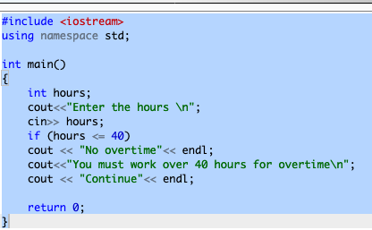

OUTPUT:
- when hours is 35: when hours is 60:
Enter the hours
35
No overtime
You must work over 40 hours for overtime
Continue

Enter the hours
60
You must work over 40 hours for overtime
Continue

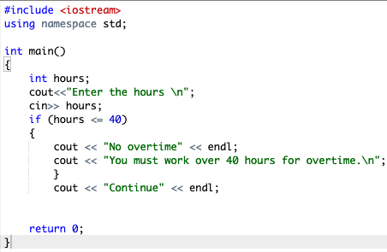

OUTPUT:
- when hours is 35: when hours is 60:
Enter the hours
35
No overtime
You must work over 40 hours for overtime
Continue

Enter the hours
60
Continue

Exercise 2:
- Write a fragment of code that test whether an integer variable score contains a valid test score. Valid test scores are in the range from 0 to 100.

Solution:
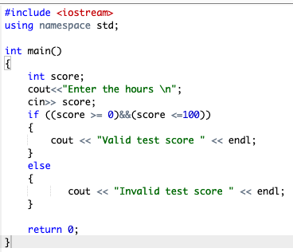

Exercise 3:
- Write a fragment of code that change an integer value stored in x as follows:
- If x is even, divide x by 2.
- If x is odd, multiply x by 3 and subtract 1.
Solution:

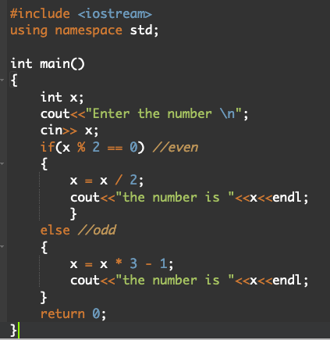

OR
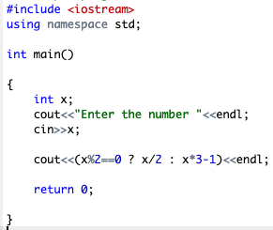

By: T.Elham Sunbu

