Q. Discuss the pros and cons of the traditional approach to system analysis.
Ans: In realizing the present system, the analyst collects a great deal of relativity unstructured data through interviews, questionnaires, on – site observations, procedures manuals and the like. The traditional approach is to organize and convert the data through system flowcharts, which support future developments of the system and simplify communication with the user. But the system flowchart represents a physical rather than a logical system. It makes it difficult to distinguish between what happens and how it happens in the system.
There are other problems with the traditional approach:
- The system life cycle provides very little quality control to ensure accurate communication from user to analyst. They have no language in common.
- The analyst is quickly overwhelmed with the business and technical details of the system.
- Present analytical tools have limitations:
  - English narrative descriptions of a system are often too vague and make it difficult for the user to grasp how the parts fit together.
  - System and program flow charts commit to a physical implementation of the system before one has complete understanding of its logical requirements.
- Problems also relate to system specifications:
  - System specifications are difficult to maintain or modify.
  - They describe user requirements in terms of physical hardware that will implement the system rather than what the user wants the system to do.
  - They are monolithic and redundant.
Q. What is structured analysis? Briefly review the tools used. How it differ from the traditional approach?
Ans: Structured analysis is a set of techniques and graphical tools that allow the analyst to develop a new kind of system specifications that are easily understandable to the user.
Several tools in structured analysis including the following:
- Data flow diagram (DFD)
- Data dictionary
- Structured English
- Decision trees
- Decision tables
Analysts work with their wits, pencil and paper. Most of them have no tools. The traditional approach focuses on cost/ benefit and feasibility analysis, project management, hardware and software selection and personnel considerations. In contrast, structured analysis considers new gals and structured tools for analysis. The new goals specify the following:
- Use graphics wherever possible to help communicate better with the user.
- Differentiate between logical and physical systems.
- Build a logical system model to familiarize the user with system characteristics and interrelationships before implementation.
Q. What steps make up the system development life cycle with structured analysis? Describe each step briefly.
Ans: The system development life cycle with structured analysis is shown in the following figure:
The primary steps are:
- Study affected user areas, resulting in a physical DFD. The logical equivalent of the present system results in a logical DFD.
- Remove the physical check points and replace them with a logical equivalent, resulting in the logical DFD.
- Model new logical system. So far no consideration is given to modifying methods called for in the feasibility report. This step incorporates the changes and begins to describe the candidate system.
- Establish man/machine interface. This process modifies the logical DFD for the candidate system and considers the hardware needed to implement the system.
- Quantity costs and benefits and select hardware. The purpose of this step is to cost justify the system; leading to the selection of hardware for the candidate system. All that is left after this step is writing the structured specification.
Q. Summarize the attributes of structured analysis.
Ans: Structured analysis has the following attributes:
- It is graphic. The DFD for example, presents a picture of what is being specified and is a conceptually easy to understand presentation of the application.
- The process is partitioned so that we have clear picture of the progression from general to specific in the system flow.
- It is logical rather than physical. The elements of system do not depend on vendor or hardware. They specific in a precise, concise ad highly readable manner the workings of the system and how it hangs together.
- It calls for rigorous study of the user area, a commitment that is often taken lightly in the traditional approach to systems analysis.
- Certain tasks that are normally carried out late in the system development life cycle are moved to the analysis phase.
Q. Write short note on DFD.
Ans: A DFD is known as a “bubble chart,” has the purpose of clarifying system requirements and identifying major transformations that will become programs in system design. So it is the starting point of the design phase that functionally decomposes the requirements specifications down to the lowest level of detail. A DFD consists of a series of bubbles joined by lines. The bubbles represent data transformations and the lines represent data flows in the system.
DFD symbol: In the DFD, there are four symbols:
- A squire defines a source on destination of system data.
- An arrow identifies data flow – data in motion. It is a pipeline through which information flows.
- A circle or a bubble represents a process that transforms incoming data flow into outgoing data flow.
- An open rectangle is a data store – data at rest, or a temporary repository of data.
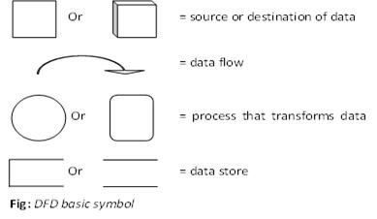
A several rules for constructing a DFD’s:
- Processes should be named and numbered for easy reference. Each name should be representative of the process.
- The direction of flow is from top to bottom and from left to right. Data traditionally flow from the source to the destination.
- When a process is exploded into lower – level details, they are numbered.
- The names of data stores, sources and destinations are written in capital letters. Process and data flow names have the first letter of each word capitalized.
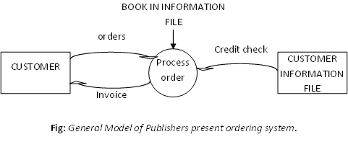
Q. “A data dictionary is a structured repository of data about data” – discuss. What advantages does a data dictionary offer in the area of documentation?
Ans: “A data flow diagrams, we give names to data flows, process and data stores. Although the names are descriptive of the data, they do not give details. So following the DFD our interest is to build some structured place to keep details of the contents of data flows, process and data store. A data dictionary is a structured repository of data about data. It is a set of rigorous definitions of all DFD data elements and data structures.
A data dictionary has many advantages. The most obvious is documentation; it is a valuable reference in any organization. Another advantage is improving analyst/user communication by establishing consistent definitions of various elements, terms and procedures. During implementation, it serves as a common base against which programmers who are working on the system compare their data descriptions. Also control information maintained for each data element is cross referenced in the data dictionary. For example, programs that use a given data element are cross referenced in a data dictionary, which makes it easy to identify them and make any necessary changes. Finally, a data dictionary is an important step in building a data base. Most data base management systems have a data dictionary as a standard feature.
Q. Define the following terms: data set, aggregates, segments, data structure. What point should be considered in constructing a data dictionary? Be specific.
Ans: Data element: The smallest unit of data that provides for no further decomposition. For example, “data” consists of day, month and year. They hang together for all particular purposes.
Data structure: A group of data elements handled as a unit. For example, “Phone” is a data structure consisting of four data elements: Area code – exchange – number – extension – for example 804 – 924 – 3423 – 236. “BOOK DETAILS” is a data structure consisting of the data elements author name, title, ISBN, LOCN, publisher’s name and quantity.
Data flows and data stores: As defined earlier, data flows are data structures in motion, whereas data stores are data structures at rest. A data store is a location where data structures are temporarily located.
In contrasting a data dictionary, the analyst considers several points:
- Definitions must be readily accessible by name.
- Each data flow in the DFD has one data dictionary entry.
- There should be no redundancy in data definition.
- The procedure for writing definitions should be precise.
Q. What do you mean by decision tree, decision table and structured English?
Ans: Decision tree: A policy statement can be time – consuming to describe and confusing to implement. The analyst needs to use tools to portray the logic of the policy. The first such tool is the decision tree. A decision tree has many branches as there are logical alternatives. It simply sketches the logical structure based on the stated policy. In this respect, it is an excellent tool: It is easy to construct, easy to read and easy to update.
Example: Book stores get a trade discount of 25% for orders from libraries and individuals for 6 or more copies of books 5% allowed on orders of 6 – 19 copies per book title; 10% on orders for 20 – 49 copies per book title; 15% on orders for 50 copies or more per book title.
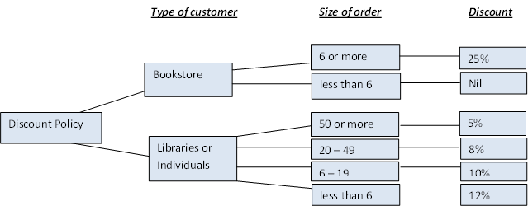
Fig: Decision tree.
Structured English: Structured English borrows heavily from structured programming; it uses logical construction and imperative sentences designed to carry out instructions for action. Decisions are made through IF, THEN, ELSE and SO statements. The structured English for our publishers discount policy is shown in following figure. Note the correlation between the decision tree and structured English.
In this tool, the logic of processes of the system is expressed by using the capitalized key words IF, THEN, Else and SO. Structures are intended to reflect the logical hierarchy. Sentences should be clear, concise and precise in wording and meaning.
COMPUTE DISCOUNT
Add up the number of copies per book title
IF order is from bookstore
and – IF order is for 6 copies or more per book title
THEN: Discount is 25%
ELSE (order is for fewer than 6 copies per book title)
SO: no discount is allowed
ELSE (order is for libraries and individual customers)
SO – IF order is for 50 copies or more per book title
discount is 15%
ELSE– IF order is for 20 to 49 copies or more per book title
discount is 10%
ELSE– IF order is for 6 to 19 copies or more per book title
discount is 5%
ELSE (order is for less than 6 copies per book order)
SO: no discount is allowed
Decision tables: A major drawback of a decision tree is the lack of information in its format to tell us what other combinations of conditions to test. This is where the decision table is useful. A decision table is a table of contingencies for defining a problem and the actions to be taken. It is a single representation of the relationships between conditions and actions. The following figure shows a decision table that represents our discount policy.
A decision table consists of two points: stub and entry. The stub part is divided into an upper quadrant called the condition stub and a lower quadrant called the action stub. The entry part is also divided into upper quadrant, called the condition entry and a lower quadrant called the action entry.
Q. Write down the pros and cons of each tool in structured analysis.
Ans: The pros and cons of each tool in structured analysis are –
- The primary strength of the DFD is its ability to represent data flows. It may be used at high or low levels of analysis and provides good system documentation. However, the tool only weakly shows input and output detail. The ser often finds it confusing initially.
- The data dictionary helps the analyst simplify the structure for meeting the data requirements of the system. It may be used at high or low levels of analysis, but it does not provide functional details and it is not acceptable to many nontechnical users.
- Structured English is best used when the problem requires sequences of actions with decisions.
- Decision trees are used to verify logic and in problems that involves a few complex decisions resulting in a limited number of actions.
- Decision trees and decision tables are best suited for dealing with complex branching routines such as calculating discounts or sales commissions on inventory control procedur
Q. There are three types of accounts in a bank. Assume that the accounts are current account, saving account and fixed deposit account. In current account bank do not give any interest, in saving account bank gives 5% of interest, and in fixed deposit account bank gives interest depend on time at following:
Duration | Interest
6 months | 8%
1 year | 10%
5 years | 12%
Draw the data flow diagram, decision table, decision tree and structured English.
Ans: Decision tree:
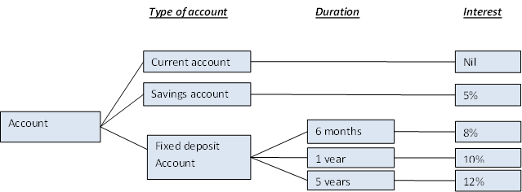
Decision table:
Condition stub |  | Condition entry
 |  | 1 | 2 | 3 | 4 | 5
IF (condition) | Account is current? | Y | N | N | N | N
 | Account is savings? |  | Y | N | N | N
 | Account is fixed deposit? |  |  | Y | Y | Y
 | Duration is 6 months? |  |  | Y | N | N
 | Duration is 1 year? |  |  |  | Y | N
 | Duration is 5 year? |  |  |  |  | Y
THEN(action) | No interest. | √
 | Allow 5% interest. |  | √
 | Allow 8% interest. |  |  | √
 | Allow 10% interest. |  |  |  | √
 | Allow 12% interest. |  |  |  |  | √
Action stub |  | Action entry
Q. In a varsity book club if a member buys a book he/she will get 10% discount. If the member buys the book more than 1000 tk then he/she will get 15% discount. If the buyer is not a member then he/she will not get any discount but he/she will get discount 7% if the amount is more than 1000 tk. Draw the data flow diagram, decision table, structured English and decision tree.
Ans: Decision tree:
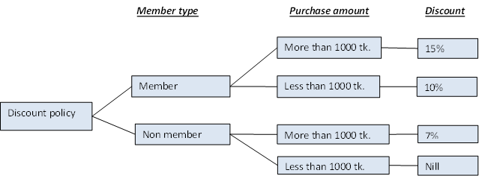
Decision table:
Condition stub |  | Condition entry
 |  | 1 | 2 | 3 | 4
IF (condition) | Customer is member? | Y | Y | N | N
 | Order is more than 1000 tk? | Y | N | N | N
THEN(action) | No discount. |  |  |  | √
 | Allow 7% discount. |  |  | √
 | Allow 10% discount. |  | √
 | Allow 15% discount. | √
Action stub |  | Action entry
http://engmamun.net/sys_analysis_06.php

