Opto 321
Binocular Vision I
1st Midterm Exam – 2nd Semester 1434/1435

Name:………………………………………..………. ID:……………………………… Date:…………………………

Part 1 :
For Each Question, Choose the Correct Answer from the Multiple-Choice List. (1 mark each)

- One of these points is not a significance of BSV :
- Stereopsis
- Enhancement of visual function
- Enhance the quality of vision
- Enhanced visual performance

- Which one is not a major advantage of BV:
- Large Visual field
- Binocular Summation
- Stereopsis
- None

- Pursuit eye movement is :
- slow eye movement for tracking and following
- fast eye movement to change the direction of the eye
- slow inward or outward movements of the two eyes
- None

- C.N. 3 innervated all the following muscles except :
- MR & SR
- IR & IO
- LR & SO
- All the above

- Once the image of the object project on the fovea, the Retinomotor value equal to:
- -1 to 0
- 0
- 0 to +1
- None

- According to the Figure below, which one is/are the correct corresponding points :
- aL & aR / bL & bR
- aL & bL / aR & aR
- aL & bR / bL & aR
- Both A & C

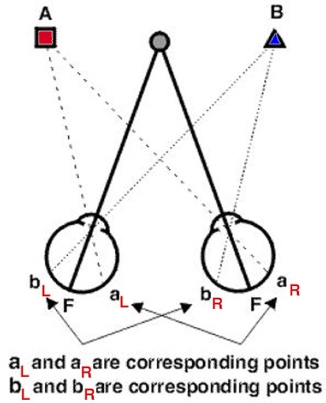

- Which one is responsible for the binocular perception of depth “ Stereopsis”:
- Retinomotor value
- Horopter
- Vieth-Muller circle
- Panum’s fusional area

- The slightly differences in the left and right images receive by the left and right retinas called :

- Depth perception
- Diplopia
- Visual direction
- Binocular disparity

- To perceive depth , we depend on :
- fixation disparity
- depth clue
- monocular clues
- All the above

- Which statement is not correct about Ocular dominance:
- Most of the population is left-eye dominant
- tendency to prefer image from one eye to the other eye
- it changes depending upon direction of gaze due to image size changes on the retinas
- both A & C

- Diplopia happens because of :
- Objects lying on the horopter
- Objects lying on Panum's fusional area
- Objects lying off the horopter and outside Panum's fusional area
- None

- Directional Dominance refers to :
- subjective alignment of two objects presented at a stereo disparity far beyond Panum's area
- the eye that does a better job of fixating on an object of regard under binocular conditions
- difference in the two retinal images that might lead to rivalry or some binocular interaction
- None

- Unit to measuring Convergence is :
- Diopter
- Degree
- Prism
- Prism per Diopter

- A high AC:A ratio can cause near
- Eso-deviation
- Exo-deviation
- Cyclo-deviation
- No deviation

- A low AC:A ratio can cause near
  - Eso-deviation
  - Exo-deviation
  - Cyclo-deviation
  - No deviation
Part 2 :
Put ( T ) for true statements and ( F ) for false statements. (1 mark each)

- Binocular Single Vision is the ability to use both eyes at the same time while Binocular Vision is the ability to fuse the two separate images seen by each eye into one image ( F )

- To have BSV, the refractive errors should be no more than 5% difference between the two eyes ( T )

- Dextroversion is accomplished by contraction of right LR and left MR muscles ( T )

- In normal BSV, the points nasal to the fovea in one eye are corresponded with points nasal to the fovea of the other eye ( F )

- As far as the extra-foveal points away from the fovea, the eye's deviation (squint) determined ( T )

- The actual Vieth-Muller Circle was found to be flatter than horopter curve ( F )

- Object within Panum’s space do not give rise to diplopia ( T )

- No sensory and motor fusion occurs unless the binocular images fall exactly on the corresponding retinal points of each eye ( F )

- Object beyond Panum’s area will stimulate non-corresponding temporal retina in each eye which projected temporally giving rise to uncrossed diplopia ( F )

- On near fixation accommodation is exerted, which leads to excessive convergence and an exo-deviation ( F )

Part 3 :
- Mention 4 types of tests which are used to determent Dominant eye and explain one?

- Miles test
- Porta test
- Convergence near point test
- Lens fogging technique

- Defined the areas pointed with arrows :

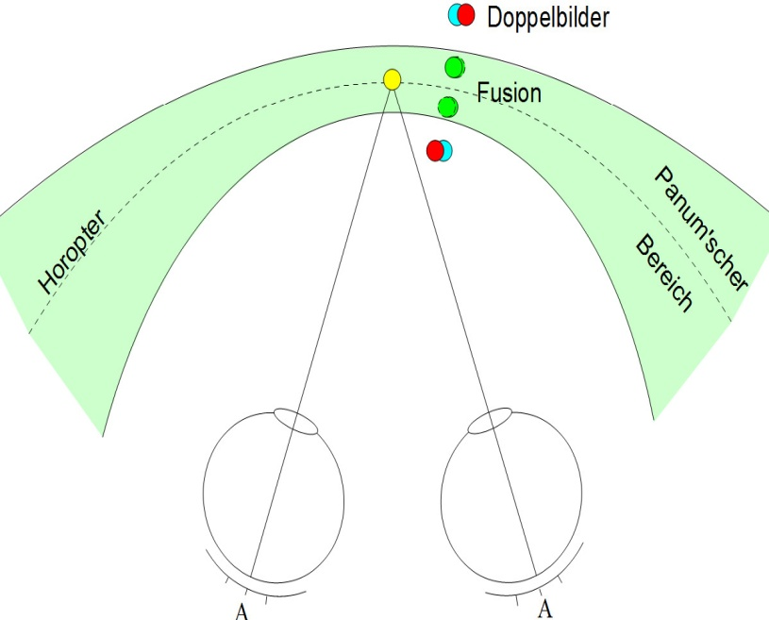

Good Luck
Lec. Waheedah Alshemmri

