Example: DreamHome  
*Collection of simplified DreamHome leases*

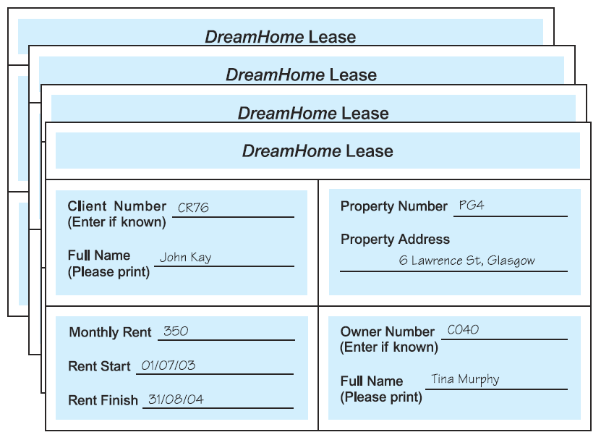

*Unnormalized table (UNF)*

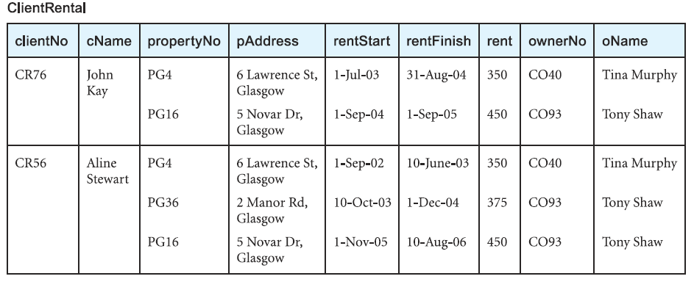

Which is considered the key attribute?

What are the repeating group of keys?

*UNF to 1NF*

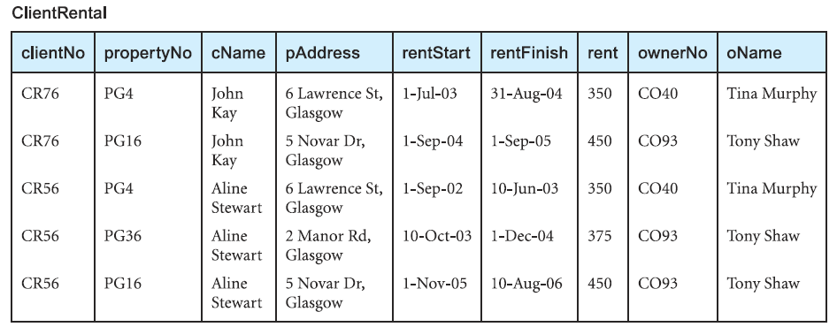*Alternative 1NF relations*

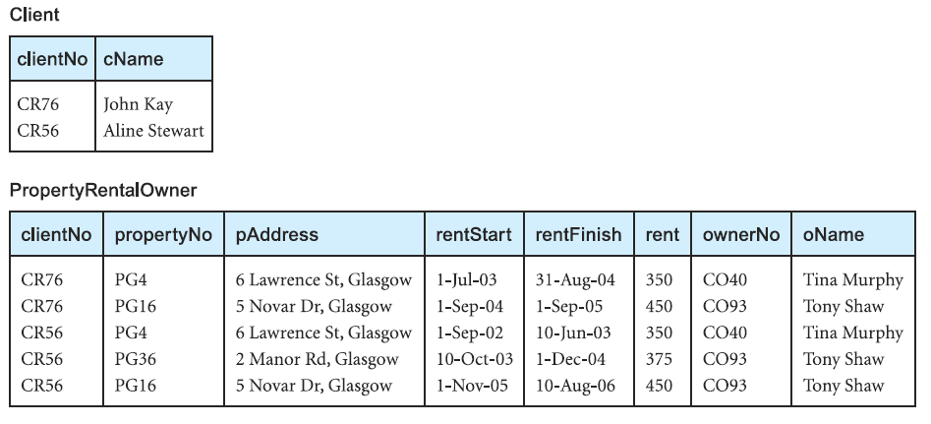

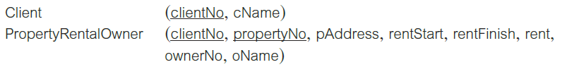

*Functional dependencies of the 1NF*

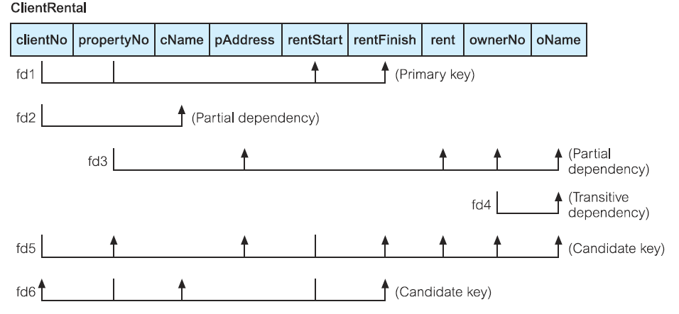



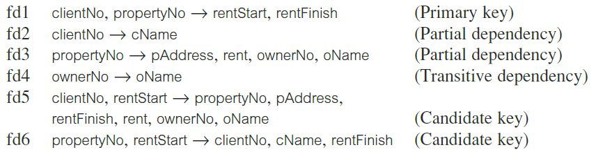

*1NF to 2NF*

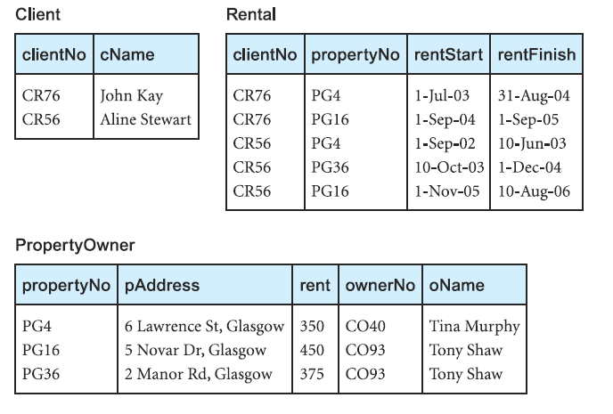

*2NF to 3NF*



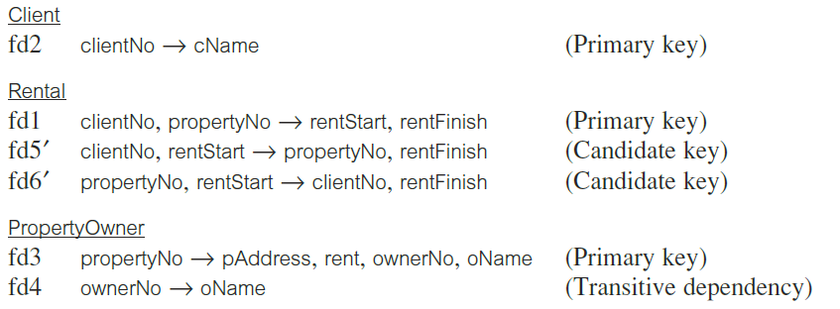

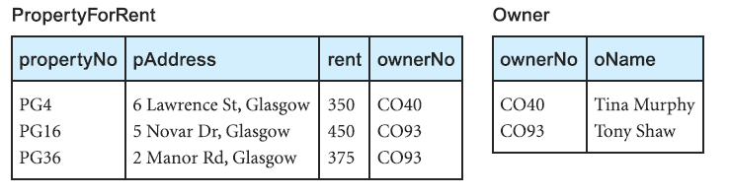

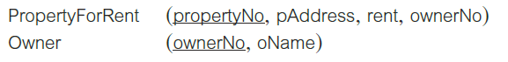

*Summary of the 3NF*

