Example: DreamHome  
*Collection of simplified DreamHome leases*

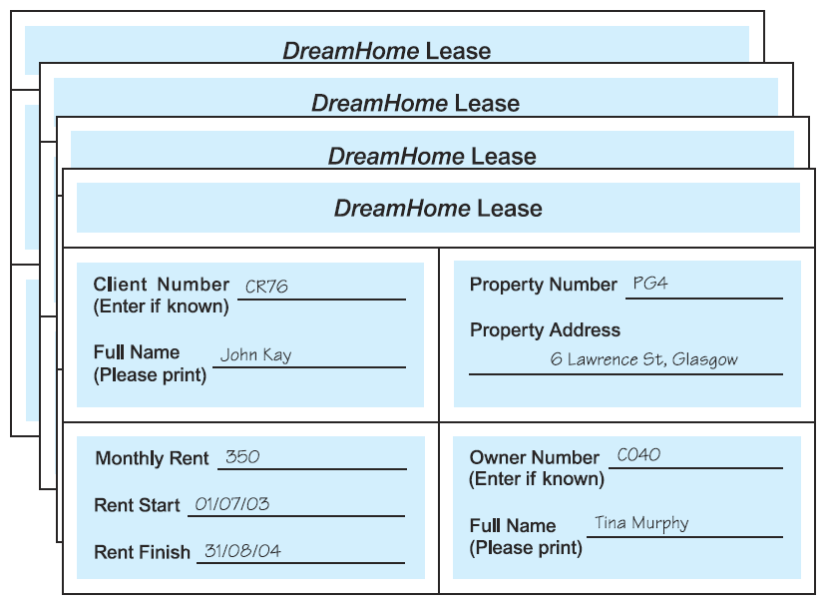

*Unnormalized table (UNF)*

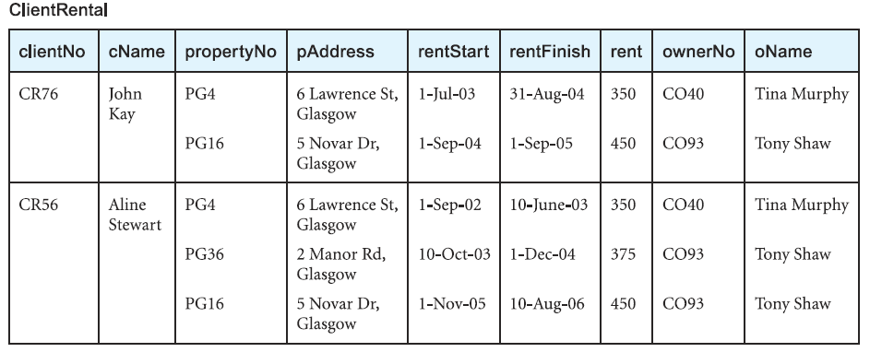

Which is considered the key attribute?

What are the repeating group of keys?

*UNF to 1NF*

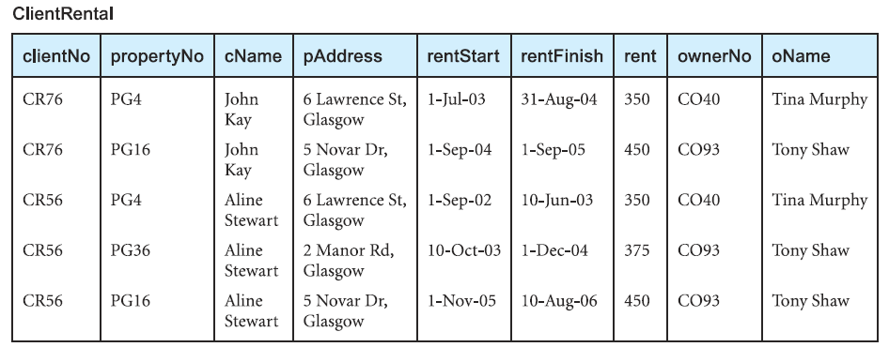

*Functional dependencies of the 1NF*

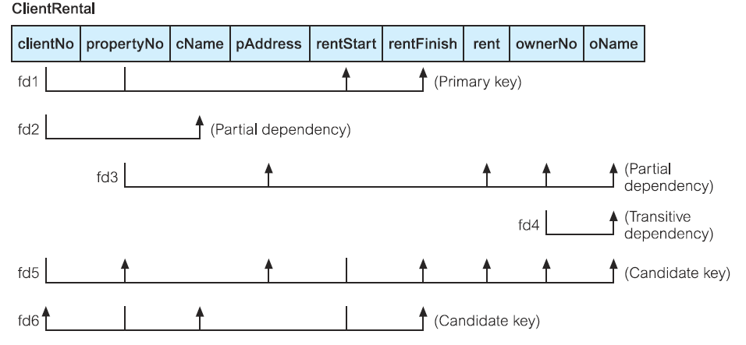



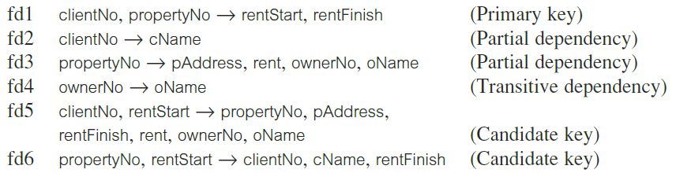

*1NF to 2NF*:

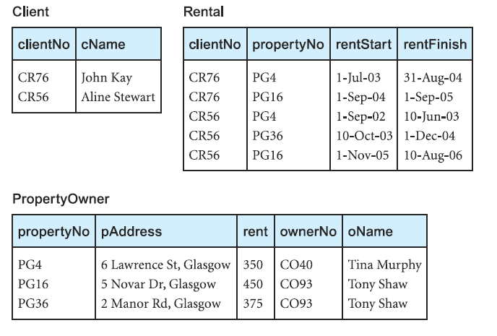

*2NF to 3NF*



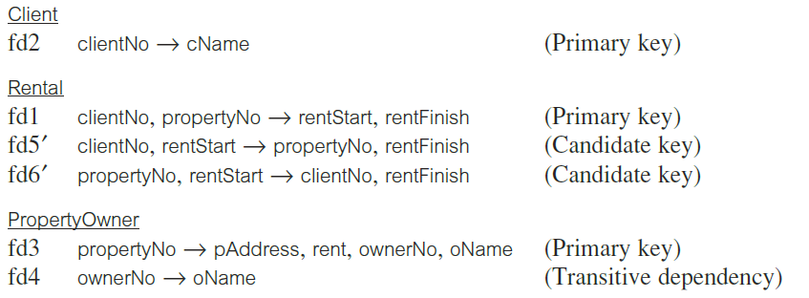

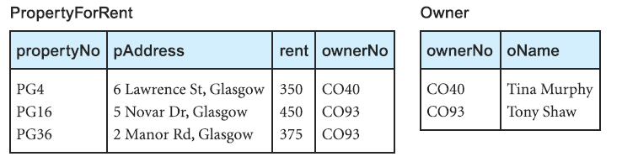

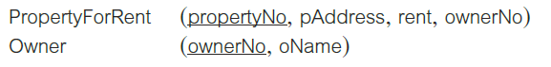

*Summary of the 3NF*

