|  |
| --- |
| Reaction Rig for DRM process  C:\Users\AWAIS HASHMI\Desktop\All graphical abst\Untitled.tif |

**Selected Publications**

**Journal Publications**

* 1. M. A. Naeem, A. S. Al-Fatesh, A. E. Abasaeed, A. H. Fakeeha, “Hydrogen production from methane dry reforming over nickel-based nanocatalysts using surfactant-assisted or polyol method”, International Journal of Hydrogen Energy. 39 (2014) 17009-17023.

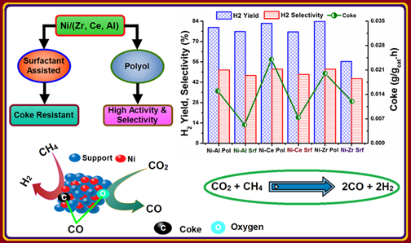

* 1. A. H. Fakeeha, M. A. Naeem, W. U. Khan, A. E. Abasaeed, A. S. Al-Fatesh, “Reforming of methane by CO2 over bimetallic Ni-Mn/γ-Al2O3 catalyst”, Chinese Journal of Chemical Physics. 27 (2014) 214–220.
  2. M. A. Naeem, A. S. Al-Fatesh, A. E. Abasaeed, A. H. Fakeeha, “Activities of Ni-based nano catalysts for CO2-CH4 reforming prepared by polyol process”, Fuel Processing Technology. 122 (2014) 141–152.

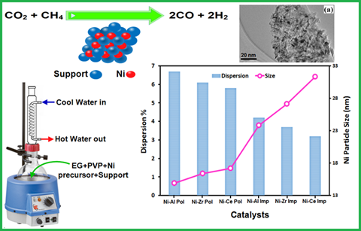

* 1. A. S. Al-Fatesh, M. A. Naeem, A. H. Fakeeha, A. E. Abasaeed, “Role of La2O3 as promoter and support in Ni/γ-Al2O3 catalysts for dry reforming of methane”, Chinese Journal of Chemical Engineering. 22 (2014) 28–37.

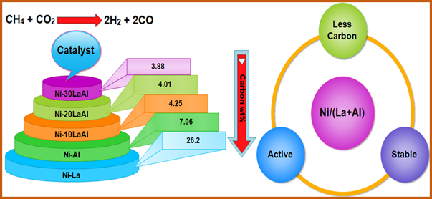

* 1. A. S. Al-Fatesh, M. A. Naeem, W. U. Khan, A. H. Fakeeha, “Effect of nano-support and type of active metal on reforming of CH4 with CO2”, Journal of the Chinese Chemical Society. 61 (2014) 461–470.

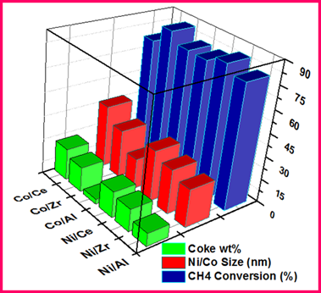

* 1. A. S. Al-Fatesh, A. A. Ibrahim, S. Haider, A. H. Fakeeha, “Sustainable production of synthesis gases via state of the art metal supported catalytic systems: An overview”, Journal of the Chinese Chemical Society. 60 (2013) 1297–1308.

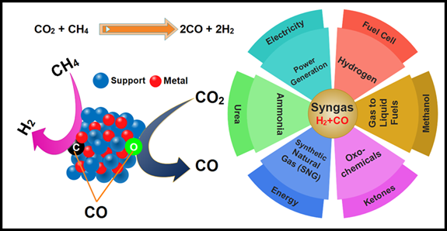

* 1. M. A. Naeem, A. S. Al-Fatesh, W. U. Khan, A. E. Abasaeed, A. H. Fakeeha, “Syngas production from dry reforming of methane over nano Ni polyol catalysts”, Int. J. Chem. Eng. Appl. 4(5) (2013) 315–320.
  2. A. H. Fakeeha, M. A. Naeem, W. U. Khan, A. S. Al-Fatesh, “Syngas production via CO2 reforming of methane using Co-Sr-Al catalyst”, Journal of Industrial and Engineering Chemistry. 20 (2014) 549–557.

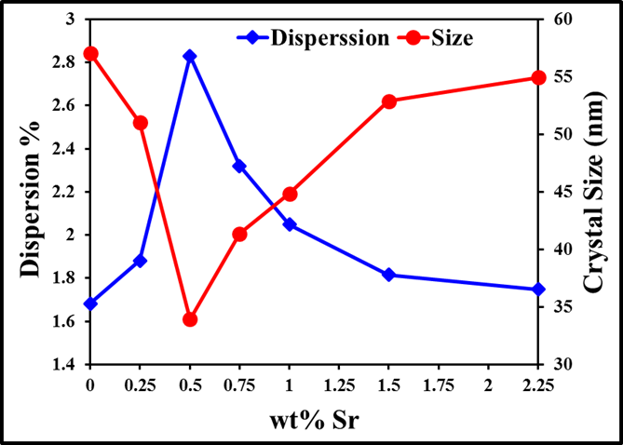

* 1. A. S. Al-Fatesh, M. A. Naeem, A. H. Fakeeha, A. E. Abasaeed, “CO2 reforming of methane to produce syngas over γ-Al2O3 supported Ni-Sr catalysts”, Bulletin of the Chemical Society of Japan. 86 (2013) 742-746.

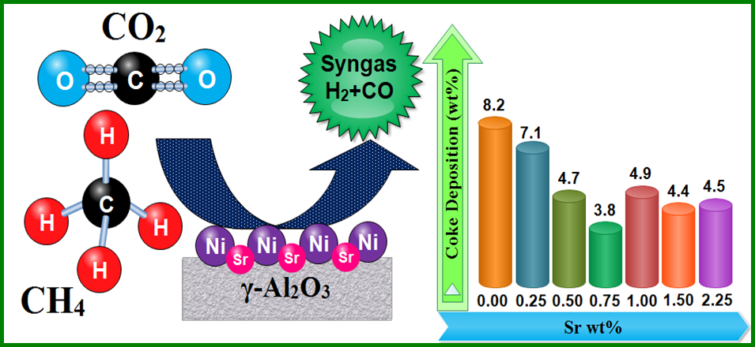

* 1. A. S. Al-Fatesh, A. H. Fakeeha, “Methane reforming using a Ni-Ag/γ-Al2O3 catalyst”, Journal of chemical engineering of Japan. 46 (2013) 158-161.
  2. A. S. A. Al–Fatesh, A. H. Fakeeha, “Effects of calcination and activation temperature on dry reforming catalysts”, Journal of Saudi Chemical Society. 16 (2012) 55-61.
  3. A. H. Fakeeha. A. S. Al-Fatesh, A. E. Abasaeed, “Ni/Y-Zeolite catalysts for carbon dioxide reforming of methane”, Advanced Materials Research. 550-553 (2012) 325-328.

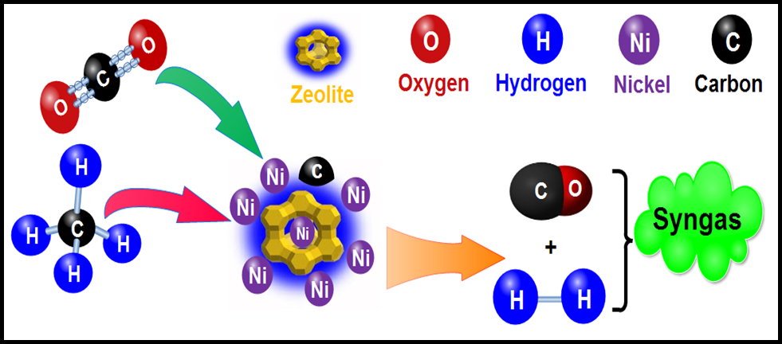

* 1. A. S. Al–Fatesh, A. H, Fakeeha, A. E. Abasaeed, “Effect of Pd on CH4 reforming with CO2 catalyzed by Ni over mixed Titian-Alumina support”, Advanced Materials Research. 476-478 (2012) 513-518.
  2. A. H. Fakeeha, A. S.A. Al-Fatesh, A. E. Abasaeed, “Modification of alumina support with TiO2-P25 in CO2 reforming of CH4”, Journal of Industrial and Engineering Chemistry. 18 (2012) 212–217.
  3. A. S. A. Al-Fatesh, A. H. Fakeeha, A. E. Abasaeed, “Effects of Selected Promoters on Ni/γ-Al2O3 catalyst performance in methane dry reforming”, Chinese Journal of Catalysis. 32 (2011) 1604–1609.
  4. A. S. Al–Fatesh, A. A. Ibrahim, A. H. Fakeeha, A. E. Abasaeed, “Activity and carbon formation of a low Ni-loading alumina-supported catalyst”, Journal of Chemical Engineering of Japan. 44 (2011) 328-335.
  5. A. H. Fakeeha, A. A. Ibrahim, A. S. Al-Fatesh, A. E. Abasaeed, “CO2 reforming of CH4 for Mitigation of green-house gases”, Res. J. Chem. Environ. 15 (2011) 836-841.
  6. A. S. Al–Fatesh, A. H. Fakeeha, “Investigation of suitable pretreatment for dry reforming of methane over Ni/Al2O3”, Advanced Materials Research. 233-235 (2011) 1665-1673.
  7. A. S. A. Al–Fatesh, A. H. Fakeeha, “Reduction of green-house gases by dry reforming: Effect of support”, Res. J. Chem. Environ.15 (2011) 259-268.
  8. A. S. A. Al–Fatesh, A. A. Ibrahim, A. H. Fakeeha, M. R. H. Siddiqui, A.E. Abasaeed, “Oxidative CO2 reforming of CH4 over Ni/α-Al2O3 catalyst”, Journal of Industrial and Engineering Chemistry. 17 (2011) 479-483.
  9. A. S. A. Al–Fatish, A. A. Ibrahim, A. H. Fakeeha, M. A. Soliman, M. R. H. Siddiqui, A. E. Abasaeed, “Coke formation during CO2 reforming of CH4 over alumina-supported nickel catalysts”, Applied Catalysis A: General. 364 (2009) 150–155.
  10. A. H. Fakeeha, M. A. Soliman, S. M. Alwahabi, Y. M. Fahmy, A. A. Ibrahim, “Influence of MO-Doping on VPO catalyst for partial oxidation of ethane”, Journal of Saudi Chemical Society. 9 (2005) 287-296.
  11. A. H. Fakeeha, F. A. Abdelaleem, A. A. Ibrahim, “Preparation of hydrogen evolution electrode by addition of zinc metal to nickel”, Al-Azhar University Engineering Journal. 8 (2005) 229-235.

**Conference proceedings**

1. A. S. Al-Fatesh, M. A. Naeem, A. A. Ibrahim, A. H. Fakeeha, “Effect of Tb promoter on catalytic performance of Ni/ZrO2 catalysts in carbon dioxide reforming of methane”, 8th International Conference on Environmental Catalysis, Asheville, North Carolina, United States of America, 24-27 August 2014.
2. A. A. Ibrahim, A. H. Fakeeha, A. E. Abaseed, M. A. Naeem, A. S. Al-Fatesh , “Study of synthesis gas production via CO2 reforming of CH4 over supported cobalt catalysts”, 8th International Conference on Environmental Catalysis, Asheville, North Carolina, United States of America, 24 - 27 August 2014.
3. A. H. Fakeeha, M. A. Naeem, A. E. Abasaeed, W. U. Khan, A. S. Al-Fatesh, “Highly coke-resistant novel Ni-Ho/ZrO2 catalyst for dry reforming of methane”, 13th International Conference on Clean Energy 2014 (ICCE-2014). Istanbul-Turkey, 8–12 June 2014.
4. A. E. Abasaeed, A. S. Al-Fatesh, M. A. Naeem, A. A. Ibrahim, A. H. Fakeeha, “Production of hydrogen via dry reforming of methane over Co-based catalysts”, The 20th World Hydrogen Energy Conference. Gwangju, Korea, 15–20 June 2014.
5. A. H. Fakeeha, A. A. Ibrahim, M. A. Naeem, A. S. Al-Fatesh, “Energy source from hydrogen production via methane dry reforming”, Fourth International Conference on Industrial Engineering and Operations Management, Bali, Indonesia, 7-9 January 2014.
6. A. H. Fakeeha, “Enhancing energy production in power plants by utilizing exhaust gases”, Global Engineering. Science and Technology Conference, Singapore, 3–4 October 2013.
7. A. S. Al-Fatesh, M. A. Naeem, A. H. Fakeeha, “Effect of Sr on Ni-Co bimetallic catalyst for dry reforming”, 11th International European Congress on Catalysis, EuropaCat-XI, Lyon, France, 1–6 September 2013.
8. A. A. Ibrahim, A. H. Fakeeha, M. A. Naeem, A. S. Al-Fatesh, “Hydrogen production from dry reforming of methane using γ-Al2O3 supported Co-Sr catalyst”, 11th International European Congress on Catalysis, EuropaCat-XI, Lyon, France, 1–6 September 2013.
9. A. S. Al-Fatesh, A. H. Fakeeha, A. E. Abasaeed, “Effect of Mn promoter on Ni-based catalysts supported on γ-Al2O3”, The Sixth Jordan International Chemical Engineering Conference (JIChEC 06), Amman-Jordan, 12-14 March 2012.
10. A. S. Al-Fatesh, A. H. Fakeeha, A. A. Ibrahim, A. E. Abasaeed, “Effect of Calcium promoter on Ni-based catalysts supported on α-Al2O3 and TiO2-P25”, The 2011 International Conference on Chemical, Material and Metallurgical Engineering (ICCMME 2011), Beihai, China, 23-25 December 2011.
11. A. H. Fakeeha, A. S. A. Al–Fatesh, “Effect of TiO2-P25 addition on Ni/α-Al2O3 catalytic activity in CO2 reforming of methane”, First United Arab Emirates Conference on Pure and Applied Chemistry (ECPAC11) American University of Sharjah, 1-3 March 2011.
12. A. S. A. Al-Fatesh, A. H. Fakeeha, “Effect of Pd and Ce promoters on the activity of Ni/γ-Al2O3 catalysts for the dry reforming of methane”, 11th International Chemistry Conference and Exhibition in Africa, Egypt, Luxor, 20-23 November 2010.
13. A. H. Fakeeha, A. S. Al-Fatish, M. A. Soliman, A. A. Ibrahim, “Utilization of carbon dioxide in dry reforming reaction to produce synthesis gas used as feed for petrochemical industries”, The seventh International Conference on Chemistry In Industry, Manama, Kingdom of Bahrain, 26-28 March 2007.
14. A. H. Fakeeha, A. S. AL Fatish, M. A. Soliman, A. A. Ibrahim, “Catalyst preparation for CO2 utilization in reforming of methane”, First Afro-Asian Conference on Advanced Material Science and Technology, Cairo – Egypt, 13-16 November 2006.
15. A. H. Fakeeha, A. S. AL Fatish, M. A. Soliman, A. A. Ibrahim, “Effect of changing CH4/CO2 ratio on hydrogen production by dry reforming reaction”, 16th World Hydrogen Energy Conference, Lyon, France, 13-16 June 2006.
16. A. H. Fakeeha, M. A. Soliman, A. S. AL Fatish, “Effect of catalyst preparation on dry reforming of methane”, 3rd International Conference on Chemical & Environmental Engineering, Military Technical College, Cairo Egypt, 16-18 May 2006.
17. A. H. Fakeeha, M. A. Soliman, A. S. AL Fatish, “The effect of using different supports on the production of hydrogen by dry reforming”, Proceeding of 1st European Hydrogen Energy Conference, Grenoble, France, 2-5 September 2003.
18. A. H. Fakeeha, M. A. Soliman, A. S. AL Fatish, “Effect of Promoters on hydrogen production by dry reforming Reaction”, Proceeding of 2nd European Hydrogen Energy Conference, Zaragoza, Spain, 22-25 September 2005.