DRUGS AFFECTING THE URINARY SYSTEM OUTLINE
19/11/2018

Outline
Review of the Urinary System
- Diuretics
  - Nursing Responsibilities
  - Patient Education
  - Nursing Consideration
- Uricosuric
  - Nursing Responsibilities
  - Patient Education
  - Nursing Consideration
- Drugs for Renal System Dysfunction
  - Nursing Responsibilities
  - Patient Education

- https://www.youtube.com/watch?v=OkyFPMXa28c
- https://www.youtube.com/watch?v=oCQ-5iwTQvM

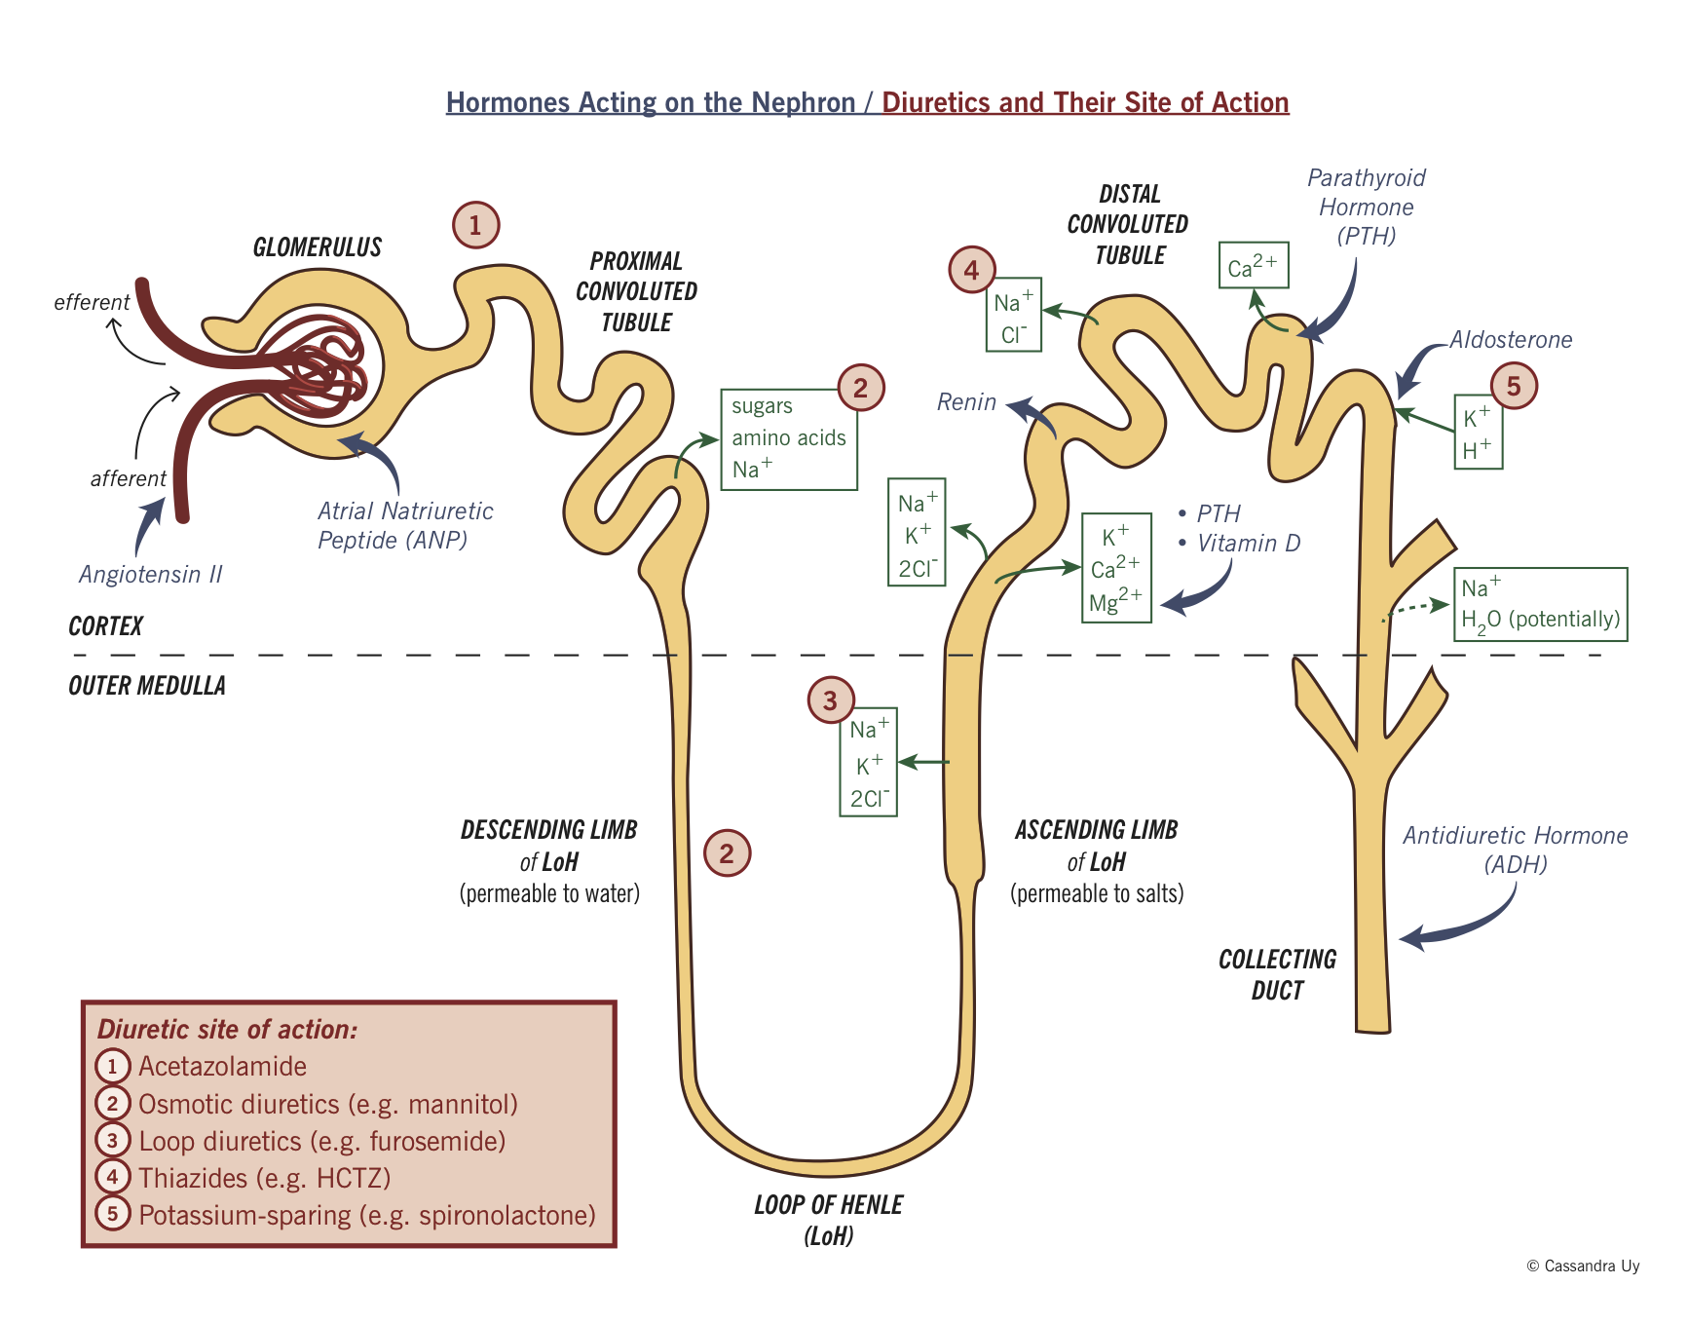

Figure. 1: The nephron Diuretics and their site of action

I – Diuretics (P.656)
Play a special role in many therapies including Heart Failure and Hypertension
Diuretics can be beneficial, but may result in many adverse effects and drug interactions
Action of Diuretics:
- Modify renal function to induce diuresis
- Increase the excretion of electrolytes, primarily Sodium Chloride
1. Loop diuretics
- Drugs that inhibit the reabsorption of sodium and water in the ascending Loop of Henle. (Furosemide / Lasix) the first loop diuretic
- Treatment of edema, associated with HF, cirrhosis or renal disease
2. Thiazide Diuretics (Hydrochlorothiazide)
- Mainstay in the treatment of Hypertension
- Act in the diluting segment of the distal tubule
- Moderately effective at diuresis
- Reduces blood pressure
- Sometimes used for fluid overload
- More commonly used to treat Hypertension
3. Potassium Sparing Diuretics (Spironolactone)
- Works by blocking sodium reabsorption in distal tubules thus increasing sodium and water excretion
- Conserves potassium
- Weak diuretics
- Sometimes used in combination with other diuretics for synergistic effect
- To offset the potassium wasting seen with the loop diuretics and thiazide diuretics
- Prevention and treatment of hypokalemia and adjunct therapy in treating edema and hypertension
4. Proximal tubule diuretics (Acetazolamide “Diamox”)
- Carbonic Anhydrase inhibitor
- Acts to reduce the volume of sequestered fluids especially of the aqueous humor
- Management of glaucoma (lowers IOP) by decreasing the production of aqueous humor by more than 50%
- Short term management of certain seizure types
5. Osmotic Diuretics (Mannitol)
- Draws fluid into the lumen of the tubule
- Reduce cerebral edema in neurologic states and Intraocular pressure in glaucoma
Nursing Process:
Assessment;
- Conditions that would contraindicate the use of Diuretics
- Loop diuretics and Thiazides can result in hypokalemia and other electrolyte disturbances.
- Loop Diuretics may increase blood glucose and uric acid concentration
- The use of Diuretics with Liver dysfunction increases the risk of dehydration and electrolyte imbalance
- Significant Drug Interaction
- Baseline vital signs, extent and severity of Fluid volume excess, hearing, abnormalities in electrolytes, Blood urea nitrogen, Hepatic and renal function studies
- Monitor ECG changes, Observe for fluid and electrolyte imbalance
- Determine baseline IOP to assess glaucoma
- Observe for signs of allergic reaction
- For both Urea and Mannitol, avoid using lower extremity IV sites because phlebitis and thrombosis may occur, particularly in older adults
Client Education
- Weigh daily on arising on the same scale in similar clothing. Report any overnight 2 lb increase in weight
- Move carefully from a sitting or lying position to an upright position because of positional (orthostatic) hypotension
- Take pulse and BP as often as directed by the prescriber
- Maintain a record to take for office visit. Maintain follow up visit for laboratory test and monitoring of the condition
- Use sugarless candies or small sips of water or ice chips for relief (unless on fluid restriction) of dry mouth
- Maintain regular dental checkups to monitor the development of dental caries and gum disease as a result of serostomia
- Constipation may be prevented by a high fiber diet, adequate amounts of fluids (unless restricted) , moderate exercise and establishing a routine for patients taking potassium sparing diuretic
- Administer with food or milk to prevent some GI symptoms and enhance bioavailability
- Avoid excessively low salt diet and concentrated potassium intake in the form of citrus juices, cola beverages and other potassium supplements
Drug Interaction:
- Diuretics are valuable assets in the therapeutic regimen for the treatment of Hypertension and other conditions with fluid volume excess (HF, cirrhosis and Nephrotic syndrome)
- Nursing management focuses on education of the client for safe and accurate self administration of diuretics particularly in the early recognition of adverse effects
- Hypokalemia is common except in clients taking potassium sparing diuretics
An evaluation of the effectiveness of the therapeutic regimen through accurate measurement of the client’s blood pressure, fluid balance and weight is essential

II – Uricosuric Drugs
- Hyperurecemia and Gout occur in persons with an abnormality in uric acid production and / or excretion
- Risk factors for gout include obesity, hypertension, alcohol consumption and lead exposure
- Recurrent gouty arthritis is painful and can cause crystal deposits throughout the body which results in inflammatory response, and in some instances, kidney stones
Gout is a metabolic disorder characterized by hyperuricemia
The aims for therapy are:
- To end the acute attack quickly
- Prevent recurrence
- Prevent uric acid renal calculi
- Prevent or minimize the complication of sodium urate deposits in the joints
Agents used for these purposes are Colchicine, Allopurinol.
- Colchicine
- Unknown action, but it has anti inflammatory effects in gout
- Treatment and prophylaxis of acute and chronic gouty arthritis
- Side effect: Diarrhea, nausea, vomiting, abdominal pain, anorexia and with chronic therapy, alopecia
2. Allopurinol
- Decreases the production of uric acid by inhibiting xanthine oxidase.
- Treatment for chronic gouty arthritis
- Prophylaxis and treatment of hyperuricemia, nephropathy and renal calculi associated with gout, tumor lysis after antineoplastic therapy and other conditions
- Side Effect: Pruritus, allergic reaction, rash, hives, diarrhea, abdominal distress, nausea, vomiting, alopecia, dermatitis, bone marrow depression, liver toxicity, hypersensitivity reaction, peripheral neuritis, renal failure and nosebleeds.
Nursing Responsibilities
Assess patient for:
- GI disorder as Colchicine may cause additional injury to GI tissues in clients with GI disorders or in those taking medications such as NSAIDS that may increase GI ulceration
- Sensitivity to Colchicine
- Obtain a baseline assessment of general health status, uric acid levels, CBC, frequency and severity of gout symptoms, and current joint pain and stiffness.
Monitor the following:
- Affected joints for range of motion, pain and swelling
- CBC results, Serum uric acid level – risk of bone marrow depression
- Intake and output ratio to assess adequacy of urinary output
- Renal function to detect the need for dose reduction (Allopurinol may accumulate and increase the risk of allergic reaction or other adverse effect if the patient has impaired renal function
- Prothrombin levels
Nursing Consideration
- Parenteral Colchicine is generally avoided due to greater toxicity observed when given IV
- Colchicine administered IV can be very irritating to the vein and extravasation can cause tissue injury
- Colchicine cannot be given IM or SQ because it is highly irritating and will cause tissue necrosis
- Oral Colchicine and Allopurinol may be administered with food to prevent GI distress
Patient Education
1.Start the medication at the earliest sign of an attack but discontinue it:
- when the pain is relieved
- when the maximum dose is reached (6 mg)
- at the first sign of diarrhea, nausea, vomiting or stomach pain
2. Increase fluid intake to ensure urinary output of at least 2000 ml daily
3. Do not drink alcohol because alcohol increases the risk of GI toxicity and decreases the effectiveness of medication by increasing the level of uric acid
- Maintain a low purine diet. Exclude foods rich in purine (organ meats, liver, kidney and sweet breads, red meat, poultry and fish)
- Inform other health care providers that he is taking Colchicine before any surgical or dental procedures are performed.
- Allopurinol helps to prevent, but does not relieve acute episodes of gout
- Drowsiness may occur and that hazardous activity requiring mental alertness, such as driving, need to be avoided
Drug Interaction
- Colchicine may precipitate if diluted with or injected into IV tubing containing 5% dextrose solutions, solutions containing bacteriostatic agents
- Allopurinol has the potential to accentuate the bone marrow suppression effects of other drugs, including agents used in the treatment of cancer.
- The potential for kidney stones may be higher when Allopurinol is administered with large doses of Ascorbic acid (Vitamin C)
- Allopurinol may inhibit the metabolism of anticoagulant Warfarin resulting in an increased serum levels, activity and perhaps toxicity

III – Drug Therapy for Renal System Dysfunction
1. Calcium Acetate
- Binds to dietary phosphate, which is not absorbed and instead, is eliminated in the stool
- Control of hyper-phosphatemia in end-stage renal disease
- Side Effect: Constipation
- Severe hyperkalemia can manifest with mental status changes and coma
Nursing Responsibilities
Assess for concurrent drug regimen for other calcium containing preparations, including dietary supplement and antacids
2. Monitor for:
- results of serum calcium and serum phosphate concentration
- CBC, Hematocrit
- Renal function (BUN, serum creatinine, serum phosphate, serum potassium, serum sodium and serum uric acid)
- Fluid balance ratio
3. Perform neurologic Assessment for premonitory signs of the risk of seizures, particularly during the first 90 days of therapy
Patient Education
- Avoid other Calcium containing preparation, such as dietary supplements and antacids.
- Report constipation, anorexia, nausea or vomiting to the prescriber as these are early symptoms of hyperkalemia
- Avoid activities that may be hazardous if seizures would occur
- Instruct about dietary sources of iron, Folic Acid and B12 as adjuncts to iron and other vitamin supplementation.

--------------------------------------------------------------------------- The End-------------------------------

