Dissolved Oxygen

What is Dissolved Oxygen?
Dissolved oxygen refers to the level of free, non-compound oxygen present in water or other liquids. It is an important parameter in assessing water quality because of its influence on the organisms living within a body of water. In limnology (the study of lakes), dissolved oxygen is an essential factor second only to water itself ¹. A dissolved oxygen level that is too high or too low can harm aquatic life and affect water quality.
Non-compound oxygen is oxygen that is not bonded to any other element. Dissolved oxygen is the presence of these free O2 molecules within water. The bonded oxygen molecule in water (H2O) is in a compound and does not count toward dissolved oxygen levels. One can imagine that free oxygen molecules dissolve in water much the way salt or sugar does when it is stirred ².
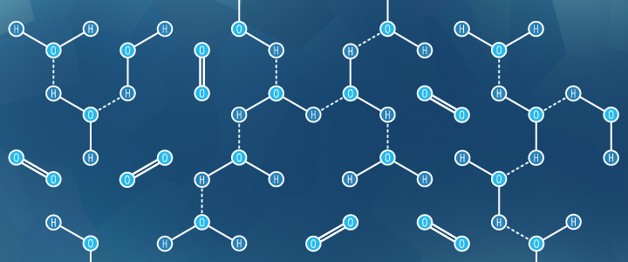
Non-bonded oxygen molecules in water

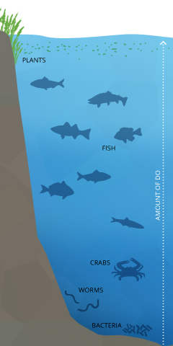
Dissolved oxygen is important to many forms of aquatic life.

Dissolved Oxygen and Aquatic Life
Dissolved oxygen is necessary to many forms of life including fish, invertebrates, bacteria and plants. These organisms use oxygen in respiration, similar to organisms on land. Fish and crustaceans obtain oxygen for respiration through their gills, while plant life and phytoplankton require dissolved oxygen for respiration when there is no light for photosynthesis ⁴. The amount of dissolved oxygen needed varies from creature to creature. Bottom feeders, crabs, oysters and worms need minimal amounts of oxygen (1-6 mg/L), while shallow water fish need higher levels (4-15 mg/L)⁵.
Microbes such as bacteria and fungi also require dissolved oxygen. These organisms use DO to decompose organic material at the bottom of a body of water. However, if there is an excess of decaying organic material (from dying algae and other organisms), in a body of water with infrequent or no turnover (also known as stratification), the oxygen at lower water levels will get used up quicker ⁶.

Where Does DO Come From?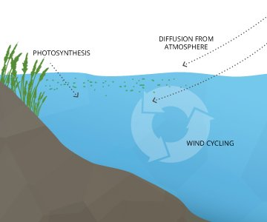
How dissolved oxygen enters waterDissolved oxygen enters water through the air or as a plant byproduct. From the air, oxygen can slowly diffuse across the water’s surface from the surrounding atmosphere, or be mixed in quickly through aeration, whether natural or man-made ⁷. The aeration of water can be caused by wind (creating waves), rapids, waterfalls, ground water discharge or other forms of running water. Man-made causes of aeration vary from an aquarium air pump to a hand-turned waterwheel to a large dam.
Dissolved oxygen is also produced as a waste product of photosynthesis from phytoplankton, algae, seaweed and other aquatic plants ⁸.
Dissolved Oxygen from Photosynthesis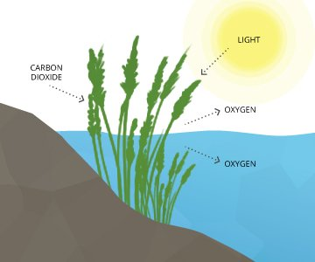
While most photosynthesis takes place at the surface (by shallow water plants and algae), a large portion of the process takes place underwater (by seaweed, sub-surface algae and phytoplankton). Light can penetrate water, though the depth that it can reach varies due to dissolved solids and other light-scattering elements present in the water. Depth also affects the wavelengths available to plants, with red being absorbed quickly and blue light being visible past 100 m. In clear water, there is no longer enough light for photosynthesis to occur beyond 200 m, and aquatic plants no longer grow. In turbid water, this photic (light-penetrating) zone is often much shallower.
The basic reaction of aquatic photosynthesis remains:
CO2 + H2O → (CH2O) + O2
As aquatic photosynthesis is light-dependent, the dissolved oxygen produced will peak during daylight hours and decline at night ⁸.

Dissolved Oxygen Saturation
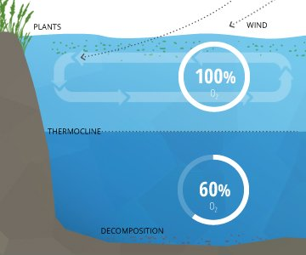
Not all water depths reach 100% air saturation
In a stable body of water with no stratification, dissolved oxygen will remain at 100% air saturation. 100% air saturation means that the water is holding as many dissolved gas molecules as it can in equilibrium. At equilibrium, the percentage of each gas in the water would be equivalent to the percentage of that gas in the atmosphere – i.e. its partial pressure ¹³. The water will slowly absorb oxygen and other gasses from the atmosphere until it reaches equilibrium at complete saturation ¹⁰. This process is sped up by wind-driven waves and other sources of aeration ³.
In deeper waters, DO can remain below 100% due to the respiration of aquatic organisms and microbial decomposition. These deeper levels of water often do not reach 100% air saturation equilibrium because they are not shallow enough to be affected by the waves and photosynthesis at the surface ³. This water is below an invisible boundary called the thermocline (the depth at which water temperature begins to decline)¹¹.

What Affects Oxygen Solubility?
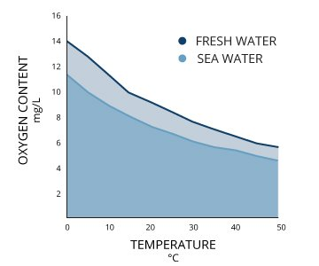
Dissolved oxygen concentrations decrease as temperature increases
Two bodies of water that are both 100% air-saturated do not necessarily have the same concentration of dissolved oxygen. The actual amount of dissolved oxygen (in mg/L) will vary depending on temperature, pressure and salinity ¹.
First, the solubility of oxygen decreases as temperature increases ¹. This means that warmer surface water requires less dissolved oxygen to reach 100% air saturation than does deeper, cooler water. For example, at sea level (1 atm or 760 mmHg) and 4°C (39°F), 100% air-saturated water would hold 10.92 mg/L of dissolved oxygen. ³ But if the temperature were raised to room temperature, 21°C (70°F), there would only be 8.68 mg/L DO at 100% air saturation ³.
Second dissolved oxygen decreases exponentially as salt levels increase ¹. That is why, at the same pressure and temperature, saltwater holds about 20% less dissolved oxygen than freshwater ³.
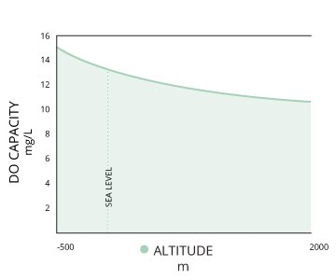
Dissolved oxygen concentrations decrease as altitude increases (pressure decreases)
Third, dissolved oxygen will increase as pressure increases ¹.
In summary, colder, deeper fresh waters have the capability to hold higher concentrations of dissolved oxygen, but due to microbial decomposition, lack of atmospheric contact for diffusion and the absence of photosynthesis, actual DO levels are often far below 100% saturation ¹⁰. Warm, shallow saltwater reaches 100% air saturation at a lower concentration, but can often achieve levels over 100% due to photosynthesis and aeration. Shallow waters also remain closer to 100% saturation due to atmospheric contact and constant diffusion ¹⁰.
If there is a significant occurrence of photosynthesis or a rapid temperature change, the water can achieve DO levels over 100% air saturation. At these levels, the dissolved oxygen will dissipate into the surrounding water and air until it levels out at 100% ³.
Typical Dissolved Oxygen Levels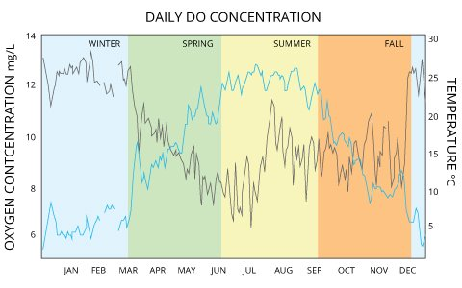
Dissolved oxygen concentrations are constantly affected by diffusion and aeration, photosynthesis, respiration and decomposition. While water equilibrates toward 100% air saturation, dissolved oxygen levels will also fluctuate with temperature, salinity and pressure changes ³. As such, dissolved oxygen levels can range from less than 1 mg/L to more than 20 mg/L depending on how all of these factors interact. In freshwater systems such as lakes, rivers and streams, dissolved oxygen concentrations will vary by season, location and water depth.
Freshwater Fluctuations: Example 1
In the Pompton River in New Jersey, mean dissolved oxygen concentrations range from 12-13 mg/L in winter and drop to 6-9 mg/L in the summer ⁸. That same river shows daily fluctuations of up to 3 mg/L due to photosynthesis production ⁸.
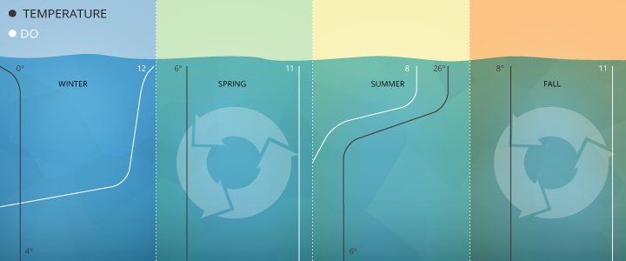
Dissolved oxygen levels often stratify in the winter and summer, turning over in the spring and fall as lake temperatures align.
Freshwater Fluctuations: Example 2
Studies at Crooked Lake in Indiana show dissolved oxygen concentrations vary by season and depth from 12 mg/L (surface, winter) to 0 mg/L (32 m depth, late summer), with full lake turnovers in spring and fall equalizing DO levels around 11 mg/L for all depths ¹.
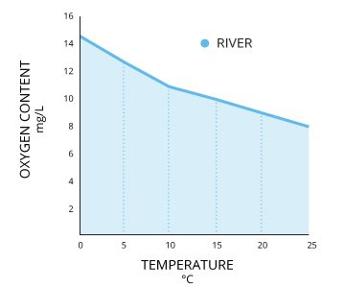
In rivers and streams, dissolved oxygen concentrations are dependent on temperature.
Rivers and streams tend to stay near or slightly above 100% air saturation due to relatively large surface areas, aeration from rapids, and groundwater discharge, which means that their dissolved oxygen concentrations will depend on the water temperature ¹. While groundwater usually has low DO levels, groundwater-fed streams can hold more oxygen due to the influx of colder water and the mixing it causes ¹⁵. Standard Methods for the Examination of Water and Wastewater defines dissolved oxygen in streams as the sum of photosynthetic byproducts, respiration, re-aeration, accrual from groundwater inflow and surface runoff ¹³.
Saltwater holds less oxygen than freshwater, so oceanic DO concentrations tend to be lower than those of freshwater. In the ocean, surface water mean annual DO concentrations range from 9 mg/L near the poles down to 4 mg/L near the equator with lower DO levels at further depths. There are lower dissolved oxygen concentrations near the equator because salinity is higher ¹⁶.
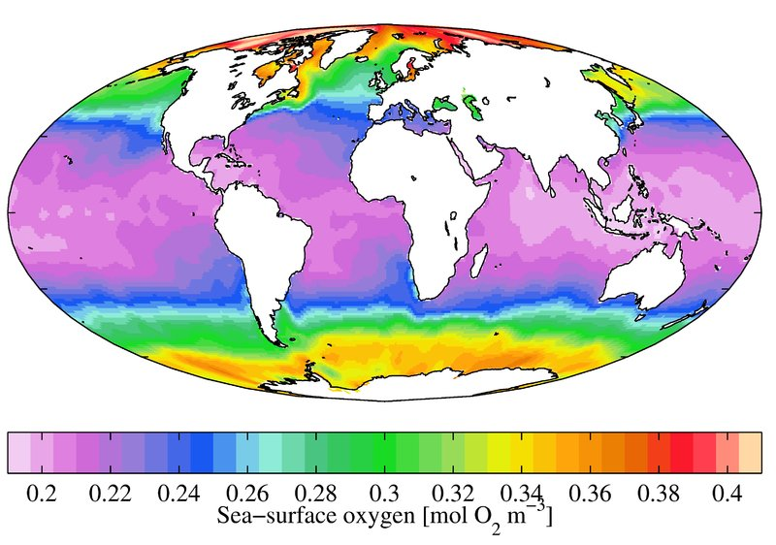

Examples of Freshwater Organisms and Dissolved Oxygen Requirements
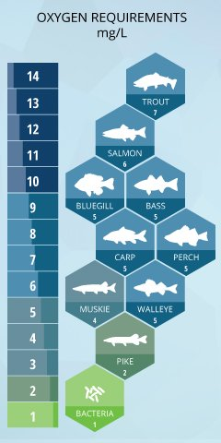
Minimum dissolved oxygen requirements of freshwater fish
Coldwater fish like trout and salmon are most affected by low dissolved oxygen levels ¹⁹. The mean DO level for adult salmonids is 6.5 mg/L, and the minimum is 4 mg/L ¹². These fish generally attempt to avoid areas where dissolved oxygen is less than 5 mg/L and will begin to die if exposed to DO levels less than 3 mg/L for more than a couple days ¹⁹. For salmon and trout eggs, dissolved oxygen levels below 11 mg/L will delay their hatching, and below 8 mg/L will impair their growth and lower their survival rates. ¹⁹ When dissolved oxygen falls below 6 mg/L (considered normal for most other fish), the vast majority of trout and salmon eggs will die. ¹⁹
Bluegill, Largemouth Bass, White Perch, and Yellow Perch are considered warmwater fish and depend on dissolved oxygen levels above 5 mg/L²¹. They will avoid areas where DO levels are below 3 mg/L, but generally do not begin to suffer fatalities due to oxygen depletion until levels fall below 2 mg/L ²². The mean DO levels should remain near 5.5 mg/L for optimum growth and survival ¹².
Walleye also prefer levels over 5 mg/L, though they can survive at 2 mg/L DO levels for a short time.²⁴ Muskie need levels over 3 mg/L for both adults and eggs ²⁵. Carp are hardier, and while they can enjoy dissolved oxygen levels above 5 mg/L, they easily tolerate levels below 2 mg/L and can survive at levels below 1 mg/L ²⁶.
The freshwater fish most tolerant to DO levels include fathead minnows and northern pike. Northern pike can survive at dissolved oxygen concentrations as low as 0.1 mg/L for several days, and at 1.5 mg/L for an infinite amount of time ²⁷. Fathead minnows can survive at 1 mg/L for an extended period with only minimal effects on reproduction and growth.
As for bottom-dwelling microbes, DO changes don’t bother them much. If all the oxygen at their water level gets used up, bacteria will start using nitrate to decompose organic matter, a process known as denitrification. If all of the nitrogen is spent, they will begin reducing sulfate ¹⁷. If organic matter accumulates faster than it decomposes, sediment at the bottom of a lake simply becomes enriched by the organic material. ²⁸.

Consequences of Unusual DO Levels
If dissolved oxygen concentrations drop below a certain level, fish mortality rates will rise. Sensitive freshwater fish like salmon can’t even reproduce at levels below 6 mg/L ¹⁹. In the ocean, coastal fish begin to avoid areas where DO is below 3.7 mg/L, with specific species abandoning an area completely when levels fall below 3.5 mg/L ²⁹. Below 2.0 mg/L, invertebrates also leave and below 1 mg/L even benthic organisms show reduced growth and survival rates ²⁹.

Fish kill / Winterkill
A fishkill occurs when a large number of fish in an area of water die off. It can be species-based or a water-wide mortality. Fish kills can occur for a number of reasons, but low dissolved oxygen is often a factor. A winterkill is a fish kill caused by prolonged reduction in dissolved oxygen due to ice or snow cover on a lake or pond ²⁰.
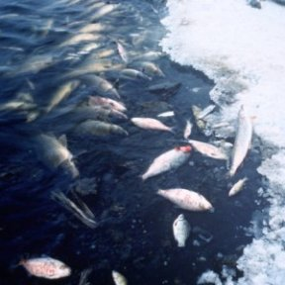
Dissolved oxygen depletion is the most common cause of fish kills
When a body of water is overproductive, the oxygen in the water may get used up faster than it can be replenished. This occurs when a body of water is overstocked with organisms or if there is a large algal bloom die-off.

Gas Bubble Disease
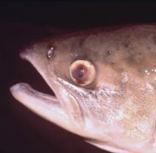
Sockeye salmon with gas bubble disease
Just as low dissolved oxygen can cause problems, so too can high concentrations. Supersaturated water can cause gas bubble disease in fish and invertebrates ¹². Significant death rates occur when dissolved oxygen remains above 115%-120% air saturation for a period of time. Total mortality occurs in young salmon and trout in under three days at 120% dissolved oxygen saturation ¹². Invertebrates, while also affected by gas bubble disease, can usually tolerate higher levels of supersaturation than fish ¹².

Dead Zones
A dead zone is an area of water with little to no dissolved oxygen present. They are so named because aquatic organisms cannot survive there. Dead zones often occur near heavy human populations, such as estuaries and coastal areas off the Gulf of Mexico, the North Sea, the Baltic Sea, and the East China Sea.
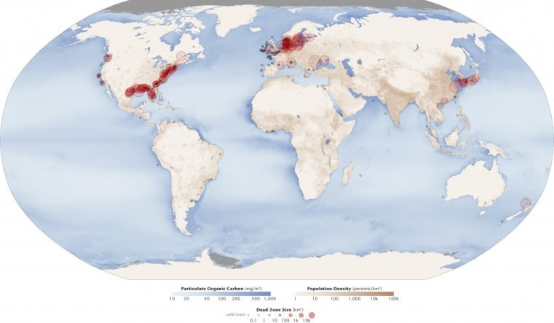
Hypoxic and anoxic zones around the world (photo credit: NASA)
These zones are usually a result of a fertilizer-fueled algae and phytoplankton growth boom.

Dissolved Oxygen and Water Column Stratification
Stratification separates a body of water into layers. This layering can be based on temperature or dissolved substances (namely salt and oxygen) with both factors often playing a role. The stratification of water has been commonly studied in lakes, though it also occurs in the ocean. It can also occur in rivers if pools are deep enough and in estuaries where there is a significant division between freshwater and saltwater sources.

Lake Stratification
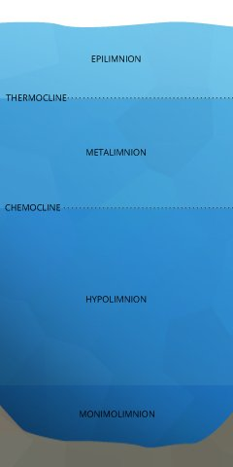
Lake stratification
The uppermost layer of a lake, known as the epilimnion, is exposed to solar radiation and contact with the atmosphere, keeping it warmer. The depth of the epilimnion is dependent on the temperature exchange, usually determined by water clarity and depth of mixing (usually initiated by wind) ¹¹. Within this upper layer, algae and phytoplankton engage in photosynthesis.
Below the epilimnion is the metalimnion, a transitional layer that fluctuates in thickness and temperature. The boundary between the epilimnion and metalimnion is called the thermocline – the point at which water temperature begins to steadily drop off ¹¹. Here, two different outcomes can occur. If light can penetrate beyond the thermocline and photosynthesis occurs in this strata, the metalimnion can achieve an oxygen maximum ¹¹. This means that the dissolved oxygen level will be higher in the metalimnion than in the epilimnion. But in eutrophic or nutrient-rich lakes, the respiration of organisms can deplete dissolved oxygen levels, creating a metalimnetic oxygen minimum ⁴².
The next layer is the hypolimnion. If the hypolimnion is deep enough to never mix with the upper layers, it is known as the monimolimnion. The hypolimnion is separated from the upper layers by the chemocline or halocline. These clines mark the boundary between oxic and anoxic water and salinity gradients, respectively. ¹¹. While lab conditions would conclude that at colder temperatures and higher pressures water can hold more dissolved oxygen, this is not always the result. In the hypolimnion, bacteria and fungi use dissolved oxygen to decompose organic material ⁶. This organic material comes from dead algae and other organisms that sink to the bottom. The dissolved oxygen used in decomposition is not replaced – there is no atmospheric contact, aeration or photosynthesis to restore DO levels in the hypolimnion ¹¹. Thus the process of decomposition “uses up” all of the oxygen within this layer.

Dissolved Oxygen Units and Reporting
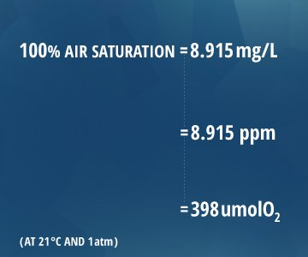

Calculating DO from % Air Saturation
O2 mg/L = (Measured % DO)*(DO value from chart at temperature and salinity)
Example:
70% DO measured
35 ppt salinity
15°C
.70 * 8.135 = 5.69 mg/L DO

