1: The following three tables include data about employees and fine tickets:

The following three tables include data about employees and fine tickets:

EMPLOYEE
Emp_ID | L_Name | F_Name | Phone_No | State_Lic |  | Lic_No
38249 | Ali | Mohand | 111-7804 | New York |  | BRY 123
82453 | Saed | Mazen | 391-1689 | New Mexico |  | TRE 141
TICKET  Ticket# Date Code Emp_ID  46383 10/17/08 2 38249  49696 11/13/08 1 38249  49585 10/05/08 3 82453  48575 11/18/08 1 82453  59686 12/13/08 2 82453 |  |  |  |  | TICKET_CODE  Code Fine Violation  1 $15 Longer than 3 hours  2 $25 On pavement  3 $100 Paralyze parking

Based on the given above tables answer the following questions:

- The attributes of table TICKET is:

- The primary key of TICKET_CODE table is:
- What is the name of employee who had the ticket # “49696”?
- What is the total of fines payable by employee Ali Mohand?

- Which State does the employee Saed Mazen belong to?
- What is the ticket number of the parking violation that was committed on 10/05/08 and how much is it?

2: Complete the missing words below, then answer the questions.

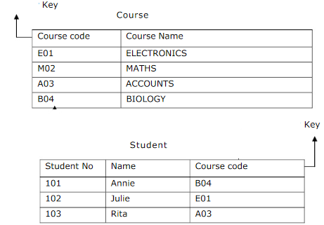
- The entities in the relations above are:----------------------------------------------------
- Name the attributes of the Course table.------------------------------------------------
- How many records in the Student table?---------------------
- Annie studies Biology course.(True, false)

3: The following two tables include data about professors and courses:

Courses Professors
Course_ID | Course_Name | Pro.ID
38 | MIS 201 | 333
39 | MIS 433 | 888
40 | MIS 201 | 222
65 | MIS 333 | 333
82 | MIS 214 | 555
Pro.ID | Pro.Name | Salary | Hire date
333 | Mazen Hani | 20,000 | 22-10-2009
888 | Fahad Saad | 15,000 | 11-3-2012
222 | Khaled Omar | 18,000 | 4-3-2010
555 | Ali Othman | 13,000 | 13-4-2013
Based on the given above tables answer the following questions:
1. The attributes of table Professors are: [1 Pt]

- The primary and foreign key of Course table are: [1 Pt]
Primary key…………….
Foreign key…………….
- What are the name of professors who teach MIS 201? [1 Pt]

- What are the name of the courses that Dr.Mazen Hani teaches? [1 Pt]

- When Dr. Fahad was hired and how many courses does Dr. Fahad teach? [1 Pt]

School Table
ID | Name | Total Cost for a year
S001 | University of Technology | 10,000
S002 | University of Applied Science | 20,000

Student Table
School ID | Student ID | Name | DOB | Semester
S001 | UT-1000 | Tommy | 05/05/1995 | 1st+ 2nd
S001 | UT-1001 | Better | 14/04/1996 | 2nd
S002 | UAS-1000 | Linda | 02/09/1995 | 1st+ 2nd
S002 | UAS-1001 | Jonathan | 22/3/1995 | 1st+ 2nd

- What are the entities?
- What are the primary and foreign key for Student table?
- How many students studying at University of Applied Science? And how much their total cost?
- How much the total cost that Better has to pay?
- How many record at Student table?

