Topology

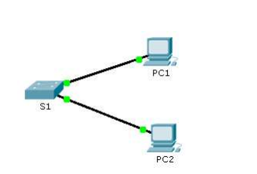
Addressing table:
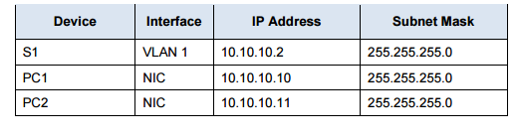

Scenario
The network administrator asked you to configure a new switch. In this activity, you will use a list of requirements to configure the new switch with initial settings, SSH, and port security.

Requirements
- Configure S1 with the following initial settings:
- Hostname
- Banner that includes the word warning
- Console port login and password s1pass1
- Encrypted enable password of s1userx
- Encrypt plain text passwords
- Management interface addressing
- Configure SSH to secure remote access with the following settings:
- Domain name of lab.com
- RSA key-pair parameters to support SSH version 2
- Set SSH version 2
- User admin with secret password labadmin
- VTY lines only accept SSH connections and use local login for authentication

- Configure the port security feature to restrict network access:
- Disable all unused ports.
- Set the interface mode to access.
- Enable port security to allow only two hosts per port.
- Record the MAC address in the running configuration
- Ensure that port violations disable ports.

Due date : Next Lab .

