_____

- Write the function prototype and show the output for the following program. What this program tries to demonstrate to us?(trace the programme)

#include <iostream>
Using namespace std;

// function prototype

void main(void)
{
int x = 3, y = 8;
for( ; y >= x ; )
y = subtract (x, y);
cout<<"y = %d\n"<< y;
}

int subtract (int a, int b)
{
return (b - a);
}

- Trace and show the output for the following program.
// for loop to print out index  #include <iostream>  using namespace std;  void dbl(int& a, int& b)  { a*= 2;  b*= 2; }  void trip(int a, int b)  { a*=3;  b*=3; }  int main(){  int x = 4, y = 6;  cout << "AT START:" << endl;  cout << "x= " << x << " y= " << y << endl; | //call the dbl function:  dbl(x,y);  cout << "AFTER DBL CALL:" << endl;  cout << "x= " << x << " y= " << y << endl;  //call the trip function:  trip(x,y);  cout << "AFTER TRIP CALL:" << endl;  cout << "x= " << x << " y= " << y << endl;  return 0;  }

- Change the following code ,convert the pass by value to pass by reference

#include <iostream>
using namespace std;
int absolute (int);// function prototype for absolute()
int main(){
int num, answer;
cout << "Enter an integer (0 to stop): ";
cin >> num;
while (num!=0){
answer = absolute(num);
cout << "The absolute value of " << num
<< " is: " << answer << endl;
cin >> num; }
return 0; }
// Define a function to take absolute value of an integer
int absolute(int x){
if (x >= 0) return x;
else return -x; }

- Write a functions :

- a function called zeroSmaller() that is passed two int arguments and then sets the smaller of the two numbers to 0.

- an overloaded function print to print 3 type of parameter one for int and one for double and the other for character.

- Over loaded function volume to cal calculate the volume of cube and for cylinder and print the result.
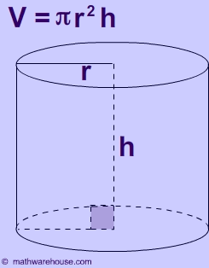
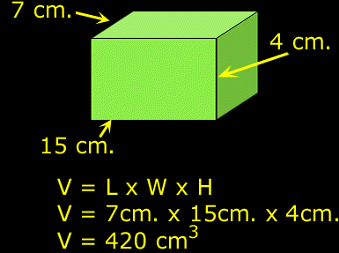
Hit:

