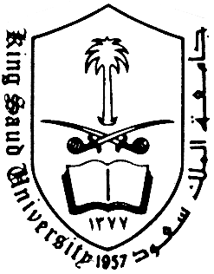
King Saud University

College of Languages & Translation
Department of European Languages & Translation
[English Language Program]

Speaking 2

Description

Course number & Code | 174 Najd
Course title | Speaking 2
Contact hours | 3
Section | 6059
-Textbook | Interactions 2 – Middle East Gold Edition

- Objectives

To get students to speak and to communicate fluently and accurately without inhibition . Its secondary objectives are to develop the students’ ability in making sentences, asking questions and to improve their pronunciation and vocabulary.

- Cognitive skills to be developed:

Using some very brief written notes when speaking.
Managing to maintain one’s audience interested.
Respecting the principles of politeness and using appropriate politeness formulae.
Developing an argument.
Using appropriate paralinguistic expressions while speaking.
Making requests, answering requests.
Apologizing, refusing, complaining.
Making invitations and declining invitations.

- Contact Information:

Miss Noura Alsultan
Email: noalsultan@ksu.edu.sa
Website: http://fac.ksu.edu.sa/noalsultan/home
Office: Building: 20 Room: 314
Gd luck

