KING SAUD UNIVERSITY
COLLEGE OF NURSING
MEDICAL SURGICAL DEPARTMENT

NURS 221 HEALTH ASSESSMENT (Practical)
Course activity
1ST SEM, AY 1442

Students Name: ____________________ Rating: _________/5
Student Number: _____________________ Date Performed: ____________

Case Scenario
Noura is a 60-year-old female presenting to the emergency department with acute onset shortness of breath. Symptoms began approximately 2 days before and had progressively worsened with no associated, aggravating, or relieving factors noted , pain score 7/10. She had similar symptoms approximately 1 year ago with an acute, chronic obstructive pulmonary disease (COPD) exacerbation requiring hospitalization. She uses BiPAP ventilatory support at night when sleeping and has requested to use this in the emergency department due to shortness of breath and wanting to sleep.
She denies fever, chills, cough, wheezing, sputum production, chest pain radiate to both shoulder , palpitations, pain like pressure, abdominal pain, abdominal distension, nausea, vomiting, and diarrhea.
She does report difficulty breathing at rest, forgetfulness, mild fatigue, feeling chilled requiring blankets, increased urinary frequency, incontinence, and swelling in her bilateral lower extremities that is new onset and worsening. Subsequently, she has not ambulated from bed for several days except to use the restroom due to feeling weak, fatigued, and short of breath.
There are no known ill contacts at home. Her family history includes significant heart disease and prostate malignancy in her father. Social history is positive for smoking tobacco use at 30 pack years. She quit smoking 2 years ago due to increasing shortness of breath. There are no known foods, drugs, or environmental allergies.
Past medical history is significant for coronary artery disease, myocardial infarction, COPD, hypertension, hyperlipidemia, hypothyroidism, diabetes mellitus, peripheral vascular disease, tobacco usage, and obesity. Past surgical history is significant for an appendectomy, cardiac catheterization with stent placement, hysterectomy, and nephrectomy.
Her current medications include Breo Ellipta 100-25 mcg inhaled daily, hydralazine 50 mg by mouth, 3 times per day, hydrochlorothiazide 25 mg by mouth daily, Duo-Neb inhaled q4 hr PRN, levothyroxine 175 mcg by mouth daily, metformin 500 mg by mouth twice per day, nebivolol 5 mg by mouth daily, aspirin 81 mg by mouth daily, vitamin D3 1000 units by mouth daily, clopidogrel 75 mg by mouth daily, isosorbide mononitrate 60 mg by mouth daily, and rosuvastatin 40 mg by mouth daily.
Physical Exam
Initial physical exam reveals temperature 37.5 C, heart rate 74 bpm, respiratory rate 24, BP 104/54, , and O2 saturation 90% on room air.
Wt 88 kg , Ht 158 , BMI =

HEENT:
- Head: Normocephalic and atraumatic
- Mouth: Moist mucous membranes
- Macroglossia
- Eyes: Conjunctiva and EOM are normal. Pupils are equal, round, and reactive to light.
- Neck: Neck erect. No JVD present. No masses or surgical scarring.
- Throat: Patent and moist
Cardiovascular: Normal rate, regular rhythm, and normal heart sound with no murmur. 2+ pitting edema bilateral lower extremities and strong pulses in all four extremities.
Pulmonary/Chest: No respiratory status distress at this time, tachypnea present, (+) wheezing noted, bilateral rhonchi, decreased air movement bilaterally. Patient barely able to finish a full sentence due to shortness of breath.
Abdominal: Soft. Obese. Bowel sounds hyperactive sound. Distension abdomen and no tenderness
Skin: Skin is very dry , capillary refill > 3sec
Neurologic: Alert, awake, able to protect her airway. Moving all extremities. No sensation losses

NB:
Based on the case scenario presented above, please answer the following questions comprehensively and submit it in the due date 30 Nov , If you do not submit by the required due date, a grade of zero will be recorded.

Health History FORMAT:

- Demographic Data:

Name: ________________________________
Age: ________________________________
Gender: ________________________________

Medical Diagnosis: ________________________________

II. Present Health/Illness

Reason for seeking care: ____________________________________

Provoked by: ________________________Palliated by: ______________
Quality: _______________________ Radiation: _____________________
Region _______________________
Severity: □ mild □ moderate □ severs scale (0-10) ______________
Timing: Onset _______ □sudden ________□ gradual __________ Frequency ________________ Duration: ____________________________

Write the present health/illness in a narrative form:

______________________________________________________________________________________________________________________________________________________________________________________________________________________________________________________________________________________________________________________________________________________________________________________________________________________________________________________________________________________________________________________________________________________________________________________________________________________________________________________

III. Past History:

Childhood illnesses: □no □yes (specify) ___________________________
Accidents and injuries: □no □yes (specify) ___________________________
Serious or chronic illnesses: □no □yes (specify) ___________________________
Hospitalizations: □no □yes (specify) ___________________________
Surgeries: □no □yes (specify) ___________________________
Immunization: □no □yes (specify) ___________________________
Allergies: □no □yes (specify) ___________________________
Current medication: □no □yes (specify) ___________________________
Last examination Date: ____________________________________________

IV. FAMILY HISTORY

Father: __________________________
Mother: __________________________
Siblings: __________________________
Grandparents: __________________________

V. PSYCHOSOCIAL HISTORY: _______________________________________________________________

Vital Signs: BP ___________ TEMP ____________ RR ______________ PR_____________

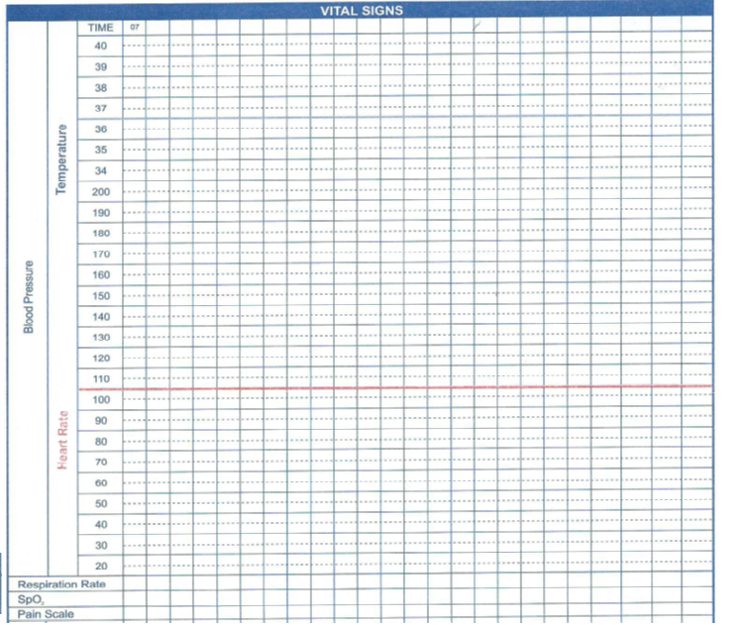

GENERAL SURVEY:

Physical Appearance:
- Skin Color : ____ WNL ABNORMALITY: ___________
- Facial Features: ____ WNL ABNORMALITY: ___________
- Body shape and build ____ WNL ABNORMALITY: ___________
- Height and weight ____ WNL ABNORMALITY: ___________
- Nutrition ____ WNL ABNORMALITY: ___________
- Signs of Distress ____ WNL ABNORMALITY: ___________

Mental Status
- Affect and mood ____ WNL ABNORMALITY: ___________
- Level of Anxiety ____ WNL ABNORMALITY: ___________
- Orientation and speech ____ WNL ABNORMALITY: ___________

Mobility
- Gait ____ WNL ABNORMALITY: ___________
- Posture ____ WNL ABNORMALITY: ___________
- Range of motion ____ WNL ABNORMALITY: ___________

Patient Behavior
- Dress and grooming ____ WNL ABNORMALITY: ___________
- Body odor ____ WNL ABNORMALITY: ___________
- Facial expression ____ WNL ABNORMALITY: ___________
- Ability to make eye contact ____ WNL ABNORMALITY: ___________

NUTRITIONAL STATUS:

Height: __________________
Weight: __________________
BMI: __________________

Physical assessment ( Head to toe per system ) depend to the scenario fill it in the schedule:
Body Part | Normal Findings | Patient Findings
Skin
Head, Eyes , Ears , Nose
Respiratory
Cardiovascular
Gastrointestinal
Urinary
Musculo skeletal
Nervous System
Skin

Good Luck

