Common Mistakes
Title
- Objective
- Introduction
- Background
- Theory
- Apparatus & Techniques
- Exp. Setup
- Procedure
- Result & Discussion
- Plots & Figures.
- Uncertainty
- Discussion
- Conclusion
- Appendix
- References
- The size of font should be 12.
- Do not write in Arabic.
- Write your group letter.
- Do not use Indian numbers, use only
Arabic numbers (1,2,3,…)
- The objective should be in the beginning.
- The equation should has a number, clear
Symbols, and explain why you use it.
- The picture should has a
caption and describe it completely.
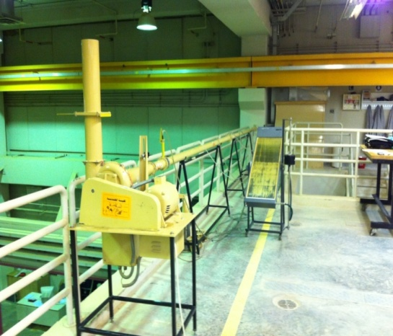

Fig….; ……………
And describe the picture in detail; the parts and why do you use, where, and when ; and so on.
- Plots and Figures:
- There should be no boundary around plots.
- The axis should have name and unit.
- Describe it in details in the text.
Describe plot in text, like
"The X-axis indicate to ….. and Y-axis to … , and from the fig. we show …; and so on"

- The appendix consists of:
- Tables "do not put tables in results"
- Do not print tables from Excel directly first organize it in Word and print it.
- Calculations

Finally:
You should stick to sample report.

