Chapter 15
Marketing Communications

Promotion: communication by marketer that informs, persuades, and reminds potential buyers of a product in order to influence an opinion or elicit a response.
-Promotional Strategy
A plan for the optimal use of the elements of promotion:
- Advertising
- Public Relations
- Personal Selling
- Sales Promotion
- Social Media
-A Competitive advantage: is the set of unique features of a company and its products that are perceived by the target market as significant and superior to those of the competition.
Competitive Advantage include:
- High product quality
- Rapid delivery
- Low prices
- Excellent service
- Unique features
-Communication: is the process by which meanings are exchanged or shared through a common set of symbols.
Communication can be divided into two major categories:
- Interpersonal communication: is direct, face-to-face communication between two or more people.
- Mass communication: refers to communicating a concept or message to larger audiences, usually through a mass medium such as television or newspapers.

Communication Process:
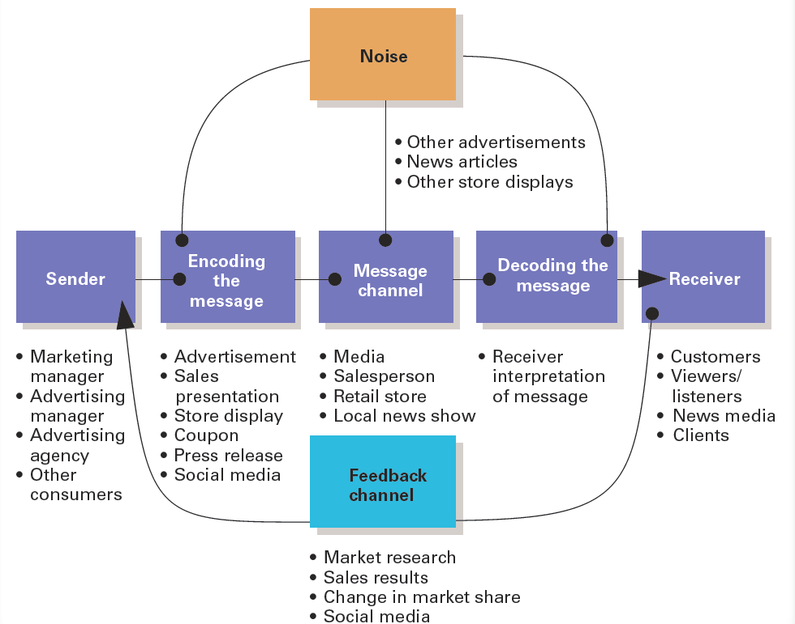

- Sender: The originator of the message in the communication process.
- Encoding: The conversion of a sender’s ideas and thoughts into a message.
- Channel: is medium of communication used to transmit a message such as Smartphone, radio.
- Noise: anything that interferes with, distorts, or slows down the transmission of information.
- Decoding: is the interpretation of the message transmitted by the sender.
- Receiver: is the person who decodes the message in the communication process.
- Feedback: may be verbal, as in saying “I agree;” or nonverbal, as in nodding, smiling, frowning.
Communication and the Internet:
- Traditional advertising model:
- Impersonal
- Numbers driven
- Unquantifiable
- Internet and social media advertising:
- Personal
- Direct communication
- Feedback driven
- Highly visible
Promotion has four basic tasks: It can;
1- Inform the target audience.
2- Persuade the target audience.
3-Remind the target audience.
4-Connect with the audience.
- Informative promotion: seeks to convert an existing need into a want or to stimulate interest in new product.
- Persuasive promotion: is designed to stimulate a purchase or an action.
- Reminder promotion: is used to keep the product and brand name in the public’s mind

Promotional Mix: the combination of promotion tools used to reach the target market and fulfill the organization’s overall goals.
-The promotional mix includes:
1- Advertising: is any form of impersonal paid communication in which the sponsor or company identified.
Advantages: Disadvantages
- Total cost is high
- National reach is expensive for small companies
- Reach large number
of people
- Low cost per
contact
- Can be micro-targeted to small group of potential customers

2- Public Relations: is the marketing function that evaluates public attitudes, identifies areas within the organization that public may be interested in, and executes a program of action to earn public understanding and acceptance.
- Sales Promotion: consists of all Marketing activities—other than personal selling, advertising, and public relations—that stimulate consumer buying and dealer effectiveness.

- Sales Promotion Include:
-Free samples -Contests
-Premiums - Trade Shows
-Coupons - Experiential marketing
-Vacation Giveaways
4- Personal selling: is a purchase situation involving a personal, paid-for communication between two people in an attempt to influence each other.
5-Social Media: are promotion tools used to facilitate conversations and other interactions among people online.
Digital Media Types:
- Owned Media
  - Web Sites
  - Blogs
  - Social Media Presence
  - Such as company web, Twitter, YouTube channels, others
- Paid Media
- Banner ads
- Sponsored posts
- Such as tv, magazine, outdoor, radio, others
- Earned Media
  - Media Coverage
  - SEO
  - Publicity activities
  - Such as media coverage, word of mouth

The AIDA Model: This model proposes that consumers respond to marketing messages in a cognitive (thinking), affective (feeling), and conative (doing) sequences.

The four steps of the AIDA process:
4-Action
3-Desire
2- Interest
1-Attention

Conative (doing)
Affective (feeling)

Cognitive(thinking)

-The model suggests that promotional effectiveness can be measured in terms of consumers progressing from one stage to the next.
-Integrated Marketing Communications(IMC); is the careful coordination of all promotional messages- traditional advertising, direct marketing, social media, interactive, public relations, sales promotion, personal selling, event marketing, and other communications-for all product and service to assure the consistency of messages at every contact point where a company meets the consumer.
Factors Affecting the Promotional Mix:
1-Nature of the product
2- Stage in PLC
3-Target market characteristics
4-Type of buying decision
5-Promotion funds
6-Push or pull strategy

