Chapter 15
Index Numbers

Use the following to answer questions 1-7:
Data for selected vegetables purchased at wholesale prices for 1995 and 2007 are shown below.

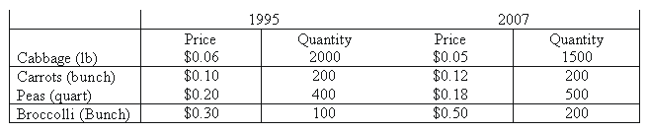

- What is the simple average price index?
- What is the unweighted aggregate price index?
- What is Laspeyres' price index?
4. What is Paasche's price index?
5. What is the average of Laspeyres' and Paasche's price indexes (Fisher Index)?
6. What is the value index?
7. What is the simple price relative for peas?

