**Resistance**

The flow of charge through any material encounters an opposing force (mechanical friction).

This is due to collision between electrons and atoms,

These collisions convert electrical energy into heat.

|  |  |
| --- | --- |
| This opposition is called resistance of the material,  The unit of resistance is the “ohm” **Ω** |  |

**Ohm’s Law, Power and Energy**

**4.1 OHM’S LAW**

$$Effect=\frac{Cause}{Opposition}$$

Effect ≡ Current

Cause ≡ Potential difference or voltage

Opposition ≡ Resistance

|  |  |
| --- | --- |
| $$Current=\frac{Potential Difference}{Resistance}$$ $I=\frac{E}{R}$ Ohm’ s Law |  |

|  |  |
| --- | --- |
| Defining the polarity:  flow of charge:  from a high **(+)** to a low **(-)** potential |  |



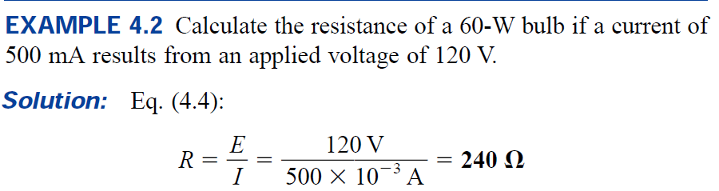





**4.3 POWER**

Power is an indication of how much work can be accomplished in a certain time

**Power ≡ Rate of doing work**

1 Watt (W) ≡ 1 Joule (J)/second(s) = J/s

$$P=\frac{W}{t}$$

|  |  |
| --- | --- |
| unit of power is Watts (W) or (J/s)  1 horsepower (hp) = 746 W | $$P=\frac{W}{t}$$ |

In electrical device the power absorbed or delivered is:

$$P=\frac{W}{t}=\frac{Q∙V}{t}=V∙\frac{Q}{t}=V∙I$$

$P=V∙I$ (W)

**In a resistance**

|  |  |
| --- | --- |
| $$P=V∙I$$ $⟹$ $P=V∙\frac{V}{R}=\frac{V^{2}}{R}$ $⟹$ $P=(R∙I)∙I=R{∙I}^{2}$ |  |

For resistive element, all the power delivered is dissipated in the form of heat.

$P=R{∙I}^{2}$ $⟹$ $I=\sqrt{P/R}$ $P=\frac{V^{2}}{R}$ $⟹$ $V=\sqrt{P∙R}$

In Voltage supply (battery)

|  |  |
| --- | --- |
| $$P=E∙I$$ Power is supplied by the source | $$P=E∙I$$ Power is absorbed by the source |



**4.5 EFFICIENCY**

|  |  |
| --- | --- |
| Energy flow in a system that converts energy from one form to another. $W_{o}<W_{i}$ due to losses and storage $$W_{i}=W_{o}+W_{lost or stored}$$ $$P_{i}=P_{o}+P_{lost or stored}$$ |  |

The efficiency (η) of the system is:

$$Efficiency=\frac{Power output}{Power input}$$

$η=\frac{P_{o}}{P_{i}}$ $⟹$ $η\left(\%\right)=\frac{P_{o}}{P_{i}}×100 \%$

η is always less than 1 (100 %)