Confidence interval for the proportion
9.53 (a) A random sample of 200 voters in a town is selected, and 114 are found to support an annexation suit. Find the 96% confidence interval for the fraction of the voting population favoring the suit.
(b) What can we assert with 96% confidence about the possible size of our error if we estimate the fraction of voters favoring the annexation suit to be 0.57?
$$\hat{p}= \frac{114}{200}=0.57$$
Z_{0.02} = 2.05
C.I : $0.57-\left(2.05\right)*\sqrt{\frac{0.57*0.43}{200}}<p< 0.57+\left(2.05\right)*\sqrt{\frac{0.57*0.43}{200}}$
0.5 < p < 0.64
b) $e will not exceed : 2.05*\sqrt{\frac{0.57*0.43}{200}}=0.0718$
9.67 A clinical trial was conducted to determine if a certain type of inoculation has an effect on the incidence of a certain disease. A sample of 1000 rats was kept in a controlled environment for a period of 1 year, and 500 of the rats were given the inoculation. In the group not inoculated, there were 120 incidences of the disease, while 98 of the rats in the inoculated group contracted it. If p1 is the probability of incidence of
the disease in uninoculated rats and p2 the probability of incidence in inoculated rats, compute a 90% confidence interval for p1 − p2.
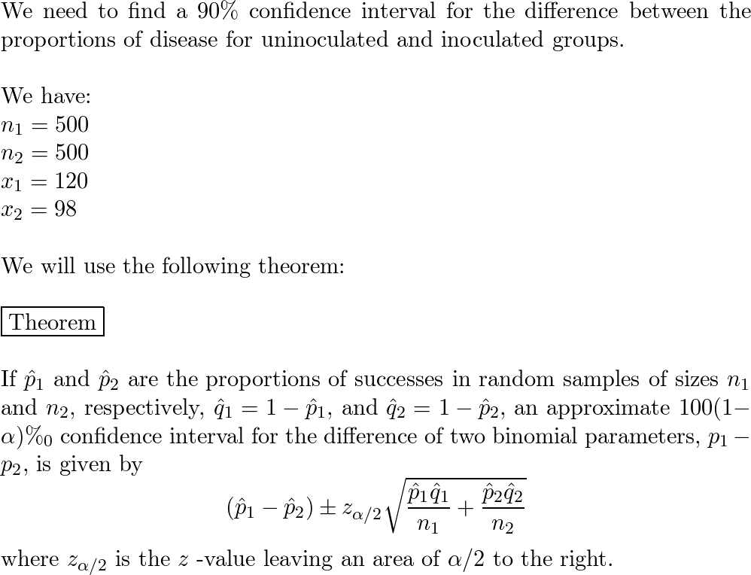
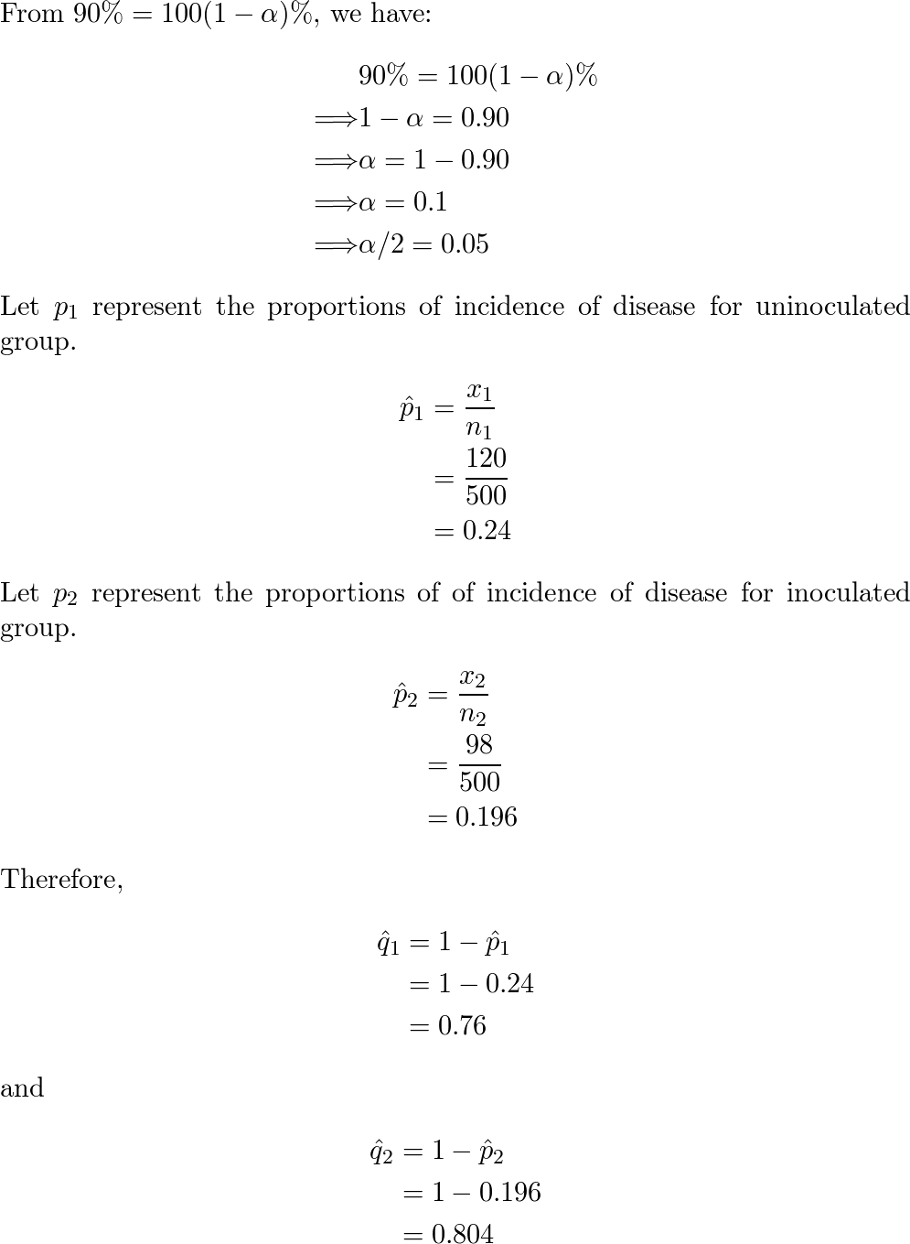
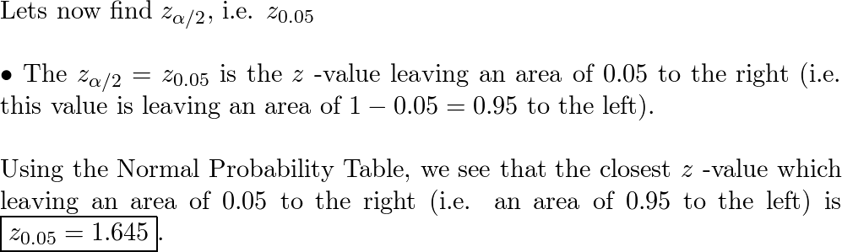
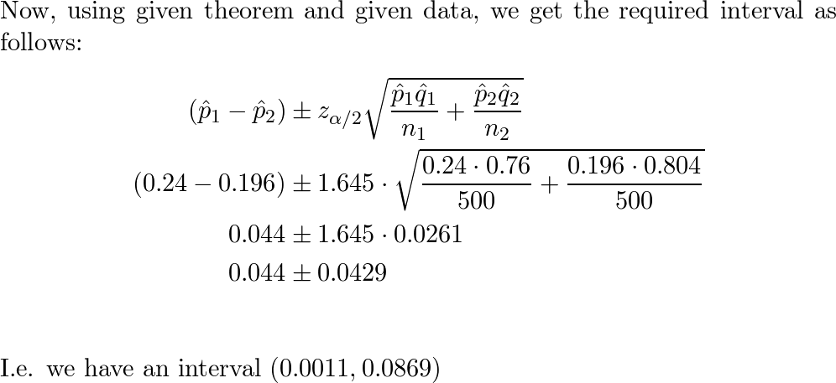
ـــــــــــــــــــــــــــــــــــــــــــــــــــــــــــــــــــــــــــــــــــــــــــــــــــــــــــــــــــــــــــــــــــــــــــــــــــــــــــــــــــــــــــــــــــــــــــــ
Confidence interval for Variance
9.72 A random sample of 20 students yielded a 𝑚𝑒𝑎𝑛𝑜𝑓 𝑥̅ = 72 and a variance of 𝑠2= 16 for scores on a college placement test in mathematics. Assuming the scores to be normally distributed, construct a 98% confidence interval for 𝜎2.
