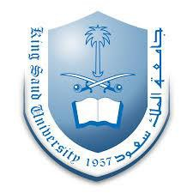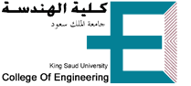

Calculus For Engineers (MATH 1110)
Dr. O. Philips Agboola
Assistant Professor of Mechanical Engineering
Office: F-092
pagboola@ksu.edu.sa, http://fac.ksu.edu.sa/pagboola

Course Content

Infinite series, convergence and divergence of infinite series, integral test, ratio test, root test and comparison test. Conditional convergence and absolute convergence, alternating series test. Power series, Taylor and Maclaurin series. Definite and indefinite integrals and the fundamental theorem of calculus. Double integral and its applications to area, volume, moments and center of mass. Double integrals in polar coordinates. Triple integral in rectangular, cylindrical and spherical coordinates and applications to volume moment and center of mass. Vector fields, line integrals, surface integrals, Green's theorem, the divergence theorem, Stoke' theorem.
Recommended books: Calculus with analytic geometry (E. W Swokowski)
Course Assessment Method

No Assessment Task Percentage
- Homework 10%
- Quizzes 20%
- Midterm 25%
- Final Exam 40%
- Class Participation 5%
Schedule of Topics to be Covered

Topics | No of Weeks | Contact hours
Sequences, Series and the tests for their convergence Q1 | 3 | 9
Power, Taylor and McLaurin Series Q2 | 1 | 3
Double Integrals and its applications to area, volume, Moments and Centre of Mass ME | 3 | 10
Triple Integrals in Cartesian, Cylindrical, and Spherical Coordinates and its applications to Volume, Moments, and Centre of Mass Q3 | 3 | 9
Vector Fields, Line and Surface Integrals Q4 | 2 | 5
Green, Divergence, and Stokes Theorems FE | 2 | 6
Total number of weeks and contact hours per semester | 14 | 42

Assignment and Quizzes’ Policy | No. Assessment task Date due (Academic Week) Proportion of Final Assessment  1 Assignments ( Home-works) After every topics 10%  2 Quizzes (4) 3rd, 5th, 9th & 11th 20%

