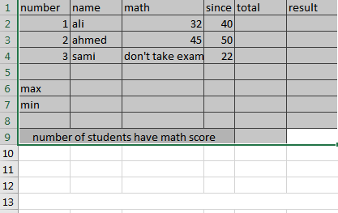

- Calculate the total using AutoSum
- Calculate the annual salary max using AutoSum
- Calculate the annual salary min using AutoSum
- Count the number of student who have math score
- Use if and right pass if the student more than 80 and unpassed
- Apply conditional formatting to the total data to highlight the cells above 80

