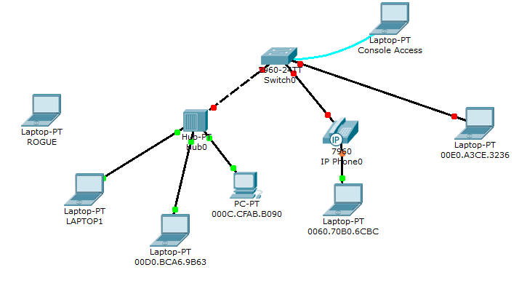
- Configure port security on interface Fa 0/1 of the switch with the following settings :
  - - Port security enabled
  - - Mode : restrict
  - - Allowed mac addresses : 3
  - - Dynamic mac address learning.
- Configure port security on interface Fa 0/2 of the switch with the following settings:
  - - Port security enabled
  - - Mode : shutdown
  - - Allowed mac addresses : 3
  - - Dynamic mac address learning.
- Configure port security on interface Fa 0/3 of the switch with the following settings :
  - - Port security enabled
  - - Mode : protect
  - - Static mac address entry : 00E0.A3CE.3236
- From LAPTOP 1 :
  - Try to ping 192.168.1.2 and 192.168.1.3. It should work.
  - Try to ping 192.168.1.4 and 192.168.1.5. It should work.
- Connect ROGUE laptop to the hub.
  - Try to ping 192.168.1.1. It should work.
  - Try to ping 192.168.1.4. It should fail.

