Health Sciences CHS 232
Bone Health
Bone function:
- providing structure,
- protecting organs,
- anchoring muscles
- Storing calcium.
While it's particularly important to take steps to build strong and healthy bones during childhood and adolescence, you can take steps during adulthood to protect bone health, too.

Why is bone health important?
Your bones are continuously changing — new bone is made and old bone is broken down. When you're young, your body makes new bone faster than it breaks down old bone and your bone mass increases.
Most people reach their peak bone mass around age 30. After that, bone remodeling continues, but you lose slightly more than you gain. How likely you are to develop osteoporosis — a condition that causes bones to become weak and brittle — depends on how much bone mass you attain by the time you reach age 30 and how rapidly you lose it later.
The higher your peak bone mass, the more bone you have "in the bank" and the less likely you are to develop osteoporosis as you age.

What affects bone health?
A number of factors can affect bone health — some modifiable and some not. For example
- The amount of calcium in your diet. A diet low in calcium contributes to diminished bone density, early bone loss and an increased risk of fractures. Institute of Medicine recommends 1,000 milligrams (mg) of calcium a day. The recommendation increases to 1,200 mg a day for women age 51 and older and men age 71 and older.
Some Foods High in Calcium:
Yogurt, 1 cup - 400 mg Milk, 1 cup - 300 mg
Cheddar cheese, 1 1/2 ounces - 300 mg Broccoli, 1 cup - 118 mg
Orange juice with added calcium, 1 cup - 300 mg

- Physical activity level. People who are physically inactive have a higher risk of osteoporosis than do their more-active counterparts.
How does physical activity help build healthy bones?
- Bones are living tissue. Weight-bearing physical activity causes new bone tissue to form, which makes bones stronger. This kind of physical activity also makes muscles stronger. When muscles push and tug against bones during physical activity, bones and muscles become stronger.

- Tobacco use and alcohol consumption. Research suggests that tobacco use contributes to weak bones. Similarly, regularly having more than two alcoholic drinks a day increases the risk of osteoporosis, possibly because alcohol can interfere with the body's ability to absorb calcium.

- Sex: Being a woman. Women have less bone tissue than do men.

- Age: Your bones become thinner and weaker as you age.

- Race. You're at greatest risk of osteoporosis if you're white or of Asian descent.

- Body mass index: You're also at greater risk if you're extremely thin (with a body mass index of 19 or less) or have a small body frame because you may have less bone mass to draw from as you age.

- Family history : having a parent or sibling who has osteoporosis puts you at greater risk — especially if you also have a family history of fractures.

- Hormone levels:
  - Too much thyroid hormone can cause bone loss.

  - In women, bone loss increases dramatically at menopause due to dropping estrogen levels.

  - Prolonged periods of amenorrhea, the absence of menstruation before menopause also increases the risk of osteoporosis.

  - In men, low testosterone levels can cause a loss of bone mass.
- Eating disorders and other conditions and procedures that affect bone health. People who have anorexia or bulimia are at risk of bone loss.

- Stomach surgery (gastrectomy), weight-loss surgery and conditions such as Crohn's disease, celiac disease and Cushing's disease can affect your body's ability to absorb calcium.

- Use of certain medications. Long-term use of corticosteroid medications is damaging to bone. Other drugs associated with an increased risk of osteoporosis include long-term use of aromatase inhibitors to treat breast cancer, the antidepressant medications called selective serotonin reuptake inhibitors (SSRIs), the cancer treatment drug methotrexate, the acid-blocking drugs called proton pump inhibitors and aluminum-containing antacids used to treat gastric and peptic ulcer.

It is especially important to build strong and healthy bones in the childhood and teen years to avoid osteoporosis later in life. Osteoporosis is a condition in which bones are fragile, making them fracture or break much easier | - 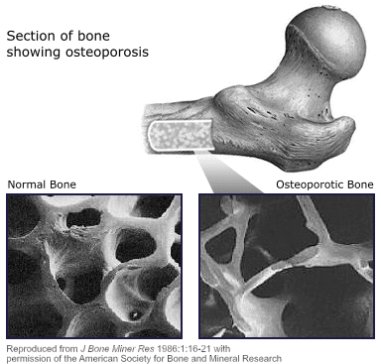
Assignment
What can I do to keep my bones healthy?

