BCH 447
Estimation of D-xylose in urine
Method:
1- Label 7 tubes and add the following to each tube:
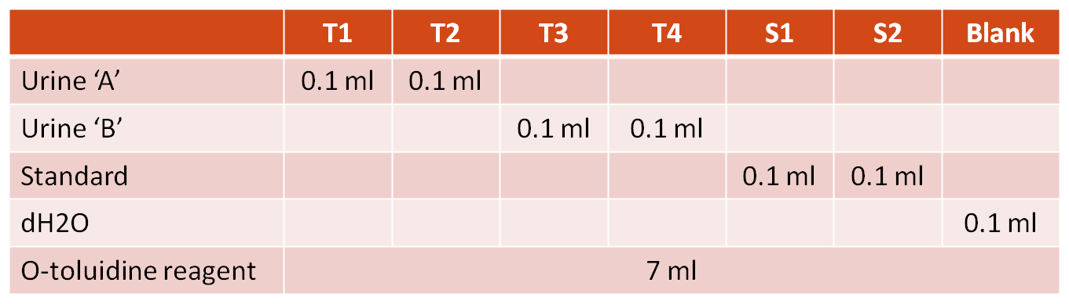
2- Cover tubes by aluminum foil and mix the contents of each tube
3- Boiling water bath for 5 minutes
4- Cool the tubes for 1-3 min
5- Read absorbance at 475 nm against blank

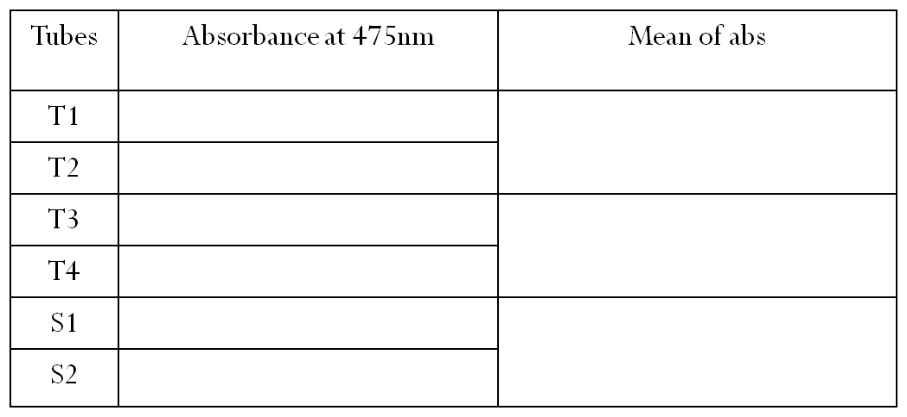
Results and calculations:
Total volume of sample A = 5.3 ml
Total volume of sample B= 5.6 ml
D.f= 10
Conc. of std = 0.01 g/ml
$Concentration of D_xylose in urine= \frac{Mean abs of test }{Mean abs of std} x Conc.of std.x D.f$

