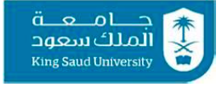

**King Saud University MKT201 Priciples of Marketing**

**College of Business Administration Section: 41501**

**Instructor: Nouf Alrayes 2nd semester 2017/2018**

|  |  |
| --- | --- |
| **Project Title** |  |
| **Group Letter** |  |
| **Student Name** |  |
| **KSU Id #** |  |
| **Serial #** |  |
| **Type of Project** | **e.g. case study, mini project, main project** |

**______________________________________________________**