**Csc1203- assignment#4**

Due on Sunday 24 Feb , 8:00am

submitted to s.moodawah@gmail.com

Q1.Map the EER model of the following databases, solved in assignment #1, to a relational model. Show all integrity types(Clarify your answer by underline the Primary key, and dotted line the Foreign Key.(

1. **International School of Technology**

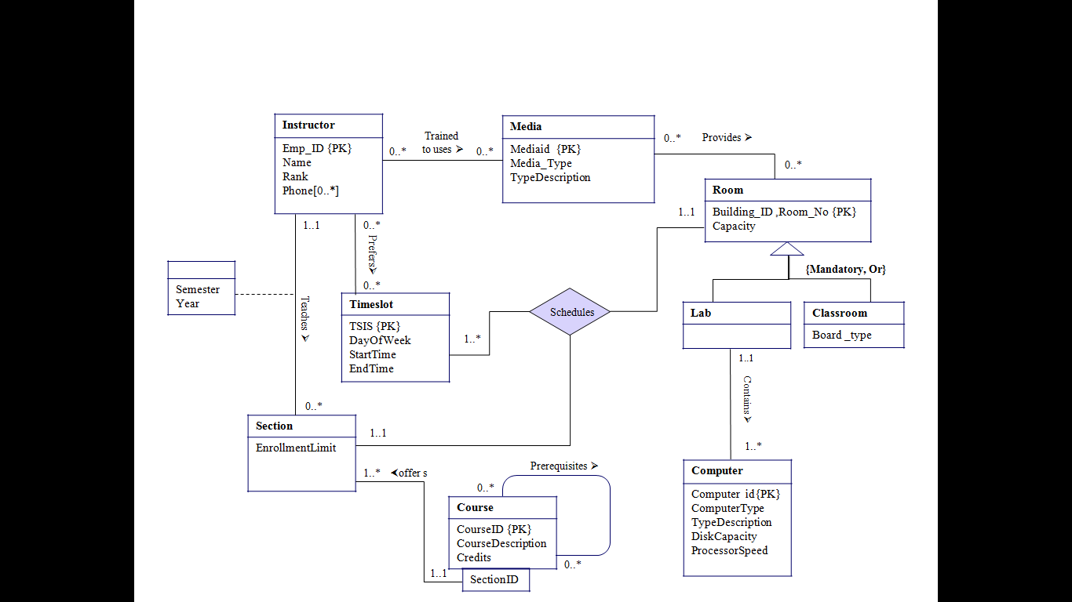

1. **Real estate firm**

