Csc1203- assignment#1 & #2 Model Answer

Real estate firm : ER diagram
A real estate firm lists property for sale and wishes to establish a database system for its operation. The firm has a number of sales offices in several states. Each sales office has office_number and address (city, state and zip). Each sales office is assigned one or more employees. Every employee has an employee_id and employee_name. An employee must be assigned to only one sales office. If an employee is married to another employee of the firm, the date of the marriage and who is married to whom must be stored; however, no record of marriage is required if an employee’s spouse is not also an employee. For each sales office, there is always one employee assigned to manage that office. An employee may manage only the sales office to which he or she is assigned. In other words, an employee cannot be assigned to one office, yet manage another office.

The firm lists property for sale; which has property_id, and address (city, state and zip). Each property must be listed with one and only one of the sales offices. A sales office may have any number of properties listed or may have no properties listed.

Each property has one or more owners. Every owner has an owner_id and owner name. An owner may own one or more property. The firm wants to keep track of the percentage that a given owner owns a given piece of property. For example, imagine that Smith and Jones both own property A. Smith owns 35% of property A and Jones owns 65% of property A. The firm wants to retain this information and they want to call it percent_owned.

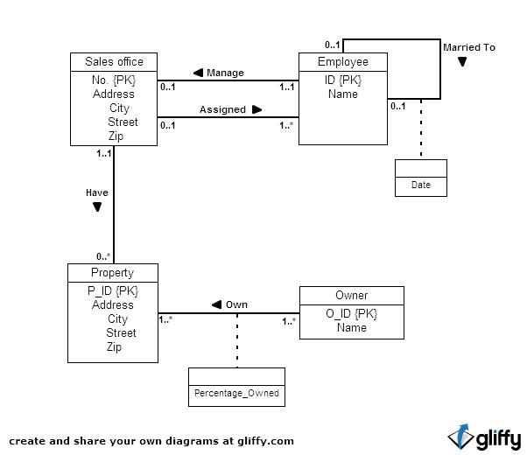

Q2. Library
A library has approximately 16,000 members, 100,000 titles, and 250,000 volumes. The librarian ensures that the books that members want to borrow are available when the members want to borrow them. Also, the librarians must know how many copies of each book are in the library or out on loan at any given time. A catalog of books is available online that lists books by author, title, and subject area. The reference librarian wants to be able to access this description when members request information about a book. Books can be checked out for 21 days.
To become a member of the library, applicants fill out a form including their SSN, campus and home mailing address, and phone numbers. The librarians then issue a numbered, machine-readable card with the member’s photo on it. This card is good for four years from the issue date. Professors at the institute are considered automatic members. When a new faculty member joins the institute, his or her information is pulled from the employee records and a library card is mailed to his or her campus address.
The library does not lend some books, such as reference books, rare books, and maps. The librarians must differentiate between books that can be lent and those cannot be lent. In addition, the librarians have a list of some books they are interested in acquiring but cannot obtain, such as rare or out-of-print books and books that were lost or destroyed but have not been replaced. The librarians must have a system that keeps tracks of books that cannot be lent as well as books that they are interested in acquiring.
Some books may have the same title; therefore, the title cannot be used as a means if identification. Every book is identified by its International Standard Book Number (ISBN), a unique international code assigned to all books. Two books with the same title can have different ISBNs if they are in different languages or have different bindings (hard cover or soft cover). Editions of the same book have different ISBNs.
The proposed database system must be designed to keep track of the members, the books, the catalog, and the borrowing activity.
